Rec Ball Court Proposals: 6 Nov 2018

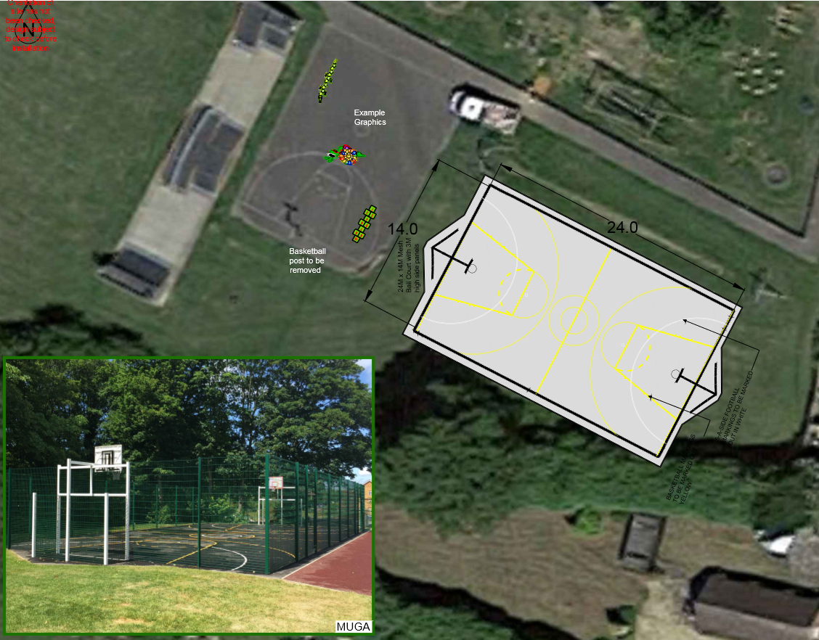
I have received the following quotes for a 24m x 14m ball court with 3m fencing around, Goals at each end and basketball nets above at each end. Marked out for football and basketball. Openings for access by each goal. Ground to be levelled to create a level playing field. (there are so many opportunities for clichés – the quotes are accurate – not Ball park!)
Sutcliffe and Miracle also include Cricket Wickets in the fence.
Wicksteed £52580
Sutcliffe £60633
Miracle £62879
Each quote also includes removal of existing ball court basketball net and making good the tarmac.
Sutcliffe and Miracle quotes also include about (£900 each for existing lines to be removed and new graphics to be painted on current ball court to create play “Roadway”). Wicksteed quoted £5100 for this!
My preference is Wicksteed, but try to drive down the quote for roadway markings significantly. Will still be < £60K. Grant only £50K – How much would Parish Council be prepared to contribute?
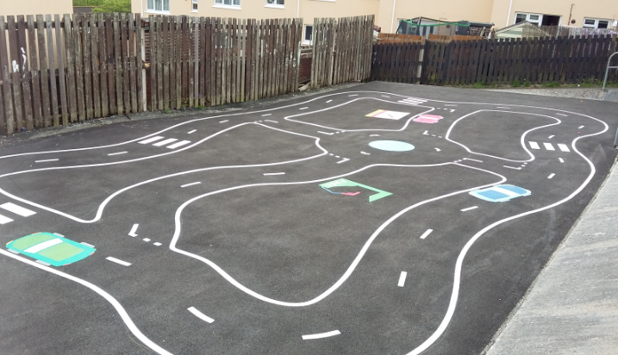
All are made from sturdy Rigid steel fence panels (not thin wire like the muga) I saw a sample from Wicksteed – very impressive.
Wicksteed fencing has 7 year anti corrosion guarantee and 25 year structural guarantee.

Funding – I’d like to apply for a Sport England grant:
https://www.sportengland.org/funding/community-asset-fund/
“Medium-scale investments typically ranging from between £15,000 to £50,000 These will address more substantial changes. This might be an upgrade to an existing facility or developing a new space in the community.”
The first stage of the application is to inform them:
> Your organisation – who you are, what you do
> What your project is – what you want to do
> Where it is – where the facility or space is
> Why your project is needed – what’s the rationale
> Who will benefit – so who are the people and customers
> How you will make it happen
> How much money do you have or need to make it happen
You then go through a preliminary screening process.
Unsurprisingly they like you to demonstrate that you have some funding already. Other finding ideas?

Whilst many communities have such a facility these days, and we have informally spoken to a few people who agree it is a good idea, we haven’t done a community “Survey”.
Any ideas how? – Can we gain support from Sports Club – either for their use or just as a captive audience who like football?
Other ideas?
Could Tim look at the application form and start to fill it out - I can work with him on details
Andrew

