Lytchett Matravers Parish Council
Proposed Revisions to the Neighbourhood Plan - November 2018

Introduction
From December 2017 through to June 2018, representatives of Lytchett Matravers Parish Council (LMPC) were involved in a series of meeting with members and officers of Purbeck District Council (PDC) to discuss matters relating to a review of the Purbeck Local Plan. These meetings covered a broad range of topics, including housing mix, car parking requirements for new developments, the protection of open green spaces within Lytchett Matravers, arrangements to ensure that any new developments in the village were phased over a number of years, ensuring that key investments in infrastructure within the village were made to increase the capacity in proportion to the size of any new developments, the importance of the Green Belt, the European Sites Mitigation measures set down by Natural England, together with various new planning policies that PDC were developing to include in the Local Plan.
Unfortunately it became clear that resource and time constraints on the Purbeck Local Plan project meant that few, if any, of the proposals put forward in these meetings by LMPC were likely to be included in the Purbeck Local Plan. However, the PDC Planning Policy officers involved in the meetings suggested that one option open to LMPC was to consider a revision to the Lytchett Matravers Neighbourhood Plan (LMNP) to include some of the proposals that had been made. Depending on the extent of proposed revisions, the steps needed to get a new plan adopted might be relatively straightforward, for example avoiding the need for a public consultation exercise.
In September 2018 the LMPC commissioned David Bevan of HLF Planning (who was extensively involved in preparation of the LMNP) to prepare a report advising the matters that could be included as revisions to the Neighbourhood Plan, taking into account changes that had been made to regulatory framework for Neighbourhood Plans since the LMNP was written. This paper reviews the advice received from HLF Planning, and sets out recommendations arising from this advice.

The National Planning Policy Framework (NPPF)
The framework for Neighbourhood Plans is set out in the NPPF, and the advice provided by HLF Planning refers to a number of the key paragraphs, as follows:

Paragraph 29 – The NPPF makes a clear distinction between strategic and non-strategic policies. Strategic policies should not extend to detailed matters that are more appropriately dealt with through Neighbourhood Plans. Neighbourhood Plans should not promote less development than set out in the strategic policies for the area, or undermine those strategic policies. Providing that a neighbourhood plan meets the overall strategy for the area, any conflict with the Local Plan on non-strategic policies will give greater weight to the most up-to-date policy. As a consequence, if the LMNP is revised and adopted after the Purbeck Local Plan, it will take precedence over a Purbeck Local Plan policy (until the Purbeck Local Plan is next reviewed – e.g. by the new Dorset Council in 2024).
Paragraphs 65 and 66 – The Local Planning Authority (LPA) should establish an identified housing need, and set out a housing requirement for designated neighbourhood areas. If requested to do so by a neighbourhood planning body, the LPA should provide an indicative figure for the housing requirement, which would be the localised housing target.
Paragraph 97 – Planning policies should be based upon robust assessments of the need for open space, sport, and recreation facilities. Existing open spaces in a settlement should not be built on unless it can be shown that the land is surplus to requirements.
Paragraphs 99 to101 – These set out the framework for designating land as Local Green Space through Local and Neighbourhood Plans. This allows communities to identify and protect green areas of particular importance to them. Local Green Space designation can be placed on land irrespective of who owns it, landowner agreement is not required.
Paragraph 136 – Whilst Green Belt boundaries have been established through strategic policies, detailed amendments to these boundaries may be made through non-strategic policies, including neighbourhood plans. This would enable Purbeck District Council to indicate that the Green Belt around the village would be amended to provide for a certain number of homes, and leave the decision as to where exactly the development takes place to be made locally (in the Neighbourhood Plan).

Proposed Revisions to the Lytchett Matravers Neighbourhood Plan
The following revisions are proposed by HLF Planning:
- Establish the localised housing need for the village as a starting point for reviewing the Neighbourhood Plan, requesting an indicative figure from the Local Planning Authority.
- Include a policy designating existing open spaces in Lytchett Matravers as Local Green Space. The open spaces to be included would primarily be those identified in Appendix 1.
- The creation of smaller open spaces, such as playgrounds, could be promoted through development briefs (site specific policies enabling development subject to specific criteria).
- Consider two policies for provision of SANG, firstly that for developments of 50 dwellings or more a SANG is provided within 400m of the development, and secondly for major residential sites a SANG is provided on-site (publicly accessible open space)
In addition to the revisions proposed by HLF Planning, the LMPC also intends to consider other policies for inclusion in a revision to the LMNP. These include a policy requiring specified levels of car parking space for new developments, taking into account the special circumstances associated with the village, and also the development of a maximum limit that might apply to the Small Sites Policy proposed in the Purbeck Local Plan for sites within the village.
In order for any revisions to the Neighbourhood Plan to be successful, each revision will need to be supported by a robust set of evidence.

The National Playing Fields Association (Fields in Trust)
Three of the spaces identified in Appendix 1 have been protected from future development through Deeds of Dedication entered into by the LMPC and the National Playing Fields Association (which has adopted the operating name Fields in Trust). The protection provided by these Deeds of Dedication is achieved through covenants added to the Land Registry titles for the land in question. The land itself continues to be owned by the LMPC.
It has been identified that the Deed of Dedication prepared for the Lytchett Matravers Recreation Ground included a map setting out the boundary of the area protected which was in error. It is proposed that discussions are held with the National Playing Fields Association with a view to correcting this error. This is required to enable the improvements to the Village Centre set out in the LMNP. Two options might be explored:
- Amending the boundary to exclude the Recreation Ground Car Park from the area protected, together with a 7 metre strip from the edge of the grassed area.
- Amending the boundary so that the area protected is limited to the level playing area of the Recreation Ground, excluding the small Car Park on Eldon’s Drove and the strip of land along the north side of Eldon’s Drove.
In order to secure agreement from the National Playing Fields Association, it is proposed that a further Deed of Dedication be entered into to cover the Foxhills Open Space. This would effectively enable the release of land from the area of the Recreation Ground protected under the terms of Clause 4 of the Deed of Dedication.

Recommendations
The Parish Council is asked to approve the recommendations set out in sections 3, and 4 above. If approved, the action required in relation to the recommendations in section 3 would need to be taken forward by the Neighbourhood Plan Working Group, and it is proposed that the actions required in relation to the recommendations in section 4 should be taken forward by Councillor Norris, based on his working relationship with Fields in Trust.

Keith Norris
Ralph Watts

Appendix 1 : Valued Green Spaces in Lytchett Matravers
The Lytchett Matravers Parish Council has carried out a survey of the public open spaces in Lytchett Matravers, the results of which are summarised in Table 1. The Parish Council has considered the results of this survey and have selected the spaces listed in Table 2 as of sufficient value to the community that they should be protected and enhanced, including a recommendation that they should be designated as Local Green Spaces as set out in paragraphs 76 to 78 of in the National Planning Policy Framework (NPPF).
Table 1 – Public Open Spaces in Lytchett Matravers
Public Open Spaces
Open Space | Landscape Quality | Recreational Value | Wildlife Value | Linkage to Other Open Spaces | Safe Local Space for Children to Play | Ownership | Other
Charborough Close | Medium | Low | Low/Medium | Low/Medium | Medium | Parish Council
Foxhills Open Space | High | High | High | Medium | High | Parish Council
Fry’s Close | Low | Low | Low | Medium | Low
Library Walk | Medium | Low | Medium | Medium | Medium | Parish Council
Lockyers Way – Space 1 | Low | Low/Medium | Low | Medium | Low/Medium
Lockyers Way – Space 2 | Low/Medium | Medium | Low | Medium/High | Medium
Lockyers Way – Space 3 | Low | Low | Low | Low/Medium | Low
The Recreation Ground | Medium/High | High | Medium | High | High | Parish Council | The Living Hub of the Village
Scutts Close | Low/Medium | Medium | Low/Medium | Low | Medium
The Spinney | Medium | Medium | Medium | Medium | High
Turbetts Green | Low | Medium | Low/Medium | Low | Low/Medium | Parish Council
War Memorial Green | Medium | Low | Medium | Medium | Low | Parish Council | Historic relevance
Vineyard Close | Medium | Low/Medium | Medium | High | Low/Medium

Table 2 – Open Green Spaces of Value to the Community which should be protected

Protected Green Spaces
Open Space | Overall Rating from Table 1
Charborough Close | Medium
Foxhills Open Space | High
Library Walk | Medium
Lockyers Way – Space 1 | Medium
Lockyers Way – Space 2 | Medium
The Recreation Ground | High
Scutts Close | Medium
The Spinney | Medium
Turbetts Green | Medium
War Memorial Green | Medium
Vineyard Close | Medium

No development other than minor works to preserve the recreational function and openness will be allowed in the spaces listed in Table 2, which are protected areas of green infrastructure within Lytchett Matravers.

Photographs of each space identified in Table 1.

Charborough Close
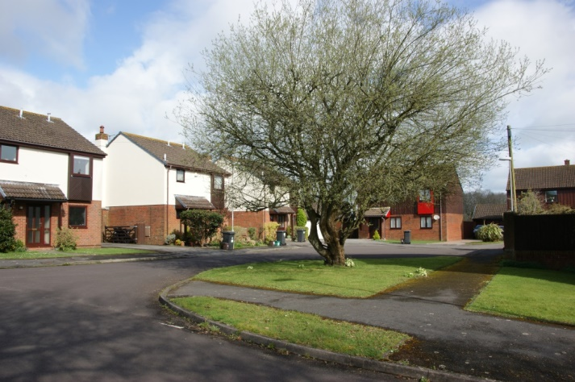

Foxhills Open Space
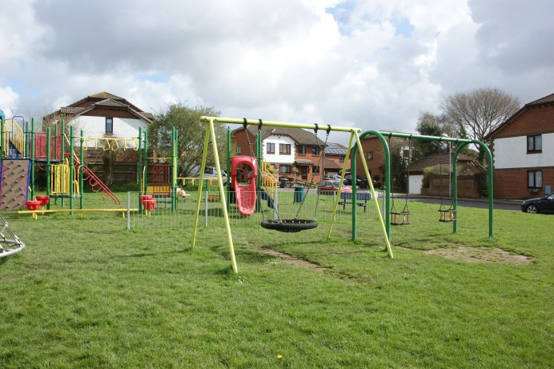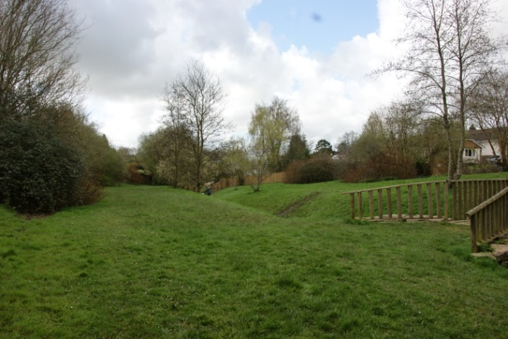

Fry’s Close
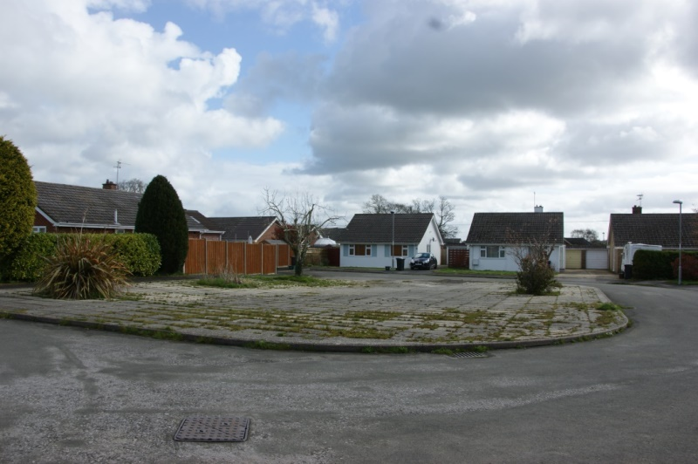

Library Walk
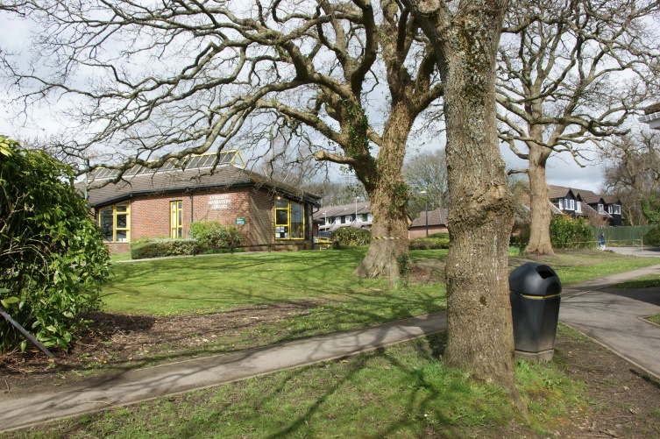

Lockyers Way – Space 1
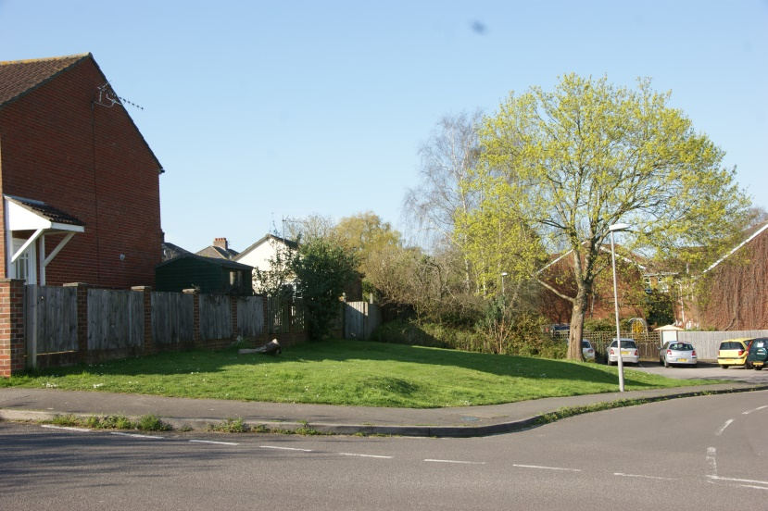

Lockyers Way – Space 2
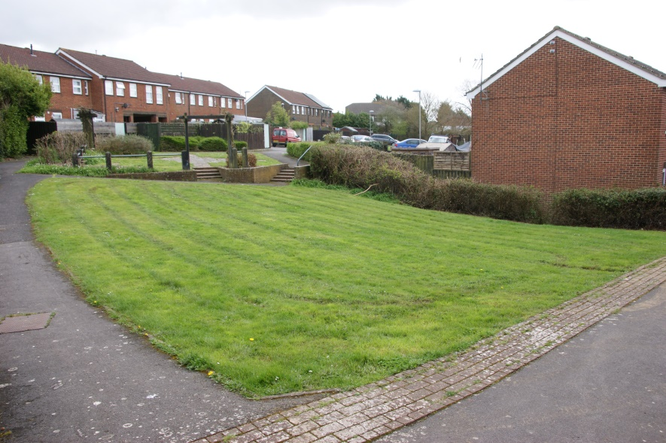

Lockyers Way – Space 3
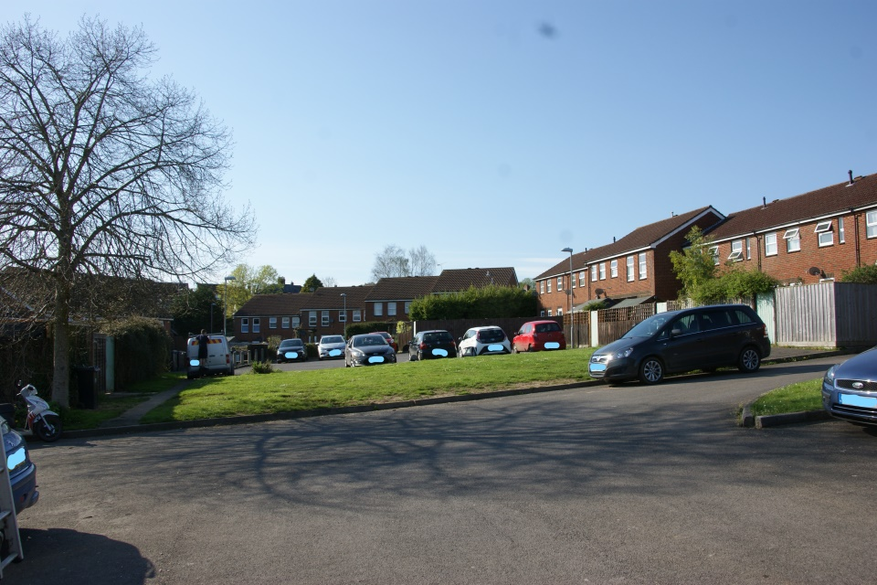

The Recreation Ground
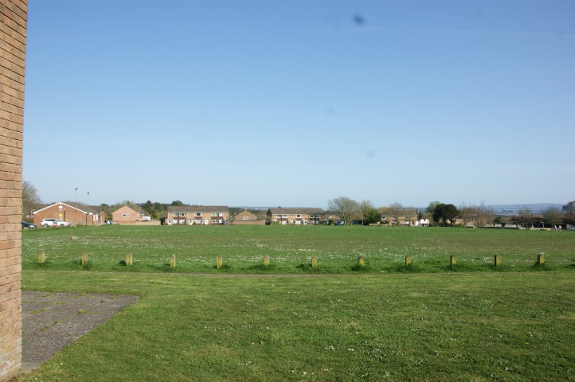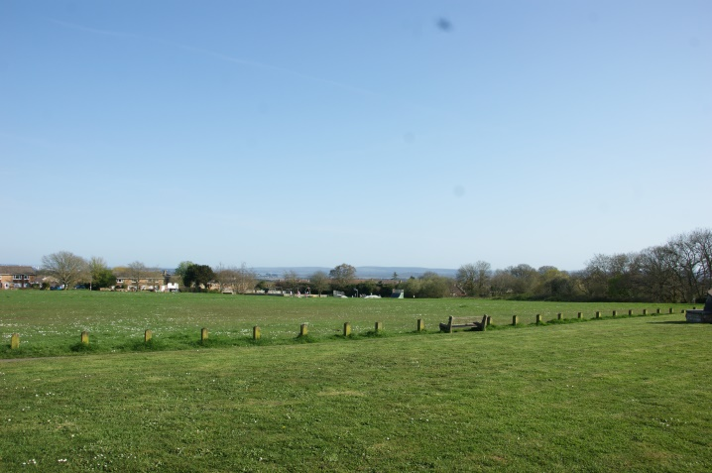

Scutts Close
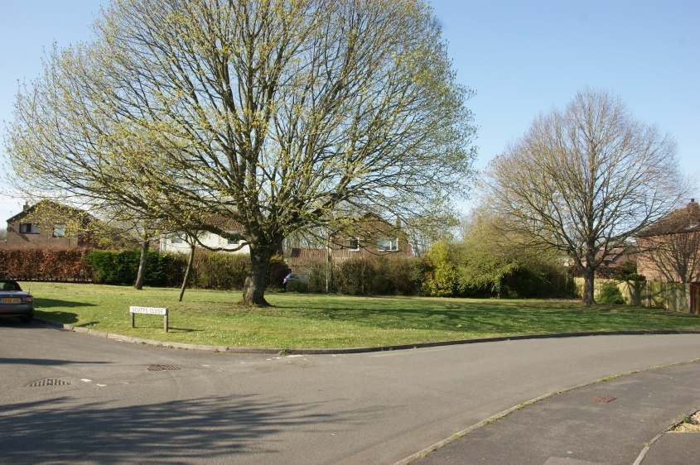

The Spinney
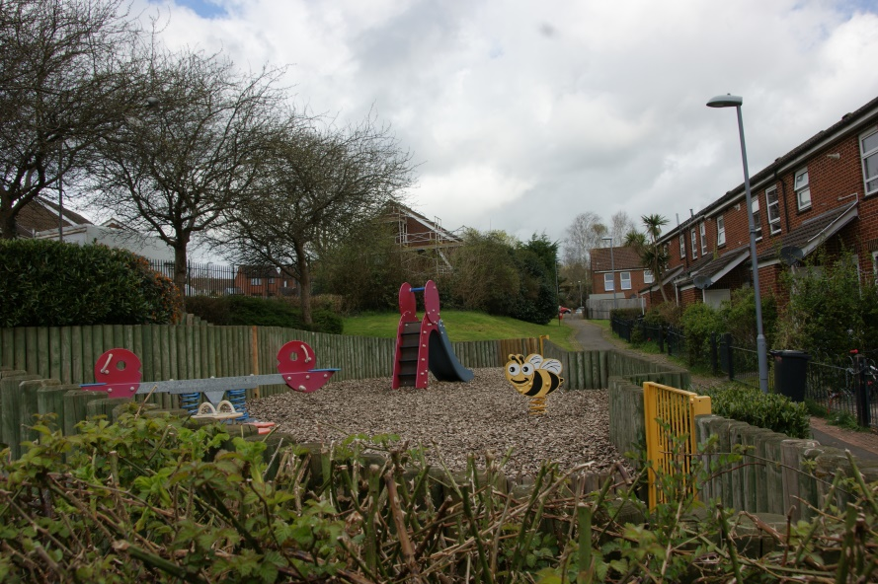

Turbetts Green
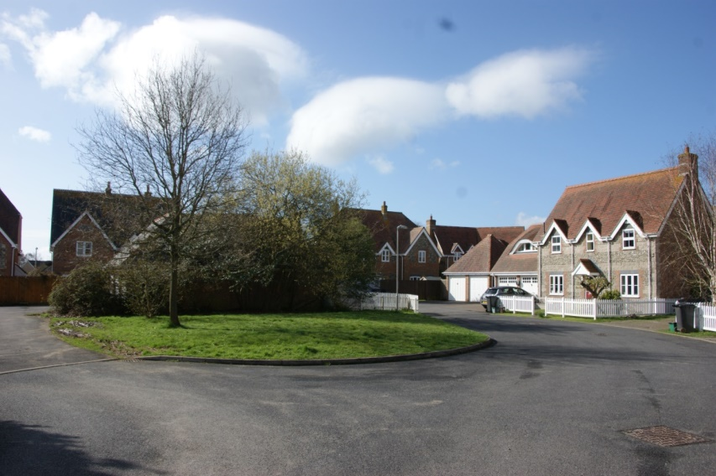

War Memorial Green
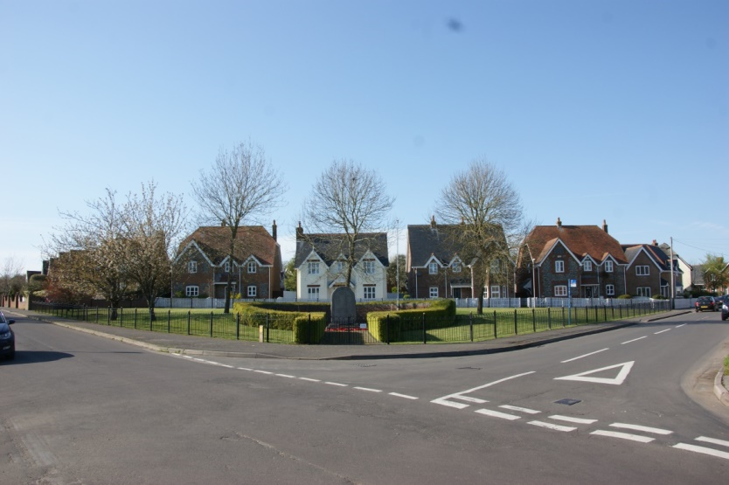

Vineyard Close
