Securing the Rec (Not just Dolly Posts)
I had previously proposed to replace ALL the wooden Dolly posts around the rec at a total estimated cost of £8090, but in fact there are a couple of options:
- With LMPC plans for restyling of the rec lower car park as part of the village centre project, rather than spending £2136 on posts we could spend £575 on a bund (decent soil and grassed rather than wild flowers with a couple of “break points” to allow easy pedestrian access through). This will be less “wasteful” when it is later removed but provides an attractive protection. I’d propose that we’d need the OK form the Sports Club for this.
- The West side of the rec is lined with 34 Dolly Posts which would cost £2594 to replace. But this area is almost protected by the village hall bunds. Access could only be gained by driving up either of the pathways to the village hall. So I’d propose that we place dolly posts snug adjacent to each side of the path leading around the front of car Village Hall, and installing a new dropping post (normally up) on the path to the side of the hall (key to be given out with the main village hall key). This would be subject to Village Hall Cttee agreement, but would cost us around £385 rather than £2594. I have asked Cllr Cottman to raise this to the Village Hall Ctte meeting Monday this week.
- We would still replace the 42 posts to the upper end of the car park as I believe posts as the most appropriate solution there, at a cost of £3205.33. We would also install 2 dropping posts (or re-side the ones just around that corner?) right at the top to allow emergency service vehicles access to the rec. We should also consider dropping the last 3 kerbstones (cost??).
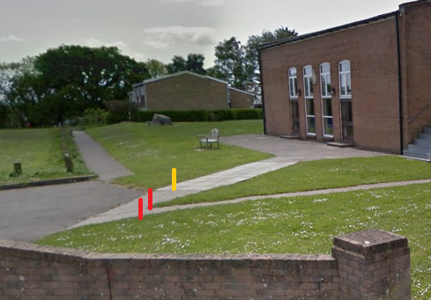
There would be a small labour cost to remove the redundant dolly posts along the West side and fill the holes (or we leave them to rot and get the handyman to remove them as they naturally expire).
If we do all this, instead of costing £8090 to secure the Rec with “posts for life” it will cost us £4150 + cost of dropping kerb, one or two dropping posts or re-siting of existing, and any removal costs of old Dolly Posts.
If Cllrs agree to this in concept, with estimated pricing, I will go ahead and get full and accurate quotes. For consideration at a future meeting.
Cllr Huggins 6 Sept 2019

