Morden Parish Council Purbeck District BH20
Chairperson. Alex Brenton Cllralex.brenton@dorsetcouncil.gov.uk
Parish Clerk. Lindsay Hole woodlands20@hotmail.com

21 October 2019
Dear Chairman and members of Lytchett Matravers Parish Council
Morden Parish Council has been concerned about the state of Bridlepath 6 from Cockett Hill Morden which crosses the Parish boundary into Lytchett Matravers over the stream below Dolmans Hill Farm and continues by Bridlepath to the Dolmans Hill lane. The Parish would like Lytchett Matravers Parish Council to join in encouraging Dorset Council Rights of Way team to upgrade this path so it is a useful route for Horses and bicycles. There is even more urgency in upgrading rural paths to become cyclist friendly with the knowledge of the climate emergency and the need to promote alternatives to car transport. Please could you consider promoting this scheme and supporting Morden Parish.
I enclose most of the letter originally asking for support from Dorset County in Novemebr 2018.
Since then we have had a quote from a local contractor for about £40k to upgrade and gravel the Morden side of the route. Our Parish has about £2k from CIL money it could put towards the scheme. Obviously we are at the mercy of funding streams and grants, but a coordinated appeal may help to promote this route as a viable proposition.
Katie Black of the ROW Ranger Service has visited the route and some minor clearance of branches has happened. The definitive path on the Morden side is down an overgrown green lane which is wide enough to encourage users to avoid the gulley which runs down one side. There would have to be a better pipe/culvert at the bottom and probably a boardwalk over the wetter area.
The Lytchett side has had some gravel surfacing in the past but is eroded to a narrow strip which would need re contouring to create a better width.
As with all these schemes it is a question of gathering funds and plans so that the scheme is ready to go when the political will appears.
Please put this scheme on your agenda and consider backing this achievable safe route between the villages.
Alex Brenton Chair of Morden Parish Council.

November 11th 2018
Dear Tara S Hansford DCC
Morden Parish Council ( North West Purbeck) has a Bridlepath 6 which crosses the parish border to Lytchett Matravers (via Dolmans Hill Farm ) where it joins a network of rural lanes linking to Lytchett Minster.

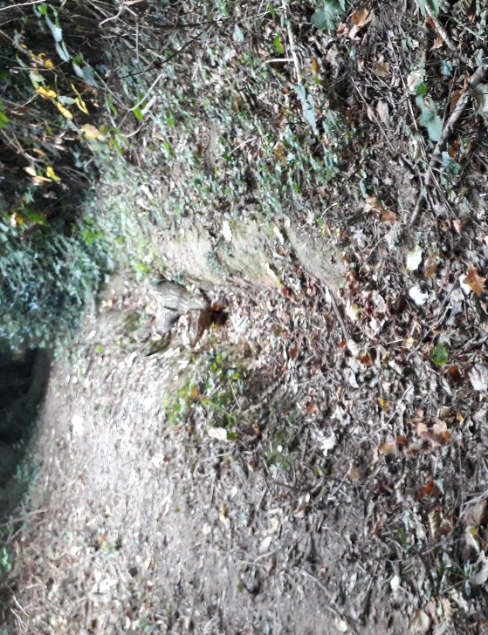
In the past this was well used by horseriders and parts of it are still wide and pleasant to walk. In some sections however, encroachment from the sides is becoming unpleasant for walkers and it is no longer used by horse riders because of the ground condition. It is now in a dangerous condition with seriously eroded surface which diverts the ditches to form sink holes in the centre of the path.
Lack of maintenance has also brought branches down creating hazards, for cyclist or riders.
The modern need is for a path useable by cyclists. Morden and Lytchett Matravers are villages only 2 miles apart as the crow flies or via this path, but 4-5 miles via the public road. There are no public busses and to cycle along the narrow A35 is an unacceptable risk in the Parish Councils opinion, it would never be classed as a safe route to school.
The village of Lytchett Matravers is important to Morden village as this is where children go to school (primary and senior). This is where the nearest shops are and other services like Doctors surgery and Library. Morden will also be part of the Lytchett and Upton ward for the new Unitary council so one assumes links between the two will be even more important.
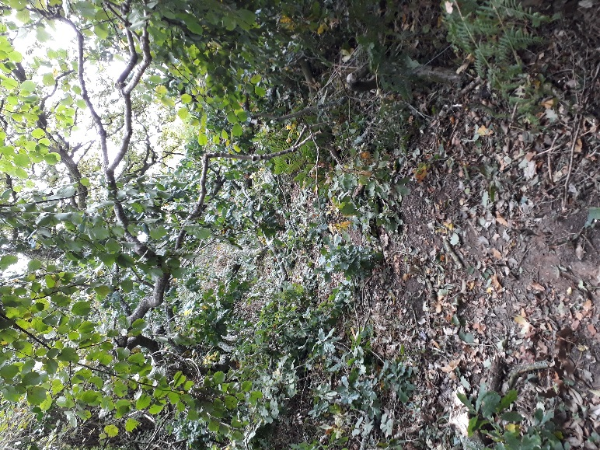
It would have benefits in encouraging cycle use including making possible cycling to school or work. It would link rural villages so the loss of a bus service is manageable. It would be easy to promote as a safe route to Poole using the existing cyclepath from Lytchett Matravers to L Minster and onto to the Upton Harbour trail. In the other direction it would link through to Bere Regis via the Bloxworth wood Bridlepath. This scheme would have health benefits to residents and holiday makers seeking to explore the are and would remove some of the risks involved in cyclists on the A35 from Bere Regis to Poole, a stretch of road with a terrible safety history

Morden Parish council asks the DCC Rights of Way team, Access enhancement, Green spaces team to consider an enhancement scheme for this Bridlepath 6, to make a surface which can be cycled safely. We feel it would meet many criteria for increasing sustainable transport links, improving rural accessibility and preventing isolation for youngsters.

We are aware there was a scheme to encourage ROW enhancements to promote outdoor activity, and some grants may be available.
Morden Parish Council awaits your comments with interest.
Best wishes,
Yours sincerely
Alex Brenton Chair of Morden Parish Council

