Lytchett Matravers Parish Council
A Photographic Record of Japanese Knotweed in the South East Corner of the Recreation Ground

Introduction
On 20th May 2019 during an ecological survey associated with the project to improve the footpath from the Recreation Ground to Eldon’s Drove, and area of Japanese Knotweed was discovered in the South East corner of the Recreation Ground. The Parish Council has implemented a plan to eradicate this infestation by spraying the above ground growth with a suitable herbicide.
This paper provides a photographic record of the extent of the Japanese Knotweed infestation created on 11th July before the first programme of spraying.

Location
The Japanese Knotweed infestation was estimated to be about 70 feet wide, running along the north side of the rough footpath from Rocket Park down to Eldons Drove, and had spread from the top of the bank down to the side of the path, making it about 20 to 30 feet deep. The approximate location is shown bounded by a blue line in Figure 1.
Figure 1 : Location of Knotweed
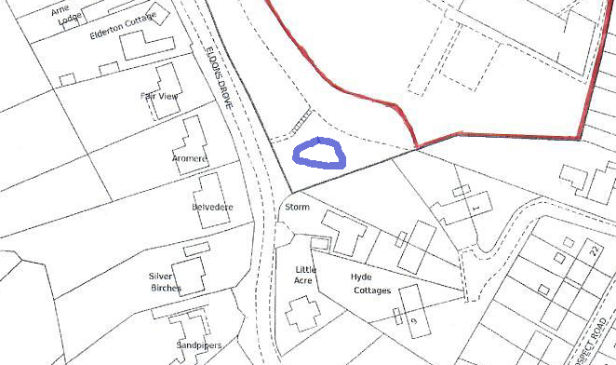

Photographs of Individual Plants for Identification
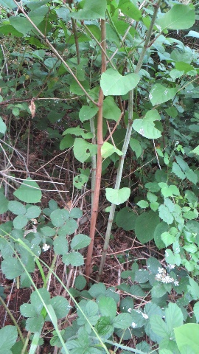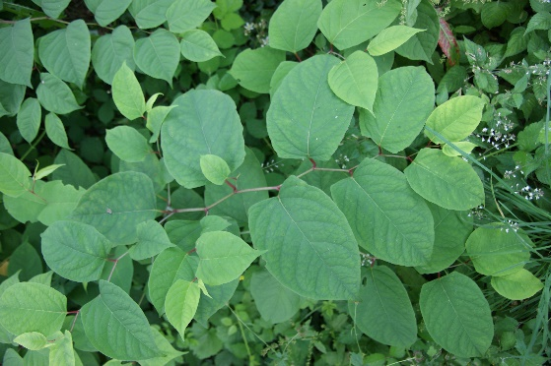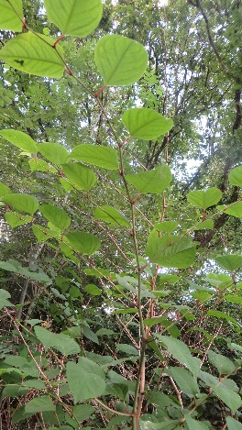

Photographs from Gate on Eldon’s Drove

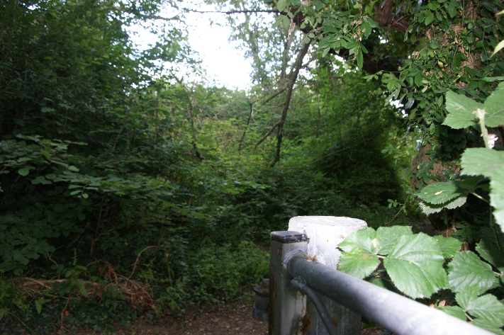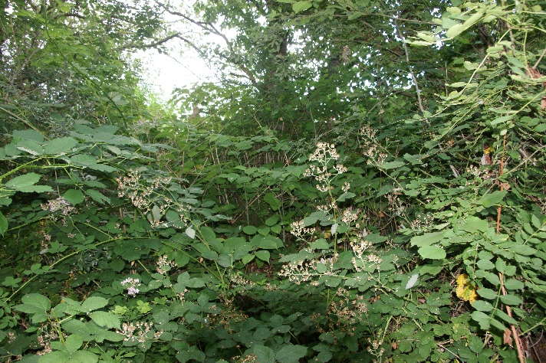

Photographs from East End of Knotweed Patch Looking West
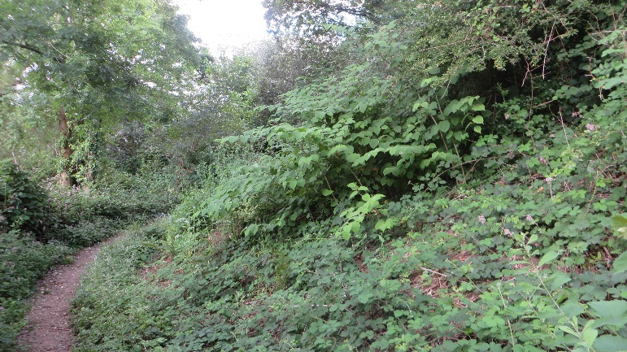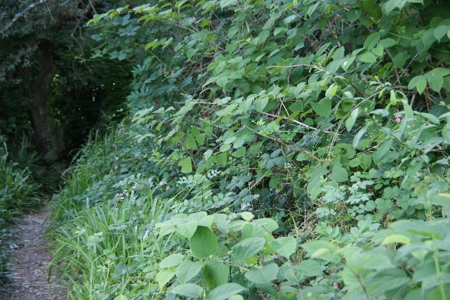

Photographs Showing Proximity to Path at Closest Point
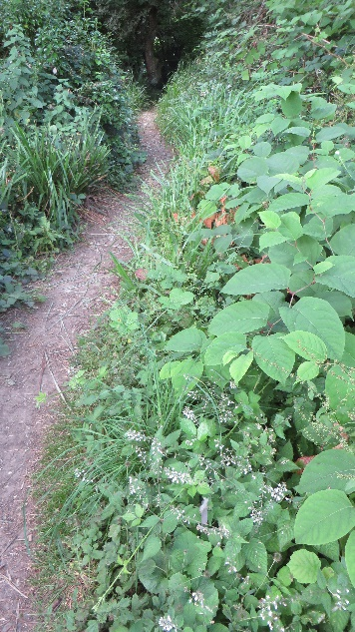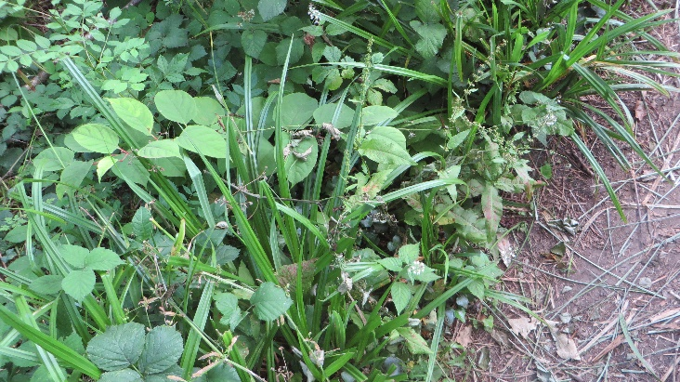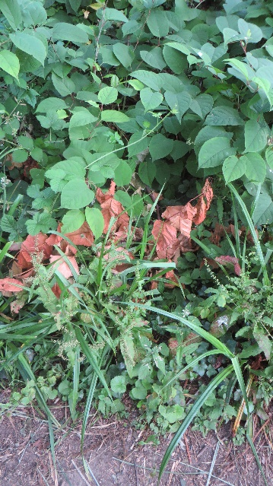
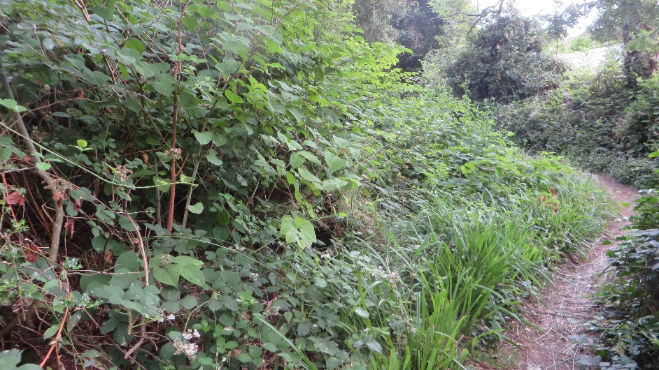

Photographs Looking up the Bank

