Jubilee Walk assessment 1 Mar 2020
Cllrs Huggins and Wood

As noted in the minutes of Full Council 27 Nov 2019,
8. to consider for approval a proposal to establish a service level agreement with dorset council for the maintenance of church walk and jubilee walk. This matter came out of a discussion with Countryside Services who have made an offer of 0.25p per metre matched by Parish Council to keep the paths clear – this would come to £250. It was RESOLVED to approve this.
Cllrs raised that there are now a few groups that are forming to clear vegetation and whether these could be formalised and have a monthly meeting to cut back vegetation. This was discussed however it was concluded that the groups should remain separate due to their different purposes. The matter of Jubilee Walk was also discussed as Countryside Services will maintain the path in whatever condition it is in. There is therefore a potential need to clear the path to have it maintained at a more acceptable state. Action: Councillors to walk Jubilee Walk to note the extent of the clearance work.

Cindy and I walked the path to assess its condition with respect to Dorset Council takin over the ongoing maintenance of the path. The goal is to ensure that it is handed over at a standard which they can then maintain.
The pathway, running from Wimborne Road to Huntick Road is formed of a hoggin pathway about 2-3m inside of the natural hedgerow edge of the field, which has been separated from the field by a stock fence.

For much of the pathway it was noted that grass encroachment over the hoggin path means that for much of the path barely 30cm of the hoggin is still visible. We pulled back small patches of grass to expose much wider “laid” pathway. We felt that, as well as scraping back the overgrowth to reveal the full path, walkers should actually be encouraged to walk to the edges to keep the growth back. We also felt walkers should be encouraged to walk with secateurs and trim the odd annoying brambles as they come across them.
Along much of the path, there is bramble overgrowth which creates dangerous, and very tough tripping hazards across the path (indeed Cindy tripped at one point), and these will only get worse if unattended. We felt that it would be wise to cut back/strim along the pathway on the stock fence side to keep this growth at bay.
At the Wimborne road end, the path starts off running parallel to the road, then turns 90 degrees. This parallel stretch is already getting quite overgrown, and when you turn the corner there is very dense heather and brambles on the hedge side which could be cut back. These are “dense scrub” but some way in front of the actual mature hedge.
From this point the path gradually slopes down to the low point, then there is a climb up before it then slowly descends to Huntick Road. There are many areas along this length where the brambles on the “hedge side” could well be trimmed back as these are only going to get worse in the coming months.
This stretch of final gentle descent to Huntick Road is in pretty good condition, wide, open and not really in need of attention.

We would recommend some work to the first ¾ of the path from the Wimborne Road end to get the path to a standard where we’d like it to be maintained by DC:
- scrape the pathway to original width
- Strim/cut the brambles/growth on the stock fence side
- Cut back the brambles and briars at many points on the “hedge” side of the path.

We wondered if the Guerrilla Gardeners would be interested in this project as they may approach it with a little more finesse than a contractor with hefty power tools.
Additionally, as we walked along Wimborne Road from RBL site to the entrance to the path we had to jump to the rough verge many times for cars. We wondered of this could be mown/maintained by GG’s to form an unofficial pathway

Brambles either side:
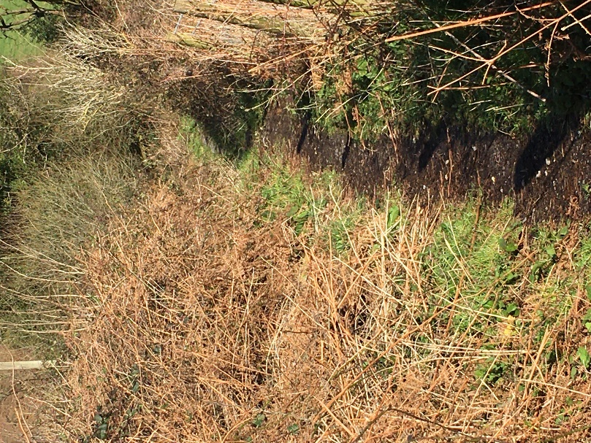

Thick Fern and brambles just around corner
at Wimborne Road end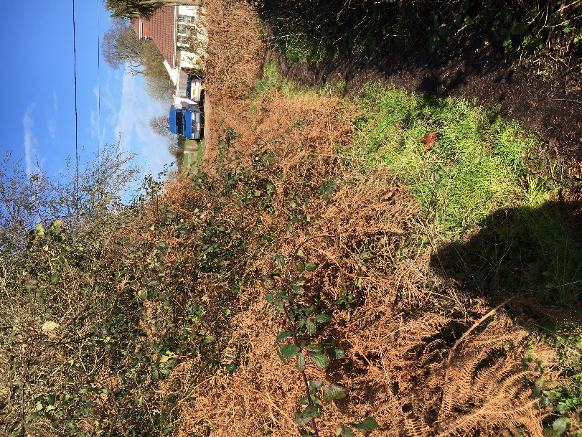

Scrub along the stock fence
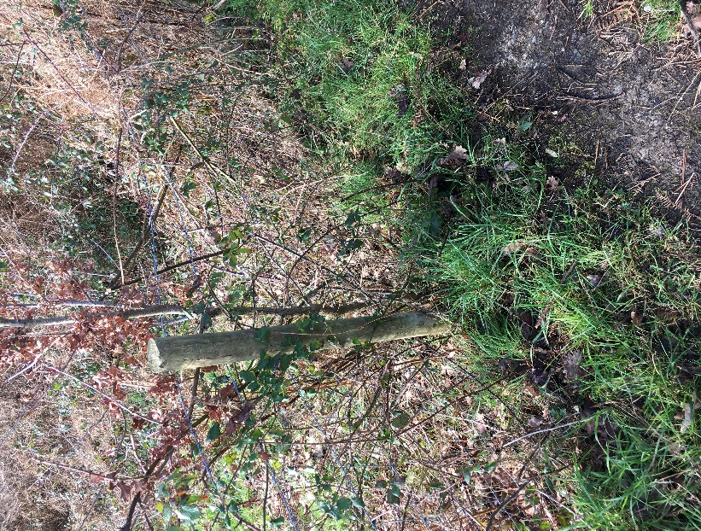

END

Pretty clear at the Huntick Road end, but still very narrow actual path
