**Lytchett Matravers Parish Council**

**Climate Emergency Action Plan – Phase 1**

# **Contents**

Page

Section 1 – The Climate Emergency 1

Section 2 – Greenhouse Gases and Climate Change 1

Section 3 – Parish Council Action Plan 4

Section 4 – Issues for Phase 2 12

Appendix 1 – Lytchett Matravers Carbon Footprint 15

Appendix 2 – Parish Council Buildings – Sports Pavilion EPC 19

Appendix 3 – Parish Council Buildings – Youth Hall EPC 23

Appendix 4 – Parish Council Buildings – Sports Pavilion Energy Usage 27

Appendix 5 – Parish Council Buildings – Youth Hall Energy Usage 28

Appendix 6 – Survey of Solar Panels in Lytchett Matravers 29

# **The Climate Emergency**

* In June 2019 the UK became the first major economy to pass laws committing the country to a legally binding target of net zero Greenhouse Gas (GHG) emissions by 2050. Net zero means any emissions must be balanced by schemes to offset an equivalent amount of GHGs from the atmosphere, such as by planting trees or using technology like carbon capture and storage.
* In May 2019 the Dorset Council declared a Climate Emergency, and is developing an Action Plan to cover its area of responsibility.
* In October 2019 the Lytchett Matravers Parish Council declared a Climate Emergency, and this document presents Phase 1 of an Action Plan to reduce the GHGs emissions from Lytchett Matravers. This covers the period through to 2024/25, by which time Phase 2 of the Action Plan will need to be developed (see section 3.3 for an explanation of the Phased Approach to the Action Plan, and section 4 for issues relating to Phase 2).
* An article providing background information on the Climate Emergency was published on the Lytchett Matravers Parish Council’s website in November 2019. Section 2 summarises some of the key points from that article, together with information on future GHG emissions, and on UK Met Office long term forecasts of the impacts of climate change on Southern England.

# **Greenhouse Gases and Climate Change**

* Over the last 200 years the burning of fossil fuels has released enormous amounts of manmade GHGs into the atmosphere, causing the concentration of CO2 in the atmosphere to increase by 50%. This has caused global average atmospheric temperatures to increase by 1.1oC compared to pre-industrial levels. This trend is continuing, with global annual emissions of manmade GHGs still increasing, despite significant efforts by some of the major economies.
* Fig 1 shows the level of global emissions of CO2 each year since 1850.

Fig 1 : Historic and Projected Global CO2 Emissions

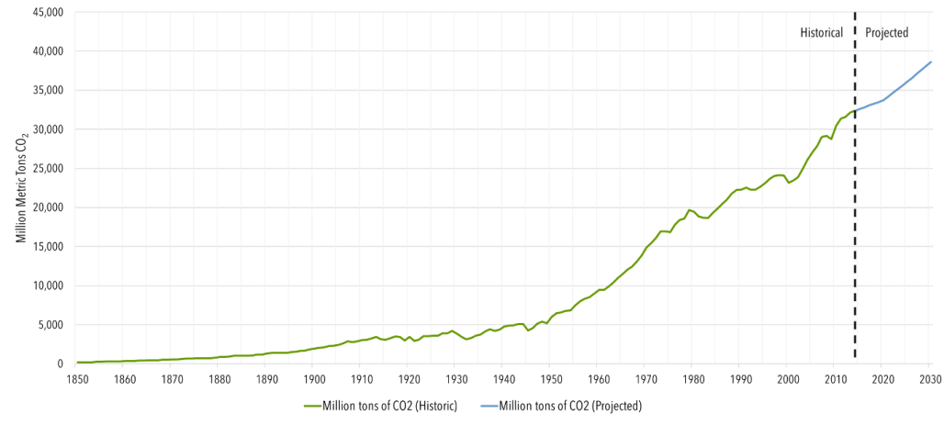

* Fig 2 shows the contributions to global GHG emissions for each of the major economies since 1990.

Fig 2 : Major Economy Contributions to Global GHG Emissions

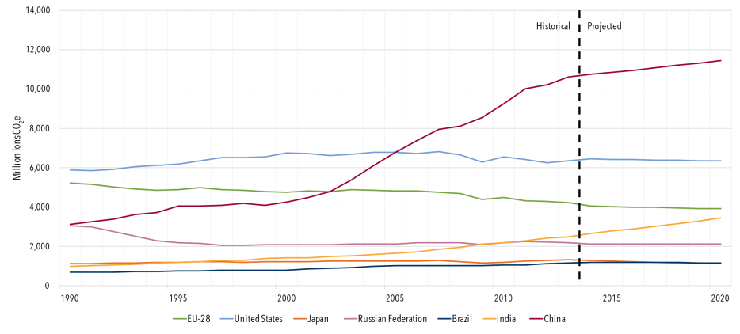

* To forecast the future effects of climate change, climate scientists have developed a range of global emissions scenarios, called Representative Concentration Pathways (RCPs). These were adopted by the Intergovernmental Panel on Climate Change (IPCC) for its report in 2015. The forecasts for 3 of these scenarios have been chosen here to give an idea of the range of possible future climate change impacts. These scenarios are known as RCP2.6 (low emissions), RCP4.5 (medium emissions), and RCP8.5 (high emissions), which can be summarised as follows:
  + RCP2.6 - corresponds closely to achieving global net zero carbon emissions by about 2070. This requires rapid and substantial global emissions reductions, with pledges made in the 2015 Paris Agreement achieved by 2030. Under this scenario, the global temperature increase compared to pre-industrial levels is forecast to remain below 2oC.
  + RCP4.5 - significant reductions slow the rate of increase of annual emissions until about 2050, when emissions stabilise before gradually going into decline during the second half of the century. Under this scenario, global temperatures continue to rise, reaching an average of about 2 to 3oC above pre-industrial levels by 2100.
  + RCP8.5 - global emissions continue to increase at current rates of growth until about 2050, after which time the rate of increase slows rapidly to the end of the century, by which time emissions have stabilised at about twice the current annual level. Under this scenario, global temperatures will continue to increase, reaching an average increase of about 6 to 8oC above pre-industrial levels by 2100.
* The future global emissions of CO2 for each of these scenarios are shown in Fig 3.

Fig 3 : Global CO2 Emissions for Each RCP

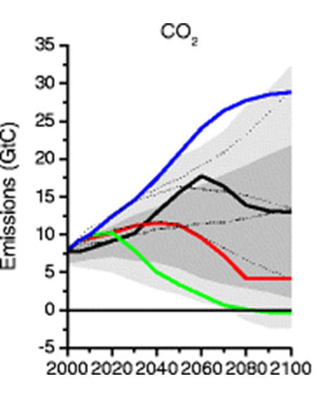

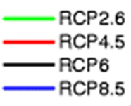

* Comparing the Fig 3 trends for each RCP with the actual global emissions trends shown in Fig 1 and Fig 2, it is patently obvious that the substantial reductions in global GHG emissions starting in 2020 required to match RCP2.6 will not be achieved. It seems likely that the most likely global emissions over the next 50 years will be somewhere in the range from RCP4.5 to RCP8.5.
* The RCP scenarios have been used by climate scientists at Princeton University working for the US NOAA to prepare forecasts of the long term changes in global average atmospheric temperatures, which are presented in Fig 4.

Fig 4 : Forecast Long Term Changes in Global Average Atmospheric Temperatures for Each RCP

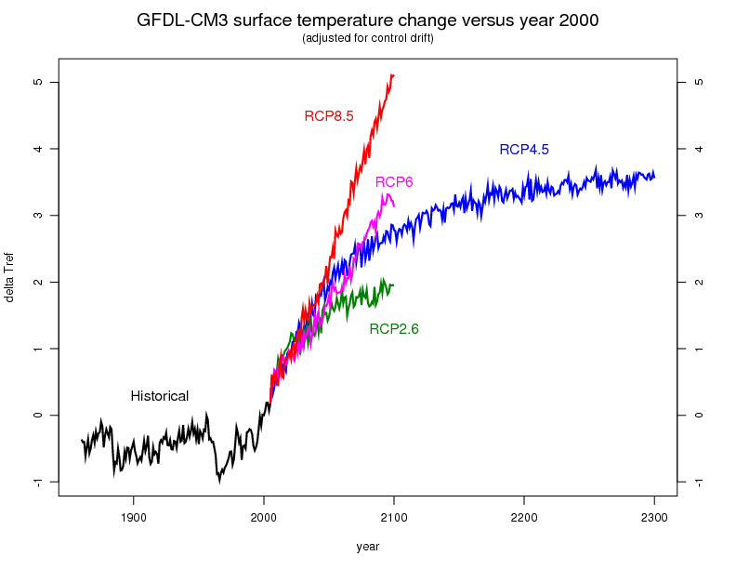

* The impacts of GHG emissions at RCP8.5 levels are generally held to represent a global catastrophe, the impacts of RCP6 are characterised as a global disaster, and RCP4.5 “very bad”. The aim must be to get as close to RCP2.6 as is possible.
* A notable feature of the trends shown in Fig 4 is that none of them, not even RCP2.6 show any reduction in global temperatures between now and 2100, they all show continuing increases. While global temperatures continue to rise, the rate of melting of the Greenland and Antarctic ice caps will continue to accelerate, as will the rise in sea levels.
* In 2019 the Met Office published forecasts of the UK climate through to 2100 using the different emissions scenarios. The forecasts show increases in both summer and winter temperatures above pre-industrial levels, as well as changes in summer and winter rainfall. The forecasts for southern England are summarised in Table 1.

Table 1 – UK Met Office Forecasts for Southern England through to 2100

|  |  |  |  |  |
| --- | --- | --- | --- | --- |
|  | Increase in Winter Temperature (oC) | Increase in Summer Temperature (oC) | Winter Rainfall (% change) | Summer Rainfall (% change) |
| RCP2.6 | 1 to 4 | 2 to 5 | -10% to +40% | -50% to +10% |
| RCP4.5 | 1 to 5 | 3 to 8 | -10% to +50% | -60% to 0% |
| RCP8.5 | 2 to 7 | 4 to 10 | 0% to +60% | -80% to -10% |

* In 2019 the UK Met Office also published for the first time forecasts of the UK sea level rise beyond 2100, with projections out to 2300. These are summarised in Table 2, which shows sea level rise for Southern England compared to 1915.

Table 2 – UK Met Office Forecasts of Sea Level Rise for Southern England by 2100 and 2300

|  |  |  |
| --- | --- | --- |
|  | 2100 | 2300 |
| RCP2.6 | 0.4 to 0.75m (1.3 to 2.5ft) | 0.61 to 2.3m (2.0 to 7.5ft) |
| RCP4.5 | 0.48 to 0.90m (1.6 to 3.0ft) | 0.90 to 2.7m (3.0 to 8.9ft) |
| RCP8.5 | 0.66 to 1.2m (2.2 to 3.9ft) | 1.5 to 4.4m (4.9 to 14ft) |

* As indicated above, the forecasts show that sea levels will continue to rise beyond 2100 even under the low emissions scenario (RCP2.6) which requires substantial reductions in global GHG emissions over the next 50 years, starting in 2020.
* It is clear that by 2100, and beyond, Global Warming will have significant impacts on Southern England, with changes in both temperature and rainfall, and changes in sea level. The changes in temperature and rainfall will have significant impacts on natural ecosystems as well as on human activities such as agriculture. In addition, increased winter rainfall and rising sea levels will cause more and more flooding, which in some places will cause significant disruption to human populations as low lying land is overtaken by the sea. In Dorset this will affect in particular the low lying areas around Poole Harbour (including parts of Poole, Hamworthy, Upton, and Wareham), as well as coastal towns such as Weymouth and Lyme Regis. Further afield there will be substantial impacts across the UK, perhaps most notably around the Thames Estuary where the flooding risk to London will be substantial. In other parts of the world, there will be substantial impacts on human civilisation and natural ecosystems, through flooding and inundation, through crop failures due to changes in temperature, and also through water shortages.

# **Parish Council Action Plan**

## **Targets**

The following targets are designed to fully comply with the UK legal requirement to reduce GHG emissions to net zero by 2050, and are considered to be both readily achievable and affordable.

* Parish Council Carbon Footprint - achieve net zero GHG emissions by 2030.
* Community Carbon Footprint - achieve net zero GHG emissions by 2040.

The starting points for these targets are set out in Appendix 1, which provides estimates of the carbon footprint for both Lytchett Matravers as a whole and for the Parish Council.

## **Residents Survey**

During December 2019 and January 2020 the Lytchett Matravers Parish Council carried out an online survey on the Climate Emergency. The survey questions and the results obtained have been reported to the Parish Council in a separate paper. However, some of the key results relevant to the Climate Emergency Action Plan are repeated here for ease of reference.

The topics covered by the survey can be separated into 4 areas, namely (1) information about residents’ housing, heating, and transport, which might be used to refine estimates of the Lytchett Matravers carbon footprint and develop future actions, (2) information about resident’s understanding of the climate emergency, which might be used to establish topics for future communications, (3) resident’s views on actions the Parish Council might take in response to the Climate Emergency, and (4) anything else to add.

The results arising in the last two areas are particularly relevant to this Action Plan, and are summarised in Fig 5 and Tables 3 and 4.

Table 3 : “Other” Responses linked to Fig 5

|  |
| --- |
| Install a community wind turbine. |
| If the area was one where generally people take pride, less of everything would be needed, for every crisp packet collected in the library, 3 can be found as litter...as an example. Public buildings are not well kept. Perhaps help from Corfe Mullen might help, they take more pride. Which buildings are exactly parish council buildings? |
| Encourage other shopping facilities in village & therefore reduce need to travel to shop.we do not all like to shop at Tesco s chain .start |
| Commit to helping to improve bus services! |
| Stop permitting trees to be cut down for new builds |
| The Parish Council can only be an exemplar of best practice. There should be an economic test for each action that would prioritise the order in which all beneficial actions could take place and to spread the cost. |
| Cut down use of plastic packaging in local shops. |
| Make it a planning condition that all new builds or alterations that require roofing changes should have solar panels fitted |
| Press for better bus service - to Broadstone/Wareham/Wimborne. |
| Work with the schools to reduce the number of vehicle journeys taken by their pupils |
| Providing information is not, on its own, going to change behaviour . Actual, physical changes in infrastructure for e.g are required |
| Planting trees and incentivising householders to do so seems like a great 'offsetting' place to start. Partner with woodland trust or other group and use available spaces, such as soggy end of rec, round car park, in front of shops. Combine this with protecting the trees we already have, especially when the builders move in. Whilst on it - improve drainage of Rec, add trees and improve playing fields so that teams don't have to travel away when its been raining - i.e. reduce emissions by ensuring teams can stay in LM over winter. Encourage others by making a nicer changing facility and pavillion that links with Village Hall. |
| Reduce access for cars around the village and introduce lower speed limits. |
| Improve public transport, I am reliant on my car as the buses are so infrequent and expensive |
| Improve public transport services to the village. Footpath or free/cheap bus to the senior school. Stop building housing on green spaces. |
| Cycle/foot path between Lytchett Matravers and Lytchett Minster school needs to be improved and maintained to encourage more children to alk and cycle rather than parents using cars for a very short journey. My son uses it but it is overgrown, full of potholes which make it muddy and unusable at this time of year |
| what about getting more of the people who make things to be able to sell them more easily to around the village. A village market or regular/monthly Farm/Crafts market. Perhaps we could try it at the VIlalge Fair. Get the idea kicked off & see what interest there is. We drive to get Farmers stuff from people in the village, who have also driven there - just daft. |
| Some verges could be made into wild flower 'meadows'. Less cutting required, ideal for bees. |
| Transport infrastructure needs improving, encourage walking to school for parents and children, for example a walking bus. Without a car, getting anywhere is fairly awkward and in some instances impossible. |

Table 4 : Responses to “Any Thing Else to Add”

|  |
| --- |
| I am not convinced that electric vehicles are the right way to be going. |
| Climate change is also impacted by pesticides and chemicals used by families but larger corporations. Lobbying to reduce this would have a long standing impact x |
| Parents parked outside school for long periods running their engines to keep warm or cool. |
| Encourage more walking to school, so less cars and congestion. |
| It is right for individuals and the Parish Council to take action. But it is also the case that whatever the population of the UK does in aggregate will have little overall impact globally. We should be developing new technologies and actions that can help elsewhere in the world and act as an exemplar for other nations. |
| Reduce the building of new homes on sites that have not previously been developed. |
| I believe with safe footpaths to Lytchett Minster School from Lytchett Matravers, there will be significantly less car journeys in and around the village |
| Could trees be planted in the bottom part of the village’s recreation ground. They could help absorb CO2 and also draw up water in this area which can be quite wet. |
| Can we get a farmers market, etc., on the Rec/car park once a month? There are lots of farmers and producers in the village. Help us to stop having to travel so far for basics and help local trade. |
| It would be great if there was a field where people can plant trees. |
| Improve biodiversity on verges and open spaces. Manage footpaths and green lanes better |
| A community, where everyone has an interest in ensuring they do ‘their bit’ affects this issue, as with all other issues. Litter, unkept ‘public’ buildings (apart from the library). Lack of consideration whilst parking...unneeded use of cars etc etc... |
| Why does Dorset not have wind farms? Why did Lib Dem and others object to Navitus Bay wind farm - it is hypocritical to now be proposing a Climate Emergency. |
| Start a grow your own food campaign and a market for surplus food in summer? Home made goodies? share lifts improve cycle paths |

## **A Phased Approach to the Action Plan**

* It seems likely from Figs 1, 2, 3, and 4 that the Climate Emergency will continue for several hundred years, as the concentration of GHGs in the atmosphere gradually increases, causing continuing increases in global temperatures.
* The nature of the Climate Emergency is such that its impacts will gradually get more and more severe for the foreseeable future.
* It can be expected that the social, political, economic, and technological responses to the Climate Emergency will continue to evolve over the coming decades, as the climate impacts worsen.
* To reflect this situation, and also allow for the difficulty of making reliable predictions of technology developments, etc., over periods longer than about 5 years, this Action Plan has been designed using a phased approach. Each phase will set out the actions to be taken during the next 4 to 5 years, including matters to be considered in developing the following phase. This paper presents actions to be taken by the Lytchett Matravers Parish Council during Phase 1, from 2020 to 2024/25. These actions include a number of activities aimed at developing Phase 2 of the Action Plan (see section 4).

## **Parish Council Actions – Phase 1**

* The suggestions made by residents in response to the Climate Emergency survey have been taken into account in setting the priorities for Phase 1 of the Action Plan.
* Achieving the target for the community to achieve net zero GHG emissions by 2040 is complex, partly because the Parish Council does not have direct control over these emissions, but also because reduction of the community’s carbon footprint is expected to be driven to a significant extent by actions by Central Government (e.g. the ban on sale of new fossil fuelled cars), actions by industry (e.g. further decarbonisation of electricity generation, product innovators such as Tesla), actions by the Dorset Council (not yet known), cultural pressure, and by actions by those residents who are early adopters for Climate Emergency solutions. In this context, the actions set out below are designed to augment and facilitate these other drivers, providing a sound foundation to meet the target for the community.
* The actions to be taken by the Parish Council are therefore designed to achieve one or both of the following objectives:
  1. Directly reduce its own GHG emissions to achieve the target of net zero by 2030
  2. Showcase, promote, and facilitate solutions by which the GHG emissions caused by the Community as a whole can be reduced to net zero by 2040
* Section 2 of Appendix 1, identifies three priority areas where substantial GHG emission reductions are needed to achieve the net zero target for the community. These are Heating, Transport, and Electricity. The Phase 1 actions for the Parish Council are therefore designed to showcase, promote, and facilitate solutions in these 3 areas.
* The actions to be taken by the Parish Council have been grouped into a number of categories, as follows:
* Leadership
  + actions to reduce the Parish Council’s carbon footprint
* Community Projects
  + Renewable Energy
  + Creating Carbon Sinks – Planting Trees
* Enabling and Facilitation
  + Infrastructure Projects
  + Grants
* Engagement and Support
  + Communication
* The actions set out below are at different stages of development. It is proposed that for those actions which require significant expenditure by the Parish Council (e.g. more than £5,000), the following process is adopted:
  1. A Conceptual Design will be prepared and submitted to the Parish Council for approval.
  2. The Conceptual Design will be developed into a specification which can be used as the basis for tender action to secure quotes from at least 3 selected suppliers. This specification will be submitted to the Parish Council as a Detailed Design for approval.
  3. A tender action will be launched, and quotes obtained will be submitted to the Parish Council with a recommendation as to which will be selected.
  4. The selected supplier will be instructed to undertake the works as described in the Detailed Design.

The actions described in section 3.4.1.1.1 and 3.4.1.1.2 below are at stage 1 of the above process, and are being submitted to the Parish Council through this Action Plan as Conceptual Designs for approval.

* Some of the actions set out below are in the sole control of the Parish Council, whereas others can only be implemented in collaboration with other parties. The main areas where other parties are involved are in areas for which the Dorset Council has responsibility, most notably works on the public highway. Discussions are underway with the Dorset Council on a number of the actions, and the sections below identify progress to date in those discussions.
* The total cost of the actions which will require expenditure by the Parish Council, is beyond the resources it has readily available. Where other sources of funding are identified, these will be pursued. Current examples are some of the actions in section 3.4 for which grant funding may be available, e.g. from Low Carbon Dorset, the installation of Electric Vehicle Charging Points described in section 3.5.1, and the Cyclepath to Lytchett Minster also described in section 3.5.1.

### **Leadership**

#### **Actions to Reduce the Parish Council’s Carbon Footprint**

* The Parish Council owns two buildings in the village and several parcels of land, as follows:
  1. The Sports Pavilion
  2. The Youth Hall
  3. The Recreation Ground
  4. Foxhills Open Space
  5. Library Walk
  6. Row Park
  7. Allotments
* This Phase 1 Action Plan focuses on reducing the Carbon Footprints associated with the two buildings listed above, but sets out in section 4 work needed to address the other areas of the Parish Council’s operations.
* Energy audits of the Sports Pavilion and the Youth Hall have been carried out, and the Energy Performance Certificates (EPCs) created are presented in Appendices 2 and 3. The EPCs show that the Sports Pavilion is currently rated E, and the Youth Hall is currently rated G. The EPCs give the estimated CO2 emission of 6.4 tonnes for the Sports Pavilion, and 14.4 tonnes for the Youth Hut, giving a total of 20.8 tonnes of CO2. Appendices 4 and 5 present information on the actual gas and electricity usage for the Sports Pavilion and the Youth Hall.

##### **Sports Pavilion**

The energy audit of the Sports Pavilion identified a number of actions to improve the performance of the building, which is one of the priorities supported by residents (see section 3.2). These actions are summarised in the following table.

|  |  |
| --- | --- |
| Improvement Measure | Cost estimate (£) |
| Insulate the Cavity Walls | 500 |
| Insulate the loft with 400mm mineral/glass wool throughout  (currently 100mm over 75% of the roof) | 600 |
| Install Thermostatic Valves on all Radiators (currently on ~50% of radiators) | 400 |
| Consider replacement of current radiators with more efficient modern units | 500 |
| Install PV Panels on South Facing Roof (capacity up to approximately 13.5kW) | 15,000 |
| Install PV diverter to heat hot water from PV Panels via immersion heaters | 500 |
| Install Air Source Heat Pump (ASHP) | 6,000 |
| Total Cost | 23,500 |

The benefits expected are as follows:

* Reduced energy usage for the Sports Pavilion, which will reduce the costs of heating and lighting the building using gas and electricity
* A dramatic reduction in the Carbon Footprint of the Sports Pavilion, transforming the energy supply for the building from being primarily from fossil fuels to primarily from low carbon sources
* Demonstrate tangible leadership by the Parish Council in response to the Climate Emergency
* Provide a visible showcase of energy efficiency, low carbon electricity (PV Panels), and low carbon heating (Air Source Heat Pump) for the community
* Install more solar panel capacity than is needed for the Sports Pavilion itself, to generate renewable energy for community use, which will also generate an income for the Parish Council

It is estimated that the PV Panels proposed will generate approximately 13,000 kWh per annum, which with an export tariff currently about 5p per kWh, will yield annual income of £650. In addition, Air Source Heat Pumps are eligible for Renewable Heat Incentive (RHI) payments, made quarterly for 7 years after installation, which are expected to pay back a large part of the cost.

The actions to reduce the carbon footprint of the Sports Pavilion proposed above are at the Conceptual Design stage, and are included in this Action Plan for approval by the Parish Council. If approved, a Detailed Design will then be developed for Parish Council approval and implementation in 2020/21.

##### **Youth Hall**

The energy audit of the Youth Hall identified a number of actions to improve the performance of the building, which is one of the priorities supported by residents (see section 3.2). These actions are summarised in the following table.

|  |  |
| --- | --- |
| Improvement Measure | Cost estimate (£) |
| Upgrade insulation in the roof space at the north end (with flat ceiling) – from 100mm current to 400mm | 300 |
| Change all lights to low energy - main room lighting is fluorescent, with halogen spot lights in other areas are halogen | 200 |
| Switch to green energy supplier | 0 |
| Increase insulation in walls & sloping ceilings by dry-lining with insulated plasterboard | 5,000 |
| Replace windows with double-glazed units | 5,000 |
| Fit thermally efficient doors | 2,000 |
| Install PV panels on south facing roof - up to 10kW possible | 10,000 |
| Install PV diverter to heat hot water from PV Panels via immersion heater | 500 |
| Install Air Source Heat Pump, plus all new wet central heating system with radiators | 8,000 |
| Total Costs | 31,000 |

The benefits expected are as follows:

* Reduce the energy usage for the Youth Hall, which will reduce the costs of heating and lighting the building using gas and electricity
* A dramatic reduction in the Carbon Footprint of the Youth Hall, transforming the energy supply for the building from being primarily from fossil fuels to primarily from low carbon sources
* Demonstrate tangible leadership by the Parish Council in response to the Climate Emergency
* Provide a visible showcase of energy efficiency, low carbon electricity (PV Panels), and low carbon heating (Air Source Heat Pump) for the community
* Improve the building as a community space, providing opportunities for improved utilisation by a broader range of community users.
* Install more solar panel capacity than is needed for the Youth Hall itself, to generate renewable energy for community use, which will also generate an income for the Parish Council

It is estimated that the PV Panels proposed will generate approximately 10,000 kWh per annum, which with an export tariff currently about 5p per kWh, will yield annual income of £500. In addition, Air Source Heat Pumps are eligible for Renewable Heat Incentive (RHI) payments, made quarterly for 7 years after installation, which are expected to pay back a large part of the cost.

The actions to reduce the carbon footprint of the Youth Hall proposed above are at the Conceptual Design stage, and are included in this Action Plan for approval by the Parish Council. However, the future of the Youth Hall is currently being considered by the Parish Council. Investing in the building in these circumstances is considered to be justified subject to the following requirements being satisfied:

* Any equipment purchased, such as PV Panels or an Air Source Heat Pump can readily be removed and installed elsewhere if at some point in the next 5 years a decision is taken to demolish the existing building.
* The investment is either minor, e.g. less than £500, or will quickly generate savings in energy bills equivalent to the costs to purchase and install.

Actions which satisfy these requirements will be developed into a Detailed Design for Parish Council approval and implementation either in 2020/21 or 2021/22.

### **Community Projects**

#### **Renewable Energy**

A survey has been carried out of solar panels in Lytchett Matravers using Google Earth. The results of this survey are presented in Appendix 6, and provide a useful indication of the extent to which residents have invested in renewable energy. The results also provide a baseline, against which future progress in extending the use of solar panels within the Parish can be considered. The following summarises the key results:

* 102 houses and other buildings had solar panels installed on their roofs, representing just under 7% of the housing stock of ~1,500.
* There were ~1350 panels in total, the vast majority of which (~1275) were Photovoltaic (PV - generating electricity), with the remainder being solar thermal panels (providing hot water).
* The average number of PV panels per house (or other building) was 13, which gives an estimated average generating capacity of about 3kW per house (or other building).
* The total estimated solar PV generating capacity installed was about 310kW.

The tariffs paid for electricity generated by solar PV have been substantially cut over the last decade, reducing the financial benefit from new installations. In these circumstances, it is considered unlikely that there will be much increase in the solar PV capacity installed by homeowners during Phase 1. As a result, to increase renewable energy generation in the parish, the Parish Council will also develop proposals during Phase 1 for community projects to generate renewable electricity (e.g. solar PV) on land owned by the Parish Council. The first opportunity to do this is to install an array of solar panels as part of the works being planned for 2020 to refurbish/extend the Recreation Ground Car Park. The benefits of these Community Renewable Energy Projects would be:

* Demonstrate tangible leadership by the Parish Council in response to the Climate Emergency.
* Provide a visible showcase of low carbon electricity (PV Panels) for the community
* Reduce the carbon footprint of the community by providing renewable energy for the community.
* Generate an income for the Parish Council.

The action to install an array of solar panels in the Recreation Ground Car Park will be included in a Detailed Design for Stage 2 of that project, which will be submitted to the Parish Council for approval and implementation in 2020/21.

#### **Creating Carbon Sinks – Planting Trees**

An action supported by 75% of residents in the survey (see section 3.2) is to Plant More Trees. This action is needed because there are likely to be sources of GHG emissions in Lytchett Matravers which will continue in the medium to long term. The only way to achieve net zero carbon in these circumstances is to ensure that carbon sinks exist which absorb CO2 from the atmosphere. In a community such as Lytchett Matravers, the only realistic option for carbon sinks is woodland. An acre of woodland will absorb about 2 tonnes of CO2 each year. During Phase 1 the Parish Council will carry out an audit of woodland in the Parish to estimate the existing carbon sink, and will then implement a programme to plant trees on land it already owns, to offset greenhouse gas emissions forecast to continue beyond 2040. In addition, options for planting trees during Phase 2 will be considered, including the purchase of agricultural land within the parish for the purpose of planting trees,

### **Enabling and Facilitation**

#### **Infrastructure Projects**

A number of other actions have been supported by residents in the survey (see section 3.2), including the following:

* Install Electric Vehicle Charging Points in the Recreation Ground Car Park. The installation costs will be paid by Vattenfall (a 100% renewable electricity utility who will supply the power). This action has already been approved by the Parish Council and will be included in a Detailed Design for the Recreation Ground Car Park to be submitted to the Parish Council for approval and implementation in 2020/21.
* Construction of a Cyclepath from Lytchett Matravers to Lytchett Minster to:
  + Provide a safe route for children to walk or cycle to the Lytchett Minster School
  + Provide a safe route for residents to walk or cycle to Upton, Holton Heath, Hamworthy, and Poole

This project has progressed significantly over the last 12 months, through discussions with the Dorset Council and with property developers promoting development sites in the village. An outline agreement has been reached that the Dorset Council will contribute £100,000 to the project, the Parish Council will contribute £150,000, and if the Purbeck Local Plan is completed and adopted, a Developers Contribution of £150,000 will be made towards the project. These discussions are continuing, with a view to the project being included in the Local Transport Plan. Under the current agreement, implementation is dependent on the completion and adoption of the Purbeck Local Plan. If the Local Plan goes ahead, it is estimated that the Cyclepath might be constructed within 2 to 3 years.

* Improve the walking and cycling routes to the Lytchett Matravers Primary School. The Parish Council has a project underway which is made up of the following components:
  + Creating a new footpath from Anncott Close to the High Street, across the grounds of the Library. The Library and its grounds are currently owned by the Dorset Council. However, discussions are underway for ownership to be transferred to the Parish Council. These are at an early stage, and the transfer has not yet been submitted to the Dorset Council for cabinet approval.
  + Construction of a new High Street crossing which would link the footpath across the grounds of the Library, the footpath leading past the Pharmacy, and the footpath from the shops, with the Recreation Ground Car Park and the footpath along the east side of the Recreation Ground. Discussions are underway with the Dorset Council for this crossing to be included in the Local Transport Plan in 2020 or 2021, followed by construction in 2022 or 2023.
  + Improvements to the footpath along the east side of the Recreation Ground, particularly at the southern end where an alternative route is planned from the Rocket Park play area down to Eldons Drove. This action is currently on hold pending confirmation that treatment by the Parish Council of a patch of Japanese Knotweed in the Recreation Ground has been effective.
  + Creating a footpath or delineated walkway along the south side of Eldons Drove linking the Recreation Ground footpath with the school. Discussions are underway with the Dorset Council on these options. The Parish Council favour the footpath option, which will require the consent of the home owners on the south side of Eldons Drove.
  + An improved surface on the lane leading from Eldons Drove to the gate at the north west corner of the school playing field. This lane is currently owned by the Dorset Council, and discussions are underway to improve the surface.
  + An improved school crossing on Wareham Road. Discussions are underway with the Dorset Council for this crossing to be included in the Local Transport Plan, either in 2020 or 2021, followed by construction in 2022 or 2023.

All of these projects should be capable of being delivered within Phase 1. They will all require not only the installation and construction of the relevant physical assets, but also a programme of communication and engagement to encourage the use of these assets.

Other actions for consideration during Phase 1, which might be implemented by 2024/25, include:

* Improve and extend the network of footpaths around Lytchett Matravers to encourage residents to make more journeys within the settlement on foot or by bicycle.
* Provide Waste Recycling facilities in Lytchett Matravers, for example on the Recreation Ground Car Park.

### **Grants**

* The current governance framework for Parish Councils does not allow the payment of grants to individual residents. However, there may be ways to support residents’ carbon footprint reduction efforts, for example by providing grants to Healthy Homes Dorset, to enable more active engagement with residents of Lytchett Matravers. If this option is taken forward it would be vital to ensure that any advice given to residents by Healthy Homes Dorset was focussed on reducing carbon footprints.
* The existing Parish Council policy for grant payments to organisations in Lytchett Matravers will be revised such that 50% of grants will be made for projects designed to reduce carbon footprints.
* The existing Parish Council policy for grant payments is limited to Not for Profit organisations. This policy will be reviewed in relation to grants for carbon footprint reductions to allow payments to businesses as well.

## **Engagement and Support - Communication**

### **Topics to be Covered**

The responses to the Climate Emergency Survey discussed in section 3.2 suggest that topics to be covered by communications during Phase 1 of the Action Plan should include the following:

* Promoting Solutions implemented by the Parish Council towards GHG emissions in each of the 3 priority areas, namely Heating, Transport, and Electricity
* The practicalities of owning electric vehicles, focussing on their usability in terms of range and availability of charging points
* The Timescale for Climate Change Impacts
* Information on the grants available to residents to reduce carbon footprints (52%)
* Information on how to improve energy efficiency in our homes (30%)
* Information on Climate Change and its impact (27%)
* Information on Household carbon footprints (23%)

### **Communication Routes and Climate Emergency Communications Plans**

There are a number of routes for communications to Lytchett Matravers residents relating to the Climate Emergency. These include:

* Articles in the Parish Magazine
* Articles in the Lytchett Link
* Articles on the Parish Council’s website
* Articles on the Lytchett Matravers Facebook Page
* Parish Council Annual Meetings
* Special Village Hall Meetings
* Stand at the Village Fair

The Parish Council’s Climate Emergency Working Group will work together with the Communications Working Group to develop annual communications plans making use of these different routes.

# **Issues for Phase 2**

The following outlines the main issues to be addressed by the Parish Council in preparing Phase 2 of the Action Plan:

1. Review of developments at the national level.
2. Review of the Dorset Council Climate Emergency Action Plan to identify areas for co-operation/alignment.
3. Review of the actions taken in Phase 1 to assess progress towards the GHG emissions reduction targets.
4. Assess the Parish Council’s carbon footprint from land management activities, including its supply chain (including the use of fossil fuels in power tools and equipment by contractors, and approaches taken to manage waste arisings).
5. Repeat the Climate Emergency Residents Survey in 2024/25, using a similar set of questions. However, questions should be added to improve the representativeness and interpretation of the survey.
6. Assess changes in the community, including increased deployment of solar panels, increased take up of electric vehicles, etc.
7. Refine the estimates of the Lytchett Matravers carbon footprint, including improved estimates for the Businesses and Not for Profit organisations listed in Appendix 1, and estimates of the carbon footprints for Landowners outside the Settlement Boundary.
8. Carry out an audit of the existing tree population in the parish to estimate its carbon sink contribution.
9. Develop and implement actions to discourage the use of road vehicles for short journeys within the parish.
10. Consider the establishment of a Community Bus Service, operated by volunteers, to augment the existing public transport service between Lytchett Matravers and surrounding commercial and employment locations.
11. Implement Community Projects to generate renewable energy (see section 3.4.2.1).
12. Develop options to increase woodland cover in the parish to increase carbon sinks as necessary to offset any GHG emissions forecast to continue beyond 2040 (see section 3.4.2.2).
13. Develop and implement actions to further reduce carbon footprints of the Parish Council and of the community.

**Appendix 1 – Lytchett Matravers Carbon Footprint**

In this paper the term Carbon Footprint is used to mean the total GHG emissions caused by an individual or an organisation, expressed in terms of tonnes of Carbon Dioxide (CO2) equivalent. The values stated represent the total of all Greenhouse Gas emissions, which are converted into the equivalent amounts of CO2 in terms of their effects on Global Warming.

The main contributors to the carbon footprint of Lytchett Matravers are:

* + Businesses
    - Aster Group
    - Car Wash
    - Castle Farm Retirement Home
    - Danni’s Hair & Beauty
    - Freeland Park Businesses (19 in total)
    - Gables Garage
    - Oota Property Development
    - Plants Direct
    - Tesco
    - The Rose & Crown
    - The Chequers
    - The Pharmacy
  + Not for Profit Organisations
    - 1st Lytchett Matravers Scout Group
    - Army Cadet Force
    - Heath Cottage Surgery
    - Lighthouse Church
    - Lytchett Matravers Primary School
    - Lytchett Matravers Pre School
    - Lytchett Matravers Methodist Church
    - The Library (Dorset Council)
    - Parish Council
    - St Mary’s Church
    - Village Hall
  + Housing & Residents Activities
  + Landowners within the Parish but outside the Settlement Boundary

Estimates of the carbon footprints of both Lytchett Matravers as a whole and of the Parish Council are presented below to provide a baseline for the Phase 1 Action Plan.

1. **Businesses and Not for Profit Organisations**

* A first estimate of the carbon footprint associated with the Businesses listed above is taken to be the equivalent of 40 to 60 houses, and the carbon footprint associated with the Not for Profit Organisations is taken to be the equivalent of 20 to 30 houses. This gives a total carbon footprint for the Business and Not for Profit Organisations equivalent to 60 to 90 houses, which is reckoned to be between 500 and 700 tonnes of CO2 per annum, about 5% to 10% of the total for Lytchett Matravers.
* The carbon footprint of the various Businesses and Not for Profit Organisations will be further refined during Phase 1. Actions for the Parish Council to take to reduce the carbon footprint caused by these organisations will also be developed during Phase1, to be implemented in Phase 2.

1. **Housing and Residents’ Activities**

* Three methods have been used to provide preliminary estimates of the carbon footprint associated with Housing and residents activities. Key inputs are the number of houses in the community and its population. A Population and Housing report presented to the Parish Council in 2018 gave estimates of 1455 households (~57 vacant houses) with a population of 3,610 in 2017. Using these values provides the following results:
  + A spreadsheet provided by Low Carbon Dorset uses the total carbon footprint for the Purbeck District, divided by the population of that District, to calculate the average carbon footprint per person in this area, which is 6.4 tonnes of CO2 per person per annum. Multiplying this number by 3,610 gives an estimate of the community’s carbon footprint of 23,000 tonnes of CO2 per annum. However, the total carbon footprint for the Purbeck District includes emissions from Commercial, Industrial, and Agricultural activities in the District. Since the level of these activities in Lytchett Matravers is relatively small, the estimate of 23,000 tonnes of CO2 can be expected to be high.
  + The UK Committee on Climate Change estimates the average household carbon footprint to be 8.1 tonnes of CO2 equivalent. Multiplying this number by 1455 gives an estimated carbon footprint for Lytchett Matravers of 11,800 tonnes of CO2 per annum.
  + A spreadsheet has been developed by Frome Town Council which is focussed on domestic carbon footprints, using parameters suggested in a book called Sustainable Development Without the Hot Air by David JC MacKay. This spreadsheet is constructed to allow improvements in energy efficiency to be input, so could be used over the next 10 to 20 years as the Climate Emergency progresses, and the community changes. The estimated footprint for Lytchett Matravers calculated using this method is 8,600 tonnes of CO2 per annum.
* The three methods identified above give estimates of Lytchett Matravers carbon footprint of between 8,600 and 23,000 tonnes of CO2 per annum. The exact value is not crucial to the development of the Phase 1 Action Plan. It is however important to establish a baseline against which the effects of action to reduce carbon footprints can be judged. From this point of view, the methodology built into the spreadsheet developed by Frome Town Council represents the best approach currently available. The information obtained through the survey of residents described in Appendices 7 and 8 will be used to refine these estimates during Phase 1, to provide an improved baseline for Phase 2.
* This Phase 1 Action Plan has been developed on the basis that the carbon footprint of Lytchett Matravers is primarily related to its status as a settlement, so arises from residential buildings and the domestic activities of the people who live there, i.e. it does not have significant industrial, commercial, or agricultural components. The UK Committee on Climate Change published a report in May 2019 titled “Net Zero : The UK’s contribution to stopping global warming”. This included the following analysis of Household GHG Emissions in 1990, 2017, and for different decarbonisation scenarios in 2050.



* The above analysis suggests that the target is to reduce Household GHG Emissions from an average of 8.8 tonnes of CO2 in 2017 to (i) 3.5tonnes (ii) 1.7tonnes or (iii) 1.2tonnes by 2050. The last of these, 1.2 tonnes of CO2 per annum, is identified by the Committee on Climate Change as being required to achieve the net zero target.
* The diagrams shown above show that for the net zero GHG emissions target to be achieved, three priority areas where substantial carbon reductions are needed, and which will require action at the community/householder level are Heating , Transport, and Electricity.

1. **Landowners within the Parish but outside the Settlement Boundary**

* The carbon footprint of local Landowners will be estimated during Phase 1, including an audit of the tree population in the parish (to determine the carbon sequestration contribution).

1. **Parish Council Carbon Footprint**

* The Parish Council owns two buildings in the village and several parcels of land, as follows:
  1. The Sports Pavilion
  2. The Youth Hall
  3. The Recreation Ground
  4. Foxhills Open Space
  5. Library Walk
  6. Row Park
  7. Allotments
* The Parish Council also has leases for the following parcels of land:
  1. The field where the Lytchett Astro is located
  2. The land where the Youth Hut is located
* The Parish Council’s carbon footprint arises from these buildings (heating, hot water, lighting, etc) and parcels of land (land management activities such as cutting the grass, maintaining trees and shrubs, etc). Energy audits of the Sports Pavilion and the Youth Hall have been carried out, and the Energy Performance Certificates (EPCs) created are presented in Appendices 2 and 3. The EPCs show that the Sports Pavilion is currently rated E, and the Youth Hall is currently rated G. The EPCs give the estimated CO2 emission of 6.4 tonnes for the Sports Pavilion, and 14.4 tonnes for the Youth Hut, giving a total of 20.8 tonnes of CO2. Appendices 4 and 5 present information on the actual gas and electricity usage for the Sports Pavilion and the Youth Hall.
* The Parish Council’s carbon footprint associated with land management activities will be assessed during Phase 1 of the Action Plan, and possible actions to reduce the carbon footprint will be developed for implementation in Phase 2.
* A preliminary estimate of the Parish Council’s carbon footprint (including CO2 emissions arisings both from the buildings used by the Parish Council and from land management activities) is in the range 25 to 30 tonnes of CO2.
* Given that the Parish Council’s carbon footprint is in the range 25 to 30 tonnes of CO2 per annum, it is responsible for about 0.1% to 0.2% of the carbon footprint of Lytchett Matravers. Despite this, the Parish Council has a vital role to play in providing Leadership to the Community on actions to reduce GHG emissions, providing a showcase of the options available, and by implementing community projects to respond to the Climate Emergency.

**Appendix 2 – Parish Council Buildings – Sports Pavilion EPC**

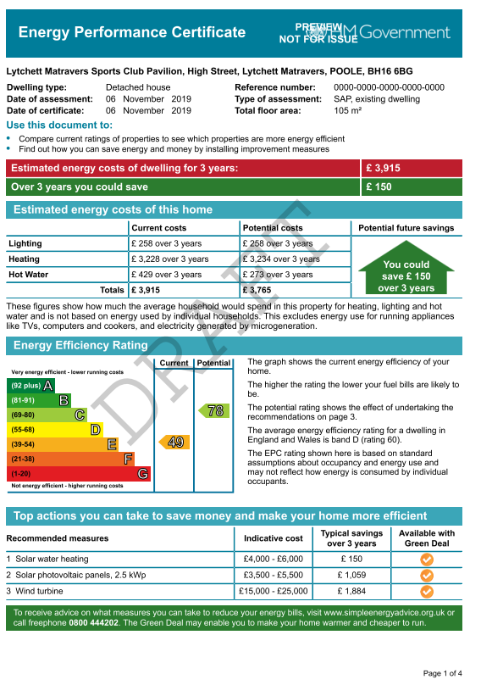

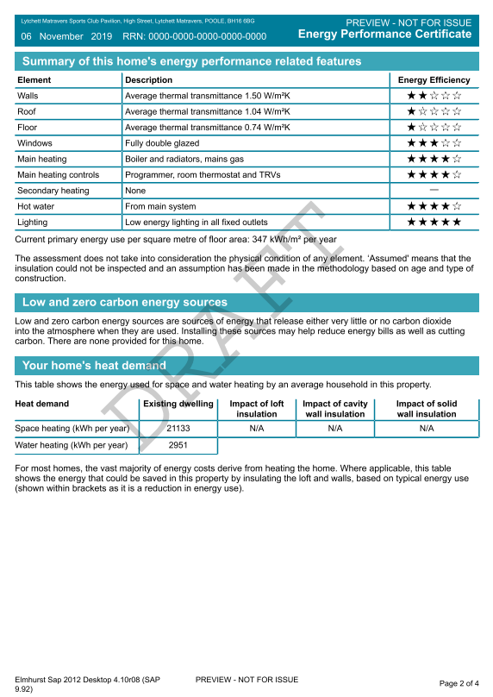

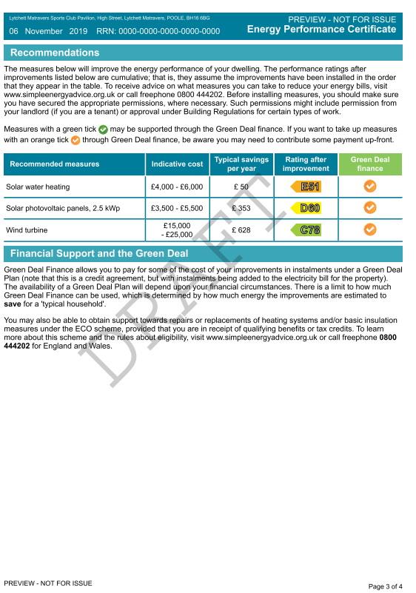

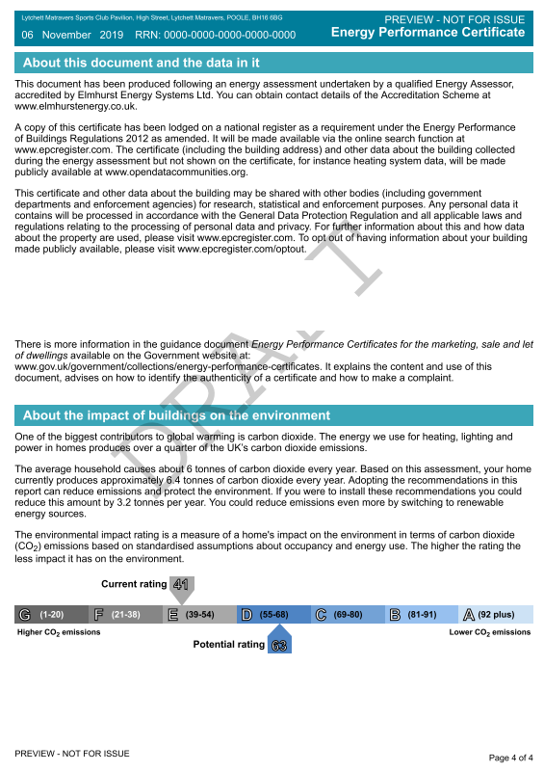

**Appendix 3 – Parish Council Buildings – Youth Hall EPC**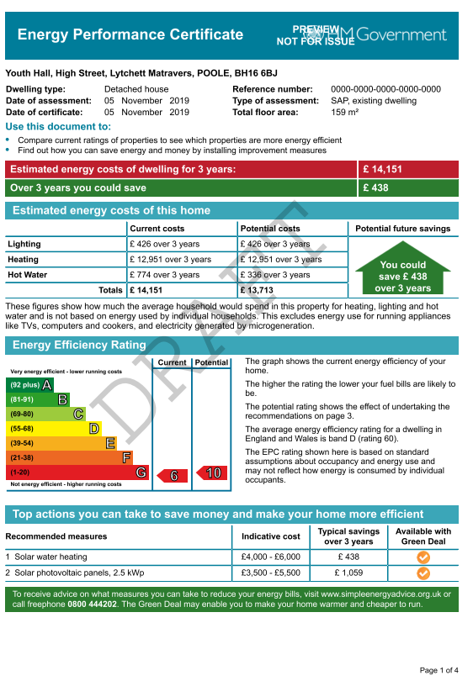

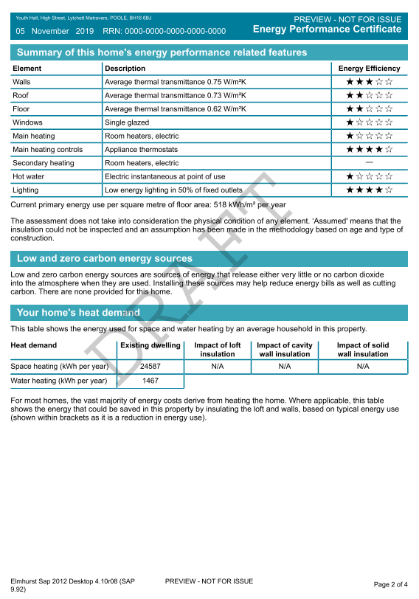

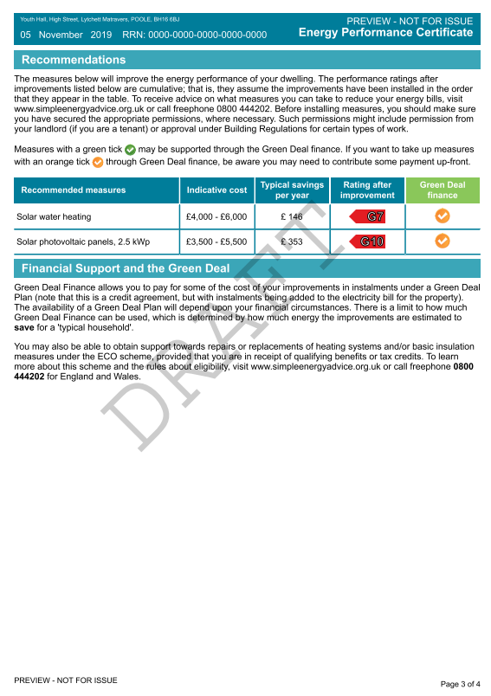

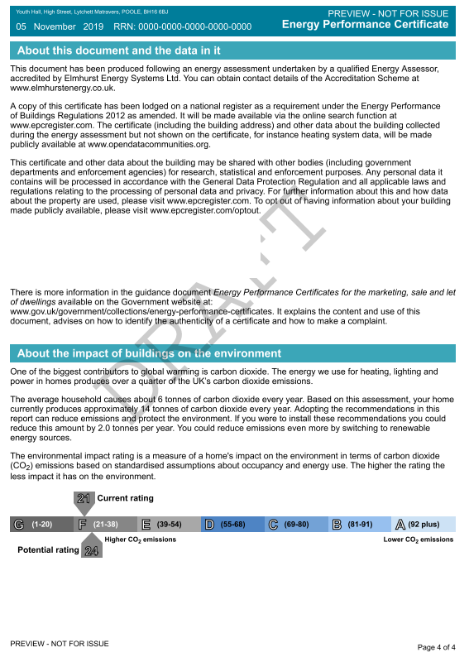

**Appendix 4 – Energy Usage – Sports Pavilion**

An analysis of the Electricity and Gas bills for the Sports Pavilion for the 12 month period starting on 13th September 2018, yields the results shown below.

|  |  |  |
| --- | --- | --- |
|  | Total kWh Used | Total Cost (£) |
| Electricity | 1,457 | 423 |
| Gas | 6,560 | 502 |
| Totals | 8,017 | 925 |

This 12 month period covers a time when the organisation of the Sports Club went through a hiatus. Due to a failure in governance of the Sports Club, the Parish Council terminated the lease granted for use of the Sports Pavilion, and assumed direct control over the Sports Club’s activities. During the first few months of this period there was very little activity in the Sports Pavilion, and a major refurbishment of the building was carried out. The information presented here should not be considered to be fully representative of usage of the Sports Pavilion under normal circumstances. Despite this, the above does provide a baseline against which future energy usage can be compared.

**Appendix 5 – Energy Usage – Youth Hall**

Copies of the Electricity and Gas bills for the Youth Hall have been requested from the current tenant, the Lighthouse Church. Unfortunately, no information has been received.

**Appendix 6 - Survey of Solar Panels in Lytchett Matravers**

During December 2019 the Lytchett Matravers Parish Council carried out a survey of solar panels in Lytchett Matravers using Google Earth. The results provide a useful indication of the extent to which residents have invested in renewable energy. They also provide a baseline, against which future progress in extending the use of solar panels within the Parish can be considered. The following summarises the key results:

* 102 houses and other buildings had solar panels installed on their roofs, representing just under 7% of the housing stock of ~1,500.
* There were ~1350 panels in total, the vast majority of which (~1275) were Photovoltaic (PV - generating electricity), with the remainder being solar thermal panels (providing hot water).
* The average number of PV panels per house (or other building) was 13, which gives an estimated average generating capacity of about 3kW per house (or other building).
* The total estimated solar PV generating capacity installed was about 310kW.

The table below lists those roads where there are houses/buildings which have solar panels installed, and the number of houses/buildings in each road with solar panels.

| **Road** | **Number of Houses/Buildings with Solar Panels** |
| --- | --- |
| Anncott Close | 1 |
| Ballard Close | 1 |
| Burbidge Close | 3 |
| Castle Farm Road | 2 |
| Cecil Place | 1 |
| Charborough Close | 3 |
| Deans Drove | 1 |
| Dolmans Hill | 5 |
| Eddy Green Road | 2 |
| Eldons Drove | 2 |
| Flowers Drove | 2 |
| Foxhills Crescent | 1 |
| Foxhills Drive | 1 |
| Foxhills Road | 2 |
| Frys Close | 1 |
| Glebe Road | 2 |
| Hann Gardens | 1 |
| High Street | 5 |
| Hopmans Close | 5 |
| Huntick Road | 4 |
| Jennys Lane | 2 |
| Landers Reach | 3 |
| Lime Kiln Road | 2 |
| Lockyers Way | 4 |
| Loop Farm Road | 2 |
| Middle Road | 6 |
| Old Chapel Drive | 1 |
| Old Pound Close | 8 |
| Paddock Close | 6 |
| Palmers Orchard | 1 |
| Peatons Lane | 1 |
| Purbeck Road | 2 |
| Sandy Lane | 1 |
| Scutts Close | 3 |
| Spy Close | 1 |
| Trenchard Meadow | 2 |
| Wareham Road | 9 |
| Wimborne Road | 3 |
| **Total Number of Houses/Buildings with Solar Panels** | **102** |