I presented this statement to Council in Sept 2019:
“The West side of the rec is lined with 34 Dolly Posts which would cost £2594 to replace. But this area is almost protected by the village hall bunds. Access could only be gained by driving up either of the pathways to the village hall. So I’d propose that we place dolly posts snug adjacent to each side of the path leading around the front of car Village Hall, and installing a new dropping post (normally up) on the path to the side of the hall (key to be given out with the main village hall key). “
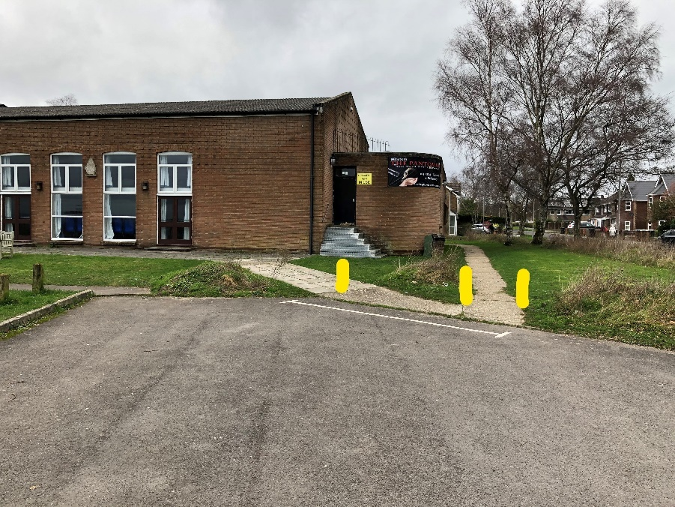
The Village Hall ctte had reservations about bollards not being visible in the dark, and also that they would be a tripping hazard when lowered on the diagonal path.
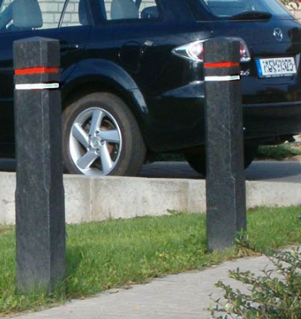
Considerations to be mindful of: We could put all Bright Yellow posts that would be visible, but an eyesore. Or we could put black posts either side of the path like the ones we use around the rec, but leave them taller (we usually get them cut short) and with fluorescent bands. These would be more consistent with the local standard style. These are £50 each.

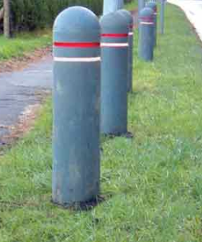
Alternatively we could go for a different style of grey, plastic bollards, again with Fluorescent bands, for £55 each, which would be more visible :

I estimate installation of 2 of these posts would be £25 each based on the previous bollard projects but this might cost more as this is such a small job.

Droping Post:
Legitimate vehicular access to the main hall side door is sometimes needed. This path is formed of 3-wide paving slabs.
I propose we replace the first middle slab with a dropping post set in concrete.
I have identified a post which drops vertically into the ground with a plate over when “down”. The post is powder coated bright yellow. (High Viz)
The VH ctte were concerned about the convenience of locking it: The post I have identified requires key to lower it (I have suggested to VH Cttee that the key be attached to the VH Door keyring), and to raise it you just pull it up and it click locks into place so no key required to raise, and no separate padlock. This is the ONLY one I have identified which has such a simple locking mechanism and appears to meet the requirements of VH Ctte.
The post costs £445 + VAT.

Strictly this is on VH land, but I am proposing that the PC pay for the supply and install of these 3 posts (2 fixed, one dropping).
Supply costs approx. £550 and installation estimate £150-£200 (I don’t have a quote for this yet but cannot envisage it being more than that).
So Total cost to council would be £700 - £800. As Opposed to £2594 to replace the line of dolly posts.

We would either pay to have the existing dolly posts removed at this point, or wait for them to rot naturally and then not replace.

I would like Council agreement in principle to LMPC paying for supply and install of these 3 posts. If agree, I will propose this to the VH Cttee.

Cllr A Huggins 4 July 2020

