Lytchett Matravers Parish Council
POLICY - COMMEMORATIVE & DEDICATION TREES
+ DONATED TREES
February 2021

The Parish Council’s ‘Management of Trees’ policy contains the following policies, which are detailed in this document:
Section 6 ‘Commemorative & Dedication Trees’
Section 7 ‘Donated Trees’

COMMEMORATIVE & DEDICATION TREES
The content of this policy may be revised as necessary at the discretion of Lytchett Matravers Parish Council (LMPC).

1. Introduction

Lytchett Matravers Parish Council (LMPC) recognises the wish of residents for Commemorative & Dedication Trees and will consider applications for planting trees on land owned by the Parish Council for this purpose.

2. Objectives

This policy has been produced with the following guiding principles: -

- To establish responsibility for the purchasing, planting, and protecting of dedicated trees.
- To establish responsibility for the maintenance, repair, and replacement of dedicated trees.
- To ensure that dedicated trees are not out of place in the area in which they are situated.

3. General
- All applications for dedication trees should be made using the Dedication Tree Application form.
- All trees must be paid for by the applicant prior to purchase and installation by LMPC.
- If not already disclosed, LMPC will inform the applicant of the price on receipt of an application form.
- The purchase of the Dedication Tree entitles the person to have a 300mm x 300mm stone plaque by the tree.
- LMPC will attempt to accommodate the wishes of applicants but may limit the number of trees in a particular area.
- Trees will be purchased & planted by LMPC, and adequately protected.
- LMPC accepts no responsibility if a tree is damaged, vandalised or stolen.
- LMPC reserves the right to remove trees at any time.
- No additional mementos e.g. vases, statues, flowers, wreaths, balloons, or other ornamentation etc., shall be permitted on or around the tree. These will be removed without reference to the original applicant.
- LMPC will be responsible for the care and watering of the tree for its first year.

4. Eligibility for a Dedication Tree

- Residents within the Parish of Lytchett Matravers (past or present)..
- Those who have been employed within the Parish of Lytchett Matravers (past or present).
- Groups or organisation that are based within the Parish of Lytchett Matravers (past or present).

5. Trees that are suitable

  - English Oak (Quercus robur)
  - Scots Pine (Pinus sylvestris)
  - Sweet Chestnut (Castanea saliva)
  - Whitebeam (Sorbus aria)
  - Hawthorn (Crataegus)
  - Field Maple (Acer campestre)
Trees will be chosen by LMPC, in discussion with the applicant, to fit into the planting scheme of an area.

6. Memorial Plaques

- Square stone plaques are permitted to be set into the ground at the base of the tree. Plaques should be no larger than 300mm x 300mm and should be a minimum of 50mm thick. Stones should be pale, and either limestone or sandstone, in order to retain consistency. Further detail can be obtained from the Parish Clerk.
- LMPC will need to approve all wording on plaques.
- LMPC will install the stone plaque.
- Plaques cost £200+VAT

7. Notes

- LMPC have the right to refuse an application if the area is deemed full, the request is not for an area approved by LMPC for a dedication tree, or the applicant(s) are deemed to be ineligible.
- LMPC will hold details of Dedication Tree ‘owners’ on file for the sole purpose of administration of the Dedication Tree scheme and to contact the applicant if there are any issues with their tree.

Appendix - Lower Rec Car Park
A “pilot” Dedication Tree project is to be used to assess suitability using trees that are already planted in the new lower recreation ground car park. Figure 1.0 shows a tree plan with the trees available for ‘sponsorship’:

Figure 1.0
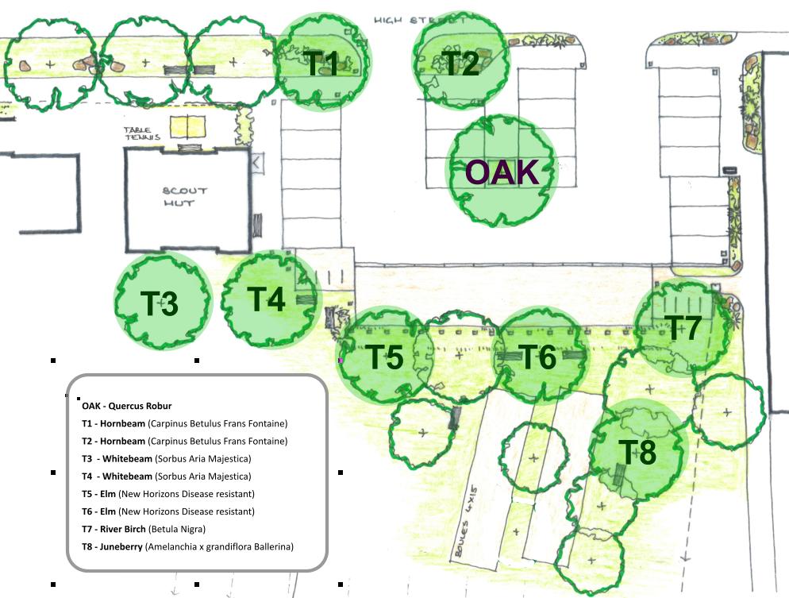

The cost to sponsor a tree are as follows:
- Trees T1 - T8 = £250
- Feature Oak = £500

DONATED TREES

Lytchett Matravers Parish Council (LMPC), in line with our declaration of a climate emergency, recognises that trees can provide an important function in sequestering CO2. Planting trees can help offset atmospheric CO2 levels and should form part of the council’s future thinking.
General
LMPC will consider offers of donated trees based on their suitability to the chosen site. Suitability relates to species as well as size of the tree.
Sites are divided into 3 categories:
- Medium Scale (Parish Council owned fields and open spaces, e.g. recreation ground)
- Small Scale (Parish Council owned areas of smaller green space, e.g. Foxhills Open Space, Old School Green)
- Road Verges (Dorset Council owned, Highways approval required)

Species of Tree
- LMPC will determine what tree species are suitable for each site, based on consultation with any relevant bodies. A list of tree species deemed suitable for the conditions in Lytchett Matravers:
  - English Oak (Quercus robur)
  - Scots Pine (Pinus sylvestris)
  - Sweet Chestnut (Castanea saliva)
  - Whitebeam (Sorbus aria)
  - Whitethorn/Hawthorn (Crataegus)
  - Field Maple (Acer campestre)
Generally, Medium Scale sites (and some small-scale sites) could accommodate trees that grow very large at maturity. Smaller tree species would be better suited for verges.

Who Plants the tree?
LMPC will appoint a contractor to plant all trees on Dorset Council land. On LMPC land either LMPC’s contractor or the benefactor will plant the tree(s), subject to approval by LMPC.

Who is responsible for the trees?
LMPC will be responsible for trees on its and Dorset Council’s land. However LMPC accepts no responsibility if a tree is damaged, vandalised or stolen. In case of damage & disease, LMPC will replace trees at its discretion.

