Minutes of the meeting of LYTCHETT MATRAVERS PARISH COUNCIL

Wednesday 27th July 2022 at 7:00 in the Blanchard Room at the Village Hall.
PRESENT were A Bush (Council Chair), V Abbott, R Aspray, K Morgan, P Webb and Mr T Watton (Parish Clerk).
Also present: Dorset Cllrs A Brenton, B Pipe and A Starr. Two members of the public were also present.

PUBLIC PARTICIPATION SESSION (Standing orders suspended)
There was none.

DORSET COUNCILLORS’ REPORT
Reports were submitted by Dorset Cllrs Alex Brenton and Bill Pipe, copies of which are associated at Appendices 1 and 2 to these minutes. Dorset Cllr Starr had nothing he wished to add to this.

In response to a point made in Dorset Cllr Pipe’s report concerning youth facilities, Cllr Bush explained that the Parish Council has recently taken back direct control of its Youth Club building and is looking for uses for it. He was interested to hear more about “Youth Grants” available from Dorset Council which Dorset Cllr Pipe had referred to. In response, Dorset Cllr Pipe suggested contacting Mr Simon Fraiz-Brown, in DC Children’s services.

Particular attention was also drawn to the item within Dorset Cllr Brenton’s report concerning Beryl Bikes. It is understood Cllr Huggins has expressed interest in the local relevance / feasibility of this initiative, and may wish to follow-up on this matter to obtain more details.

In response to a comment from Cllr Morgan about the announcement of a 2 year delay to the Dorset Local Plan, Dorset Cllr Brenton suggested that it may be some time before the details are known about how this will be taken forward.

1. To receive and consider apologies for absence.
Cllrs M Attridge, B Barker, A Huggins, K Korenevsky, and H Khanna.

2. To receive any declarations of interest, and consider any requests for Special Dispensations under Section 33 of the Localism Act 2011.
None.

3. To consider any applications for the casual vacancy on the Council.
It was noted that none had been received by the advertised deadline. An application received after that deadline will be considered at the scheduled meeting on 10th August 2022.

4. To receive and resolve to approve minutes of Council meeting held on 22nd June 2022.
It was RESOLVED by all present to approve the minutes as a true record of the meeting. They were duly signed by the meeting Chair.

5. To receive and consider reports of past subject matters (for the purposes of report only).
It was RESOLVED to receive and note the contents of the following report, which had been prepared and circulated in advance of the meeting by the Parish Clerk. Italics below indicate additional comments made during the meeting.
- Minute 21, 22nd September 2021 – signage for BMX / cycle dirt track. It was agreed that the signage would be erected by the Guerrilla Gardeners. This has been delivered to the Parish Council office.
- Minute 7.2, Full Council 27th April 2022 – Purchase of replacement litter bin for Rocket Park. This has now been received. It was agreed that the Guerrilla Gardeners will install it.
- Minute 7.3, Full Council 27th April 2022 - replacement of the elderly rectangular bin adjacent to the upper car park located approx. halfway between the Sports Pavilion and the Village Hall. This has now been received. It was agreed that the Guerrilla Gardeners will install it.
- DC Ward members’ report, Full Council, 22nd June 2022 – outstanding invitation to Purbeck CAB representative to attend a council meeting. A chaser has been sent to Helen Goldsack and Judy Herring at Purbeck CAB.
- Minute 11, Full Council, 22nd June 2022 - export tariff with Octopus Energy. On 25th June 2022 the Parish Clerk pursued the previously registered request with Octopus Energy to join their “Panel Power” scheme to export excess solar energy. They responded to ask for the DNO and MCS certificates. These were forwarded to Octopus on 1st July. After three further “no progress” updates from Octopus, Rob Carswell arranged for H2ECO to visit the site and attend to a problem which had evidently ben causing a delay in this process. As of 22 July the application is now just awaiting a “sign off” by SSE.

6. Chair’s announcements (for the purposes of report only).
There were none.

7. To receive and note the content of the minutes of the Finance & General purposes committee meeting on 13th July 2022 (for purposes of report only).
It was RESOLVED to receive and note the contents of these draft minutes.

8. To consider planning application P/PAED/2022/04074 Glenwoods Poole Road Wimborne BH21 3RP. Raise roof from 7.068m to 10.468m to create additional storey.
It was noted that this is an application seeking ‘Prior Approval’ of a 1st floor addition which the applicant considers to be Permitted Development, and a very similar earlier application for the same property was considered by the PC. That Application was subsequently refused on the basis of upper floor windows being proposed on the side elevations – which is not allowed in the PD rules. Consequently this current Application omits those windows and so is likely to be accepted by the LPA.

9. To consider planning application P/HOU/2022/02848 Owls Farm Dolmans Hill Lytchett Matravers BH16 6HP. Retain a structure used for the storage of agricultural machinery, including a tractor, and an adjacent wood store.
The Parish Council wished to OBJECT to this proposal. Members’ attention was drawn to the fact that Owls Farm was established as a severance of an already small ‘agricultural‘ holding. Permitted Development (PD) rights were agreed, despite an objection from the Parish Council. It was noted that the property was converted but also extended together with ancillary buildings – all of which is understood to be in contravention of PD rules. It was noted that a previous application to retain those structures has been refused. Parish Council members’ opinion is that the retention of this storage building will cause harm to the openness and purpose of the designated Green Belt.

10. To consider planning application P/NMA/2022/04314 (non-material amendment) Land adjacent to Wessex Water Reservoir Purbeck Road Lytchett Matravers Non material amendment to Approved P/A 6/2018/0287 (Construction of 25 dwellings and associated access, parking and landscaping) to add solar panels to specific dwellings.
NO OBJECTION

11. To consider planning application P/OUT/2022/03616 Bexington Lime Kiln Road Lytchett Matravers Poole BH16 6EL. Demolition of existing dwelling and re-development with a replacement dwelling (outline application to determine access only)
NO OBJECTION in principle to the proposal in this application.

12. To consider planning application P/FUL/2022/04306 Kiln Cottage Lime Kiln Road Lytchett Matravers Poole BH16 6EL. Demolish existing garage, erect 1 No 2 bedroom house.
The Council wished to express its OBJECTION to this proposal. They felt that the proposal is not sympathetic to the setting of the adjacent listed building - of which it is within the curtilage. The Parish Council is concerned and disappointed to see that no associated Heritage Statement has yet been included with the application. In addition, Parish Council members were concerned that the proposed car parking provision is likely to lead to roadside parking adjacent to the property – i.e. on a blind bend.

13. To receive a report from the Climate Change Emergency Working Group (for purposes of report only).
A summary report had been made available to all members ahead of this meeting and the contents were noted. A copy is associated at Appendix 3 to these minutes.
Members’ attention was drawn to the intention to hold an open day in September for prospective tenants / renters. Members were again encouraged to continue considering how to utilise the Youth Club building for the future. Action: all members to consider this and feed ideas back.
Some discussion took place regarding the water supply leak. It was noted that Dorset Council Estates Department (Rupert Williams) have been alerted. Mr Williams has arranged for a DC appointed contractor to attend the site to undertake an initial inspection with a view to detecting and dealing with the leak.

14. To receive a report from the Huntick Road Cycleway Working Group (for purposes of report only)
No formal report. However it was reported that Cllrs Bush and Morgan had met with representatives of Fletchamoore Poole Ltd to request an initial quote for the next sections of cycleway (at 2m width) – between Huntick Green / Rosalia Meadow and Jubilee walk, and from Jubilee Walk to Longacres.

15. To receive a report from the Village Environment Working Group (for purposes of report only)
A summary report had been made available to all members ahead of this meeting and the contents were noted. A copy is associated at Appendix 4 to these minutes.
Cllr Morgan explained that a re-tendering exercise was underway for the dog exercise area.
Tenders are also being obtained for the proposed new Library Green Path. With regard to this, it was clarified that a design plus the necessary quotations will be submitted to Dorset Council.
It was explained that the Community Garden initiative is being scaled down to a smaller area of garden / planting by the proposers. This is in response to the concerns expressed about the originally planned level of expenditure on this of money originally raised from donations for relief of residents’ financial hardship during the pandemic.
It was noted that Fletchamoore Ltd need detailed dates for delivery / installation for the adult exercise equipment. Cllr Bush indicated that he would contact Cllrs Korenevsky and Huggins about this. In addition, details are needed of how the equipment is to be fixed into the ground.

16. Receive a report from the Neighbourhood Plan 2 Working Group (for purposes of report only).
A summary report had been made available to all members ahead of this meeting and the contents were noted. A copy is associated at Appendix 5 to these minutes. It was noted that feedback on the PLP2 hearing held on 19th July is covered under minute 19 below.

17. To consider a report and recommendations for replacement surfaces for the Skate Park at the recreation ground.
Cllr Huggins had produced a report of the site meeting and discussion held with Mr Kinghorn of Evolution Skate Parks (Circle Leisure Ltd), who installed and are contracted to undertake the regular inspections and maintenance of the skatepark. The report also contained a choice of two recommended quotes for preventative maintenance of the skate park’s deteriorating riding surfaces, to protect and prolong the facility’s useful life. After some discussion it was RESOLVED to accept and approve quote 2 in the report – i.e. to replace all the current riding surfaces with Skatelite Pro 3000 (Black) surfacing at a cost of £20784.26 excluding VAT, to include all materials and labour.

18. To consider and approve an updated statement of CIL receipts and usage Lytchett Matravers.
The Council Chair explained that it is incumbent upon the Council to maintain a record of all CIL receipts and disbursements for local infrastructure projects, and to report this to Dorset Council on an annual basis. This agenda item is intended to inform Council members and the public of that statement. A copy of this latest statement is associated at Appendix 6 to these minutes.

19. To receive a report regarding the Purbeck Local Plan 2 Hearings from July 19, 2022.
Cllr Bush summarised key points from the report he had prepared covering the hearing itself, together with the representations made by himself on behalf of the Parish Council, and by two members of the public on behalf of a group of local residents. This report was made available to Council members ahead of this meeting, and a copy is associated at Appendix 7 to these minutes.
He reported that copies of what had been submitted to the Inspector at the hearing were acknowledged. They could now be used as evidence of submission for the Council’s appointed legal advisor on this matter.

20. To resolve to approve the following payments already made:
To Whom | For What | Net | VAT | Total

Octopus Energy | Sports Pavilion electricity charge for period 1st- 30th June 2022 | 16.90 | 0.84 | 17.74
British Telecom | Office phone and broadband – June 2022 | 48.10 | 9.62 | 57.72
SSE | Car park lighting quarter 1 2022/23 | 16.18 | 0.80 | 16.98
Water2Business | Water supply to allotments 17/12/2021-16/06/22 | 210.19 | 0.00 | 210.19
Rachel Woods | Refund of allotment deposit and proportion of yearly rental fee. | 30.00 | 0.00 | 30.00
HMRC | Repayment of employment allowance 1/4/2016 - 31/3/2022 | 6146.68 | 0.00 | 6146.68

It was RESOLVED to approve the above payments already made.

21. To resolve to approve the following payments due:
To Whom | For What | Net | VAT | Total
T Watton | Clerk’s salary – July | 1057.15 | 0.00 | 1057.15
HMRC | PAYE & ENI – July | 361.46 | 0.00 | 361.46
Dorset County Pension Fund | LGPS pension contrib July 2022 | 390.01 | 0.00 | 390.01
T Homer | Handyman duties, June 2022 | 251.75 | 0.00 | 251.75
Idverde Ltd | Cemetery maintenance June 2022, Inv 10846793 | 330.75 | 66.15 | 396.90
Idverde Ltd | Grass cutting, southern end of rec x 1 in June 2022 Inv 10846735 | 31.20 | 6.24 | 37.44
Idverde Ltd | Cemetery maintenance July 2022, Inv 10850295 | 330.75 | 66.15 | 396.90
Replay Maintenance Ltd | 6 monthly maintenance of Astro pitch July 2022 | 470.25 | 94.05 | 564.30
Dorset Planning Consultant Ltd | Planning advice PLP examination FMM, attendance at local WG meeting and production of summary paper of key points, printing, travel time and mileage disbursements. | 461.40 | 92.28 | 553.68
D&P Warr Contracting | Supply of 100 straw bales for Jubilee event – damaged by weather | 250.00 | 0.00 | 250.00
Lytchett Matravers Sports Club | Reimbursement of fees for sewer clearance on Rec Ground June 2022 | 174.00 | 0.00 | 174.00
SLCC | Fees for attendance at Finance Summit T Watton and A Bush. | 90.00 | 18.00 | 108.00
A Bush | Reimbursement of expenditure incurred on behalf of the Council – mileage and parking. | 29.10 | 0.00 | 29.10

It was RESOLVED to approve all of the above payments.

22. To note any training undertaken by members or the Clerk in the past month (for purposes of report only).
There was none reported.

23. To note any decisions and / or action taken by Parish Clerk under “Openness of Local Government Bodies Regulations 2014”, Part 3, Paragraphs 6-10, Record of Decisions and Access to Documents (for purposes of report only).
None.

24. Correspondence (for purposes of report only).
There was none reported.

25. To note date of next meeting and items for future agendas.
- The next full Council meeting is scheduled to take place on Wednesday 10th August 2022 – to be combined, exceptionally for August only, with the key content of the Finance & General Purposes Committee meeting. The meeting will commencing at 7pm in the Blanchard Room at the Village Hall.

The meeting closed at 21:05 Annotated by/on ……………………………..Signed by……………………
Appendices

APPENDIX 1
Report to Lytchett Matravers Parish Council for 27th July 2022
From Dorset Councillor Alex Brenton

Purbeck Local Plan2 Hearing 19th July 2022
The Examiner hearing about the Purbeck Local Plan was held last week and attended by Cllrs Bush and Brenton. It was focussed on the proposed SANG at Morden Park and its legality and the effect on neighbouring developments and other SANG provision. No report is expected from the Examiner until September.

Plans for up to 40 caravan homes to house Ukrainian refugees have been met with objections.
A proposed development for the outskirts of Blandford Forum, Dorset, has been lodged by the local Bryanston estate and the Rothermere Foundation. The move is in response to the Ukraine crisis.

The site had previous applications for housing rejected, according to the Local Democracy Reporting Service (LDRS), on the basis that they would ruin the character of the area at risk of being flooded.
"It is the intention of the applicants to respond to [the Ukraine] crisis through providing aid and safe housing to some of those impacted by the conflict." The plan involved stationing caravans temporarily.
Dorset Council leader Spencer Flower said there were 559 refugees in the county, including 200 children, being hosted by 148 sponsors. Policy of the Council was against refugees being grouped together in designated housing.

An email to Cllr Carr-Jones asking if any extra provision or help would be available to help Ukrainians find housing when their hosts need them to leave has not been answered.

Housing stream line - Dorset Council’s Housing Services to better support those most in need
If you work with our housing service or refer residents to the housing team, you need to be aware of the new contact details:
- Colleagues who want to contact us or send us something:
email: housinghelp4professionals@dorsetcouncil.gov.uk
To refer a case to us please continue to follow the instructions on our website.
- People wanting to contact the Housing Register team (social housing)
Phone: 01305 221000
Email: dorsetcouncilhomechoice@dorsetcouncil.gov.uk
- People worried about homelessness or wanting housing advice
Phone: 01305 221000
Email: housinghelp@dorsetcouncil.gov.uk
01305 221000 is the new single number for the public to access housing support. From here people can choose housing register (social housing), homelessness support or general housing advice.

Inefficient homes
New analysis from the LGA shows that three million households in fuel poverty in England are having to pay an extra £250 a year in fuel bills due to poorly insulated homes. Our housing stock is also generally poorly designed for dealing with extreme heat conditions. New housing regulations may improve this for new properties but not for existing properties. Questions asked about new housing regulations which include items such as insulation and power saving issues but do not include insisting on Solar Panels or Rainwater harvesting.

The Shed at Durlston, Swanage
A new weekly volunteer group at the ‘The Shed’ has started; and operates every Tuesday 2pm- 4pm. The new session is led by the Dorset Council Rangers and welcomes people of all ages and abilities to socialise, learn new skills, and volunteer in support of Durlston Country Park.
The ‘Everyone Needs a Shed!’ project offers a relaxed style of working, with tasks like gardening, woodworking, painting, crafts, and more.
There is a proposal for a Mens Shed in Lytchett Matravers as the old youth services hall is no longer being used by the Church.

Public Spaces Protection Order (PSPO) came into force on 1 July that prevents people lighting fires, including BBQs, fireworks, lanterns, and campfires, in many areas across Dorset.
Dorset Council is working with Forestry England and Dorset and Wiltshire Fire service to protect countryside area including heathlands, forests, and coastlines from the devastation that unattended naked flames can cause.

Libraries This summer, children aged 4-11 can visit any of our 31 Libraries (including 8 Community Managed Libraries) to meet the Gadgeteers and to get involved in a science and innovation themed Summer Reading Challenge. Find out about all our Summer Reading Challenge events at Library activities for children – Dorset Council

Parking Police across Dorset are urging the public to take note of which service to contact when dealing with parking issues. Dorset Police have explained that abandoned cars and anti-social parking are dealt with by Dorset Council, while untaxed cars need to be reported to the DVLA (Driver and Vehicle Licensing Agency). Dorset Police said the emergency service does not have any legal powers for vehicles parked on double yellow lines, vehicles parked inconsiderately or contravening parking restrictions. A spokesman from Dorset Police said: "Unless it's been left in a dangerous place badly parked, abandoned or untaxed cars, are not matters for police.”

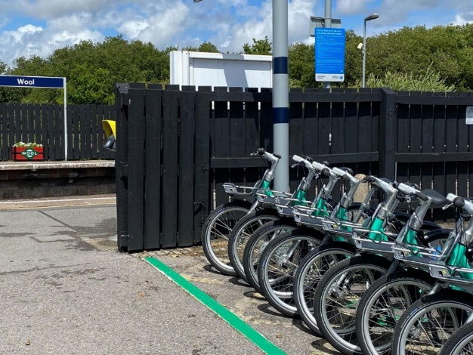
Increased Bike provision Perhaps something for Lytchett Matravers PC to think about.

The UK’s leading micromobility provider has launched 10 bikes and six parking bays at the Dorset Innovation Park and Wool railway station with further bays available in Bovington.

The new bikeshare scheme, delivered by Beryl Bikes in partnership with Dorset Council and South Western Railway, is set to boost access to employment and visitor attractions while further encouraging sustainable commuting.

Planning Personally I have had complaints about Dorset Planning system being too relaxed about breaches of permitted development rules and creeping urbanisation of Organford.

Trees. I have been encouraging Dorset Tree Officers to be more pro-active in using TPOs to preserve trees at risk of felling because of proposed developments, and also felling of trees during nesting season.

APPENDIX 2
Report to Lytchett Matravers Parish Council for 27th July 2022
From Dorset Councillor Bill Pipe
I have had planning meetings and chaired an appeals committee at County Hall in recent weeks, but was unable to attend the full sitting of Dorset Council as I had a prior engagement in York. That council decided not to confer the honorary title of Alderman upon long serving councillors who had served the former District Councils for many years and the new Dorset Council.

Along with Cllr Stewart McKell, I have still been in positive discussions with representatives of the local community, Dorset Council to reinstate the provision of Youth Services for the younger people of Lytchett Minster, Upton and the surrounding community within Dorset [not BCP]. It is envisaged that initially, a one-day-a-week [likely to be a Friday evening] youth club will be established in the town with an aspiration for further evenings to be added in due course. I have sourced a Youth Leader within the town who is willing to give her time initially, free of any charge to get this much needed project back on its feet. Negotiations continue and a likely funding stream has been identified by Dorset Council and I have arranged a meeting for today with the Youth Provision officer for Purbeck. The idea to build a youth facility alongside the library at Upton looks to be many years away at the moment as there are no plans by Dorset Council to build this facility in the "near future". All the same, I still look forward to the day when our youth and young people will have a place to meet, to enjoy the facilities on offer and be able to get help and guidance to enable them a smoother journey into adulthood and to become better citizens.

No change on the situation with regard to mineral extraction from Upton Heath.

The hot weather of late has given Upton Together some concern and we have visited our more vulnerable residents and given advise on how to stay cool in the home by keeping windows and doors closed and the curtains/blinds drawn. We have also provided bottled water to keep in the fridge and drink when necessary. Older and more special needs residents will be checked upon and monitored while the weather remains hotter than normal. I continue to work with your Member of Parliament on such matters as parking, road repairs, planning issues, the price of petrol & diesel [particularly when the 5p reduction in tax is not passed down to the customer] at the pump. My next scheduled meeting with Michael will be in August.

In my role as Armed Forces Champion for Dorset, I would encourage any ex-forces, serving member, widow or relative of any of the previous to get in touch with me on 07880 504379 or email cllrbill.pipe@dorsetcouncil.gov.uk if they have any concerns about the welfare of any forces related residents, or if they have any concerns about the Armed Forces Covenant as adopted by Dorset Council.

APPENDIX 3

Climate & Ecological Emergency Working Group – Summary Report, July 2022

Working Group Objective:
Following the Parish Council declaration of a Climate Change Emergency, identify, assess, and implement measures within the parish to reduce the carbon footprint of both LMPC and the community.

Working Group Participants:
Rob Carswell, Alf Bush, Beverly Barker

Details:
- Sports Pavilion full building upgrade with Low Carbon Dorset (LCD).
- Youth Hall full building upgrade – deferred until DC transfer and building business plan is approved.

Dependencies:
- Youth Hall Business Plan
Status/Next Steps:
Works already completed - the Sports Pavilion is fully functional with solar panels charging the battery and exporting to the grid.
- Finalise SSE inspection and sign-off
- Finalise Octopus export tariff
- H2ECO have reconfigured the export tariff facility
- Monitor electricity usage to determine savings
- Plan for Youth Hall – published in Parish Mag for any ideas.

Works to come:
- The Lighthouse Church is not renewing their licence for the Youth Hall. The building is ready for use and they are willing to donate most of the equipment, but we need to find a regular user group (s).
- Looking for a September Open Day to invite all interested parties

Financial Forecast:  (£000’s, excluding VAT) | 2022-23 | 2023-24 | 2024-25
Expense to date | 0 | 0 | 0
Forecast | 8k less 3k LCD payment | 0 | 0
Total | 5k | 0 | 0

APPENDIX 4
Village Environment Working Group – Summary Report. July 2022

Working Group Objective:
To identify areas of concern/opportunity within the physical environment of the Village and propose responses. Due to other pressures a Progress Mtg has not convened since the Nov PC mtg.

Working Group Participants:
Ken Morgan, Alf Bush, Andrew Huggins, Karen Korenevsky, Vicky Abbot, Hannah Khanna, Martyn Colvey

Details:
1. Rec Area Projects:- Exercise Trail/Outdoor Gym Equipment – Picnic Tables x4 + Benches x4 -
Boules/Petanque Pitches. Bins. Trees + Swales/sw attenuation.
2. Dog Exercise Area – retendering to 3 x prospective contractors. Add in m.g to adj car park.
3. Community Garden adj fence at top of Pond Walk – Is this now in doubt?
4. Higher Cross Bus Shelter – Demolished - Make good plinth with Planter and Bench.
5. Trees – Rec + generally– Seek sponsorship.
6. Hannams Close entrance enhancement. Benches in position. Discuss with management company.
7. Wareham Rd/School traffic/parking - DC/WSP proposals discussions ongoing. – New Car Pk?
8. Pond –J.K reduced but still evident. Treatment required.
9. Finger post Renovations – Blaneys Corner done. Vol Training + sponsorship. Progress on Upper X with discounted parts available.
10. Library Green Path – Out to tender to 3 x prospective contractors.
11. High St Crossing – Awaiting DC Highways.
12. Tesco frontage – Acceptable design agreed with DC. Suggest joint Tesco/DC/PC funding. Possible
bollard/boulder compromise?
13. Sports/Scout Bldgs ‘backside’ to High St. Short term Ideas + longer term Workplace opportunity.

Dependencies:
- Dorset Council Highways + Planning/LP. Flow of CIL monies.

Status/Next Steps:
• Await and approve Dog Exercise Fencing tenders.
• Await and approve Library Walk Path tenders. Is Dorset Co detailed approval required?
• Adult Exercise Trail + Benches/Picnic Tables/Bins – Orders Placed. Start date?
• Community Garden – Is this in doubt following withdrawal of funding?
• JK treatment adj Pond Walk
• Prepare detail dwgs + tender docs for Boules Pitches + ‘Hannams Gate’
• Work up designs for Sports Area + Rec landscaping/tree planting.
• Push Tesco/Highways re shop frontage funding.
• Investigate Grants/Funding/Sponsorship/Lottery/ Local Trusts + Loans/Mortgage possibilities.

Financial Forecast:  (£000’s, excluding VAT) | 2022-23 | 2023-24 | 2024-25
Expense to date
Forecast | 115 | 150 | ?
Total | 115 | 150 | ?

APPENDIX 6
Neighbourhood Plan 2 Working Group – Summary Report. July 2022

Working Group Objective:
To renew the Lytchett Matravers Neighbourhood Plan (LMNP) in readiness for the Dorset Local Plan.

Working Group Participants:
Ken Morgan, Micki Attridge, Karen Korenevsky, Alf Bush, Peter Webb, Ian Taylor.

Details:
The current LMNP was limited in scope by Purbeck District Council and further by the examiner. The plan was prevented from identifying any type of development and in addition many policies/strategies for the community were removed. e.g. infrastructure and employment requirements.
A renewed LMNP is required to address the chronic erosion of the green belt over the last 40 years, to ensure development is beneficial to the community in addressing its needs. i.e. sustainability, CCE net zero, design standards, local employment, community infrastructure and amenities.
Dependencies:
- PLP2 adoption – delayed due to need for new hearing on Morden Park
- JR review decision
- DLP next consultancy stage

Status/Next Steps:
- PLP2 Hearing prep meeting with planning consultant and residents to prepare. Planning consultant produced draft text.
- Attended PLP2 hearing on July 19th; presented LMPC comments as reported.
- Residents also attended and presented their comments as reported
- Both parties sent copies to the Inspector and received acknowledgment.
- Stephen Morgan (barrister) on PC responses to PLP2 and DLP.
- Follow up with Wessex Water on wetlands and Natural England nitrates/phosphates
- Continue work on draft NP2 policies
- Work with CAN/CPRE on DLP issues
- Follow up with DC on government reply to DLP delay letter

Financial Forecast:  (£000’s, excluding VAT) | 2022-23 | 2023-24 | 2024-25
Expense to date | 0 | 0 | 0
Forecast | Planning Consultant 5  Barrister review 5 | 0 | 0
Total | 10 | 10 | 0

Appendix 7
Purbeck Local Plan 2 Hearings – July 19, 2022

July 2022

PLP2 Hearings

Attendees:
- Inspector Gareth Wildgoose
- DC Planning team, led by Steve Boyt
- Charborough Estate team, led by Richard Harwood
- Nick Squirrell / Natural England
- Tim Hoskinson / Wyatt Homes
- Gerald Rigler / CPRE
- Dr Andrew Langley
- Cllr Alex Brenton
- Clare Lees
- LM residents Alan Bagley and Goretti Quinn-Bagley
- Cllr Alf Bush

The hearings were principally around the issue of Morden Park holiday village. The initial version of PLP2 included the village and an associated strategic SANG. Strategic in that this SANG was not linked to specific developments, but was aimed at drawing visitors away from the heathland. The village was to be re-designated green belt.

The plan was then ‘modified’ as a result of consultation and the proposed main modifications. The holiday village was removed, but the SANG retained. The Charborough Estate’s contention (they had a QC at the Hearings) were that DC and the Inspector had somehow reviewed new evidence not in the public domain to effect this change. Charborough Estate were clear in that their provision of a SANG only came with the agreement to build a holiday village. Their contention was also that there was no where else for a strategic SANG other than Morden Park.

Since the proposal included changes in Policy V2 Green Belt that provided an opportunity for LMPC and LM residents to include their opposition to the policy itself – see the associated representation statements below.

Currently, DC are waiting on Natural England to provide guidance on dealing with the nitrate and phosphate run-offs into Poole Harbour. As a result, many proposed developments have been temporarily removed and the building supply has reduced to 1.23 years.

NE will come up with some sort of trade-off and they will go back. DC also have an interim strategy which is designed to deliver the houses despite the Charborough Estates objection. DC indicated that they would be looking at compulsory purchase if they could not reach agreement. To note, other landowners did counter that they had not been asked if they could provide land for a strategic SANG.
The presence of a QC at these hearings mean that DC and the Inspector will need to be very careful in how they structure PLP2.

Purbeck Local Plan Examination (2018-2034)
Tuesday July 19, 2022
Representation made by Alf Bush / Lytchett Matravers Parish Council.

I would like to raise concerns we have related to Policy V2 – Green Belt. Policy V2 is trying to justify itself by using a SANG as an offset to re-designation of Green Belt. The creation of a SANG is not an exceptional circumstance.
The SANG in Flowers Drove is smaller than Natural England guidelines. In a field of 7.6 hectares the longest possible circular walk is 1.72k, way shorter than the recommended 2.3/2,5k.

Further, the 7.6 hectare Flowers Drove SANG is being used as justification for releasing 11.8 hectares of Green Belt.

Currently, there is a site for 46 houses under construction (PLP1), another infill site for 25 houses and a total of 29 planning applications in progress for infill building in back gardens. Yet none of these 100 additional houses deserves a SANG.

This is clearly in conflict with the published guidelines and unsound.

Policy V2 before the modifications highlighted the application of NPPF at a local level, surely the purpose of a local plan. The reference to the council protecting the Green Belt to:

- prevent the spread of the Poole, Bournemouth and Christchurch conurbation
- safeguard the countryside from encroachment
- preserve the setting and special character of Wareham
- prevent neighbouring settlements of Holton Heath, Lytchett Matravers, Lytchett Minster, Morden (East and West), Organford, Sandford, Upton and Wareham merging

has been deleted.

This is a very retrograde step and defeats the purpose of a local plan, the application of national planning guidelines as they are applied locally.

What are the exceptional circumstances to provide for Green Belt re-designation?
Green Belt is just 2.9% of Dorset. Are we seriously saying that there is insufficient space in 97.1% of Dorset for non-Green Belt development?
Dorset Council have stated that these areas around Lytchett Matravers do not have a material impact on the village. The reality is that the salami strategy, slice by slice, over the successive local plans has had a very material impact.
Lytchett Matravers is surrounded by Green Belt created in 1980. This was designed to have a very special purpose as defined by NPPF. Despite that protection, more than 369 houses have been built in Lytchett Matravers since 1980 on re-designated Green Belt land. In PLP2, Dorset Council have proposed further re-designation for 150 houses and in the DLP a further 200 houses.

With respect to Green Belt, NPPF states 3 critical protection aspects:

- NPPF 141 states that it must be demonstrated that all other options have been fully examined before Green Belt exceptional circumstances could apply. Yet, Dorset Council stated in section Question 2 (6) that ‘as explained in the Housing Background Paper [SD19], the Council could theoretically deliver Purbeck’s local housing need without making changes to Green Belt boundaries, by concentrating development in Wool and Moreton Station / Redbridge Pit. The Council does not consider that this is an appropriate option for meeting Purbeck’s housing requirement’.

So there are no justifiable exceptional circumstances. We consider this approach unsound; use the 97.1%.

- NPPF 140 states that Local Plan strategic policies that can establish the need for any changes to Green Belt boundaries, need to have regard to their intended permanence in the long term so they can endure beyond the plan period. Yet Purbeck District Council and Dorset Council repeatedly re-designate Green Belt around Lytchett Matravers and elsewhere at every opportunity. The re-designation in PLP1 should remain as is.

We consider this repeated re-designation of Green Belt boundaries conflicts with NPPF and is unsound.

- NPPF 142 states that when drawing up or reviewing Green Belt boundaries, the need to promote sustainable patterns of development should be taken into account. However, PLP2 includes no plan for employment or retail opportunities, no plan for infrastructure, no plan for improvement of public services in Lytchett Matravers. NPPF 142 states that plans should give first consideration to land which has been previously developed and/or is well-served by public transport. Currently, the village bus has been cut-back to a one-way only service. You can catch a bus from Wareham Road/Glebe Road (the site of the proposed 95 houses) to the village centre and be there in 2 minutes. If you want to return, it takes 2 hours.

We consider the lack of any element of sustainability conflicts with NPPF and is unsound.

- Purbeck Local Plan – Further Main modifications
Hearing 19 July 2022
This is a statement on behalf of:
- Goretti Quinn-Bagley
- Alan Bagley
- Amanda Backhouse
- Ian Taylor
- Mr and Mrs Dunlop
- Alf Bush
- David Tarver

We are now more than 3½ years since the Purbeck Local Plan was submitted for its examination. The interim mitigation strategy that is central to this latest set of changes, appears to be a sticking plaster that simply won’t do the job of shoring up a plan that is not soundly based.

Firstly, the interim strategy is intended to last until 2023/24. At this point in time, it has a lifespan of just 18 months. It appears to rely partly on the Flowers Drove SANG in Lytchett Matravers providing spare capacity for 100 homes from a total assumed capacity of 410 households within this period. This is not backed up by evidence.

Using their own calculations of between 8 – 16ha of SANG per 1000 population, this 7.6ha site would have a capacity of between 196 – 393 houses with a 2km catchment. Given that it does not meet their own standards, in terms of providing a circular walk of at least 2.3km in length, and has limited parking, it would seem logical to assess the capacity to be towards the lower end of this scale, i.e. about 200 homes. It should therefore have been assessed as having no spare capacity, without even considering the 59 existing commitments in Lytchett Matravers that the Council expects to be adequately addressed in perpetuity by the wardening and awareness raising activities in the SAMMs.

There is also no sign of the developer delivering the SANG in advance of their own sites, which do not feature in the latest 5 year housing land supply report and rely on the release of Green Belt land.

There is also very little evidence that this strategy will be effective. The monitoring data for SANGs has not been reported through the annual monitoring reports as was intended, and only came to light for the examination hearings. The data appears inconclusive and does not report on numbers comparative to the heathlands that the sites are intended to protect. The calculations used still appear to rely on the Thames Heaths data.

The changes to Policy V2 add in another role for the Flowers Drove SANG – as compensation for the loss of Green Belt. Again, this is simply not evidenced or soundly based. Where is the justification that the provision of a 7.6ha is sufficient compensation for the loss of Green Belt (which we calculate to be 11.8ha)? This also seems to be erroneous double-counting, given that the SANG is intended to off-set recreation on other Green Belt sites in order to be successful – so how can it really compensate?

This interim mitigation strategy is part of the package of measures on which the release of Green Belt land in these heathland zones is based. It is a short-term strategy, and yet decisions for changes to Green Belts are expected to be fully evidenced and justified, and have regard to their intended permanence in the long term, so they can endure beyond the plan period. The Council are relying on the new Dorset Local Plan to re-assess the release of Green Belt land and re-examine the effectiveness of the habitat site mitigation.

To compound this, the Leader of the Council announced in January 2022 that he was in dialogue with the Department for Levelling Up, Housing and Communities offering a constructive, bold and ambitious alternative for their new Local Plan – one that is based on sustainability and local needs, and not about chasing housing targets. He is proposing that it is better to have fewer bigger-scale new developments, rather than lots of small developments which put further pressure on already-stretched community resources. We understand an announcement on this is imminent, which could indicate that they will look again at whether and where they may rely on the release of Green Belt land.

All of these points suggest to us, as local residents that value our Green Belt, that this increasingly out of date, poorly evidenced, sticking plaster plan should not be pushed through, and it should be a matter for the Dorset Local Plan.

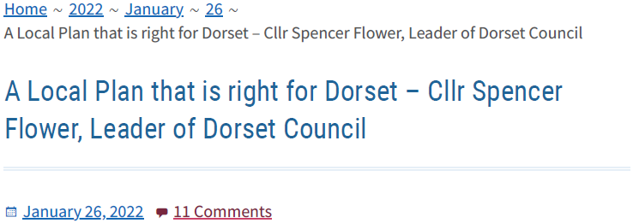
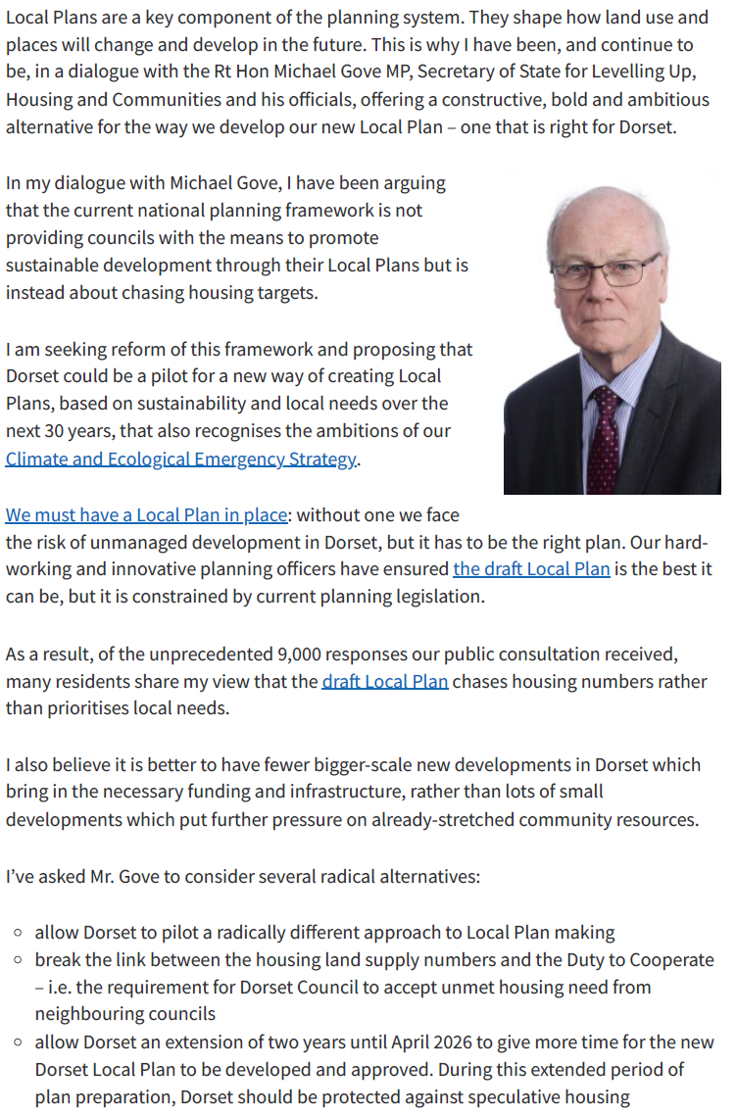
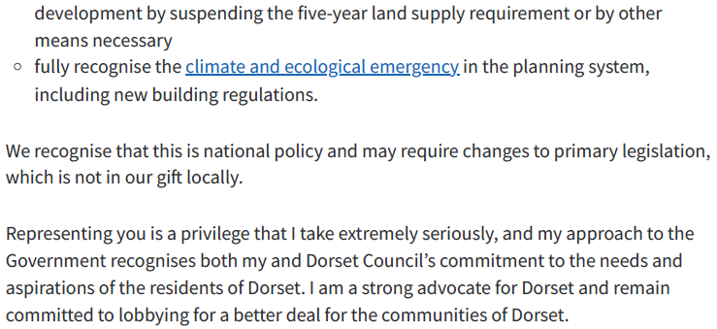

The 59 is based on the PLP1 settlement extensions of Lytchett Matravers (46) that is still extant (IMS Table 1) a further 13 dwellings on minor sites within the village (5yr HLS Appx 1)
As published in June 2022
The latest AMR (2017) does not provide any data, the monitoring was reported in the SD93 appendices
NPPF para 140
Paragraph 116 of the IMS
https://news.dorsetcouncil.gov.uk/2022/01/26/a-local-plan-that-is-right-for-dorset-cllr-spencer-flower-leader-of-dorset-council/ and appended

