Minutes of the meeting of LYTCHETT MATRAVERS PARISH COUNCIL

Meeting of Full Council, Weds 26th July 2023 at 7.00 p.m. in the Blanchard Room, Village Hall.
PRESENT were A Bush (Council Chair), R Aspray, M Attridge, K Morgan, and Mr T Watton (Parish Clerk / RFO).

Also present: Dorset Cllrs A Brenton, A Starr and three members of the public.

PUBLIC PARTICIPATION SESSION (Standing orders suspended)
The Chair of the School Governors introduced herself, the current crossing patrol person, and a school parent. The main point they wished to make was that they felt the proposed zebra crossing would still be dangerous without a crossing patrol person. The crossing patrol person gave an impassioned talk about the job, her experiences, the current problems and why she felt a zebra crossing alone would still need managing. She explained that within her role she not only provides a safe crossing for pedestrians, but also often finds she needs to provide additional safety support for children with special needs, and to respond to unpredictable situations arising from driver and pedestrian behaviours. So, whilst visibility was a factor, the principal problems came from impatient and/or careless drivers.

They also highlighted the desirability of introducing a single length of roadside barrier covering the whole length of the school frontage to encourage people to use the crossing.

In response, Council members summarised how DC Highways had been engaged and what steps have led to the zebra crossing proposal. In 2018/19 there was no crossing patrol person at all for a year. This then led to the residents’ petition for a formal crossing (supported by 500+ signees), the resulting Sustrans community consultation event commissioned by DC Highways and the subsequent challenges of dealing with DC Highways to get them to a point of agreeing to provide a crossing which was the core of the Sustrans Report recommendations. This proposal remains subject to final internal approval and a public consultation. The related conditions associated with DC Highway’s agreement to the crossing were also outlined: relocation of the bus stop, removal of the lay-by, establishment of the no parking zone and cessation of resourcing for the crossing patrol.

The members also outlined the Council’s related initiative, which has also been pursued with DC Highways over a lengthy period, to introduce an off-road school drop off / pick up point on the land alongside the school near the Lytchett Astro.

The three representatives felt that they could support the drop-off / pick-up initiative, although they expressed some concerns about the practicalities of the pick-up aspect because unlike the arrivals in the morning, the timings at the end of the school day are not staggered.

DORSET COUNCILLORS’ REPORT
Dorset Cllr Alex Brenton produced a report which had been made available to members ahead of the meeting. Members noted its content, and a copy is associated at Appendix 1 to these minutes.

Dorset Cllr Brenton highlighted that only five Parish & Town Councils so far have been informed that their applications for 20mph limits are worth pursuing. Cllr Bush wondered why Dorset Council are approaching the initiative in this way – in contrast to apparently much simpler approaches by principal authorities in other parts of the Country.

1. To receive and consider apologies for absence.
Cllrs A Huggins, H Khanna, K Korenevsky and P Webb.

2. To receive any declarations of interest, and consider any requests for Special Dispensations under Section 33 of the Localism Act 2011.
None.

3. To consider any applications for the casual vacancy on the Parish Council.
None received.

4. To receive and resolve to approve minutes of Council meeting held on 28th June 2023
It was RESOLVED to approve the minutes of the meeting as true record of it. They were duly signed by the Council Chair.

5. To receive and consider reports of past subject matters on the minutes of the Full Council meetings (for purposes of report only).
It was RESOLVED to receive and note the contents of the following report, which had been prepared and circulated in advance of the meeting by the Parish Clerk. Italics below indicate additional comments made during the meeting.
- Minute 17, Full Council 10th Aug 2022 – dog exercise area. Actions:
Removal of the bramble roots and re-seeding with grass. The Parish Clerk received an update on this from Mr Warr on 26th June. Although it had originally been arranged to carry out this work during week commencing 22nd May 2023, the ground conditions were considered unsuitable for seeding. Mr Warr has advised that since then it has continued to be very dry and therefore remains unsuitable conditions. However, he is continuing to monitor it and will carry this work out as soon as conditions are right.
- Minute 18, 22nd Feb 2023 - Parish Clerk to write to the Village Hall Management Committee with request for the replacement of the windows and frames in the Parish Council office. It was reported by the Clerk during the meeting on 24th May that the Chair of the Village Hall Committee had indicated their desire to accept a quote from the supplier / installer of the windows for the Youth Hall but, due to limited availability of funds, she had asked whether the Council might meet the cost initially and accept a part reimbursement from the Village Hall Committee. In response the Council members agreed to suggest to the VH Management Cttee that instead they may like to consider a grant request to the Council to support this. As a result the Parish Clerk wrote to the VH Management Cttee making that suggestion and enclosing a copy of the Grant Application Form. This was submitted by the VH Management Committee and during a subsequent discussion (see F&GP Cttee minutes 12/07/23 minute 11) it was decided to suggest to them that the Council meets the cost of the windows. This was put to the VH Management Committee and agreed by them. A site meeting was arranged with the contractor, the original £1000 quote confirmed and the order placed.
- Minute 20.1, 22nd Feb 2023 - communication of outcome of grant request and the confirmation of Council responsibility for churchyard maintenance including the boundary wall. The Parish Clerk had written to the PCC; and also suggested that they may wish to seek additional quotes from providers approved by the diocese. A response from Rev. Partridge thanked the Council for this and confirmed that they would seek the additional quotes. In the meantime a “Churchyard Maintenance policy” was prepared and approved by the Parish Council at its March 2023 meeting. In June 2023 a communication was received from the Fabric Chair of St Mary’s Church which reiterated the original quote obtained in August 2022 plus one further one. At a site meeting held on 10th July the Fabric Chair confirmed that the August 2022 was still valid, and he agreed to try to obtain one further quote. ON HOLD – awaiting one further quote for the required work on the boundary wall. It was also noted that the site meeting on 10th July had also coved a number of other maintenance matters. Notes were produced of this meeting and will be distributed to all members for information Action: parish Clerk to distribute the meeting notes to all members.
- Minute 25, 22nd Feb 2023 - offer from a mobile catering company to operate from the High St Car Park on Saturday mornings / Cllr Bush to speak to the Football Club about this. At the meeting on 24th May 2023 the Council Chair summarised the situation so far – highlighting that whilst the Football Club had indicated their intention to extend their service to an offering to the wider public, nothing had really changed - so the general public remain largely unaware of any opportunity. The Parish Clerk reported back at the F&GP Cttee meeting on 14th June (see minute 21) confirming the details of the service offering and that the organisation was the same group of people who provided the service at the Coronation celebration event locally. At the June F&GP Cttee meeting it was agreed to offer this company a 3 month trial licence at an admin fee of £50. The Parish Clerk has written to the company accordingly and the response was reported to the F&GP Cttee at its meeting on 12 July 2023 (see minute 4 iii).
- Minutes 3, 4 and 5, Extraordinary Full Council meeting, 12th April 2023 – Opening of Lloyds bank account. The progression of Lloyds Bank account opening was the subject of the Extraordinary Council meeting at Full Council meeting on 26th April 2023. The Lloyds application process required submission of evidence of the declaration, plus a signed copy of the minutes. This final part of the submission was posted to Lloyds on Thursday 27th April. A response from Lloyds is now awaited. Each signatory should be contacted directly by Lloyds with their log-in details. It is understood that the account opening process can take up to 6 weeks. Still awaiting finalisation by Lloyds. A formal complaint has been logged with Lloyds bank over the excessive delay in them activating this account.
- Minute 6, Extraordinary Full Council meeting, 12th April 2023 – to open bank account with The Charity Bank. The Clerk has now obtained the details of this bank’s Easy Access Savings Account (Business version, as advised by the Charity Bank’s Customer Support team), plus a hard copy of the application form and Terms of Business. These are currently being examined with a view to putting forward a proposal to the June F&GP meeting to enable approval at Full Council and completion of the application form for submission by the end of June 2023. This matter is subject of a separate further agenda item at the Full Council meeting on 26th July 2023 (see item 16)
- Minute 18, 22 March 2023 - mandate for inactive Santander accounts. The Clerk has called Santander to discuss this. The process for updating the mandate involves the completion of a Change of Details form – which is now held by the Clerk. This will need to be supported by a copy of a Council minute listing the signatories to be removed (Keith Norris, Julie Dyball, Robin Miller, Maureen Munford and Dennis Gillard) and the new signatories to be added (still to be agreed). This will also need to be accompanied by a letter from the Council signed by the Chair, Vice Chair and Clerk also listing the signatories to be removed and added. This matter is subject of a separate further agenda item at the Full Council meeting on 26th July 2023 (see item 17).
- Minute 16, Full Council, 26 April 2023 - to provide a mobile phone for the use of the Parish Clerk on Council business in support of remote working. The Parish Clerk followed up on a mobile phone deal with Tesco Mobile identified by Cllr Huggins. However following two lengthy calls with Tesco mobile, plus a visit to their phone shop, Tesco were unable to successfully progress the request in a way which treats the Parish Council as the customer. ON HOLD - This matter will be picked up again when time permits.
- Minute 9, Full Council, 28th June 2023 (VEWG) – to clarify the Council’s opinion on the possibility of a restriction, such as a kissing gate or chicane, at each end of Jubilee Walk to prevent access for cycles and horses. As requested, the Parish Clerk wrote to Katie Black DC Rights of Way Ranger. She advised that both Jubilee Walk and Church Walk are designated as “public footpath[s] so bikes and horse should not be travelling down […].” Regarding the matter of installing gates or chicanes she advised that “Sadly, installing a gate is not as easy as it sounds as permission needs to be sort from the Highway Authority (is me) and I need to advertise and there may be objections. There are also limited reasons which enable gates to be installed, and standards which need to be maintained.” Ms Black said that she would be happy to meet to discuss this if required. The above response was passed back to the VEWG.
- Minute 13, Full Council, 28th June 2023 – corporate response to DC consultation on Dog related PSPO. As agreed, the Parish Clerk completed a response on behalf of the Parish Council.

6. Chair’s announcements (for the purposes of report only).
There were none.

7. To receive and note the content of the minutes of the Finance & General Purposes Committee Meeting on 14th June 2023 (for purposes of report only)
It was RESOLVED to receive and note the contents of these draft minutes.

8. To consider the following recommendations from the F&GP Cttee meeting on 12th July 2023
- To adopt the process as set out in the DAPTC Guidance Note dated 22nd June 2023 for responding to Unauthorised Traveller Encampments within the parish; and to confirm that the Parish Clerk has the delegated authority to agree to the payment of £600 to Dorset Council to enable the police to issue a “Section 62”, if one is required.
It was RESOLVED to approve this. In response to a question from Cllr Attridge is was confirmed that this specific approval of delegated authority would continue to apply in the event of any increase in the related fee.

9. To receive a report from the Village Environment Working Group (for purposes of report only)
A summary report had been made available to all members ahead of this meeting and the contents were noted. A copy is associated at Appendix 2 to these minutes.

10. To receive a report from the Highways Working Group (for purposes of report only)
A summary report had been made available to all members ahead of this meeting. A copy of the report is associated at Appendix 3 to these minutes.

11. Receive a report from the Neighbourhood Plan 2 Working Group (for purposes of report only).
A summary report had been made available to all members ahead of this meeting. A copy of the report is associated at Appendix 4 to these minutes.

12. To receive a report from the Lytchett Matravers Youth Hall Working Group (for purposes of report only).
The Council Chair summarised the current position. In April 2023 prices for the phase 1 works had been obtained from three contractors and one had subsequently been selected based on price and timing / availability. Further details were then worked up for consideration and response from the contractor, but a delay in any response from him had then ensued. As a result it was recognised that there was a need to consider a replacement contractor – either through a re-tendering exercise or by going back to the other two contractors who responded and reviewing with them their quoted prices and availability. Consequently Cllr Morgan contacted both contractors and agreed with them that they would review and then come back with updated prices. Of these, one could not do anything before the year end, whilst the other (the more expensive quote originally) had raised their prices further.

Cllr Bush went on to explain that attempts have since been made to obtain a quote from one more contractor and a site meeting took place on Monday 24th July 2023. A response is expected shortly.

Cllr Bush reported that in the meantime it is PROPOSED that a reduced set of improvements extracted from the phase 1 planned works is undertaken at a minimum spend of around £15K to get the building into operation as soon as possible – i.e. to include a refresh / refit of the toilet block, replace doors, refresh the kitchen area, install water heater and repaint internally. The full phase 1 planned improvements would then be undertaken when the requested quotes have been received and considered, and the selected contractor is available.

The above proposal was unanimously APPROVED by the members present.

13. To receive a report on planning towards D-Day anniversary community event in 2024 (for purposes of report only).
Cllr Aspray had prepared a discussion paper which had been made available to all members ahead of this meeting. A copy of the report is associated at Appendix 5 to these minutes.
Regarding the D-Day commemoration event, it was AGREED that the event will take place on the evening of Thursday 6th June 2024 on the Recreation Ground and in the Village Hall. This will follow the national event plan being promoted by Bruno Peek and will include the lighting of a beacon on the Recreation Ground. However Cllr Aspray will also speak to Mr Martyn Colvey about also arranging a film show (possibly “The Longest Day”).
There was also discussion about a possible separate community event held over the weekend of 22/23 June 2024. In order to evaluate the public interest / support for such an event it was agreed that in September 2023 a public meeting will be advertised to take place in October for anyone interested in helping to organise this event.
Immediate actions:
- Parish Clerk to contact Village Hall bookings secretary to request a booking of the Village Hall for Saturday and Sunday 22nd and 23rd June 2024.
- If (i) is successful, Cllr Bush to contact the Lytchett Matravers Youth Football organisers to offer them to take over the Parish Council’s current booking of the Village Hall on 8th and 9th June 2024.

14. To receive report on Annual Parish Meeting held 10 June 2023 (for purposes of report only)
A summary report had been made available to all members ahead of this meeting. A copy of the report is associated at Appendix 6 to these minutes.

15. Consider a proposal for Dropped Kerbs at various locations
DEFERRED until the August Full Council meeting.

16. To resolve to deposit an initial £10,000 in an Ethical Easy Access account with Charity Bank Ltd and that the following be authorised to operate the account on the Council’s behalf: Councillors Karen Korenevsky, Micki Attridge, Kenneth Morgan, and Andrew Huggins.
RESOLVED to approve.

17. To resolve to confirm to Santander Bank the following signatory / “account operator” changes on the bank mandate for the Council’s Santander Bank accounts; i.e. to remove Maureen Munford, Julie Dyball, Keith Norris, Robin Miller and Dennis Gillard; and add Andrew Huggins, Karen Korenevsky, Kenneth Morgan and Micki Attridge.

Also to confirm to Santander Bank the following full list of organisation members: Councillors Victoria Abbott, Robert Aspray, Micki Attridge, Beverly Barker, Alf Bush, Andrew Huggins, Hannah Khanna, Karen Korenevsky, Kenneth Morgan and Peter Webb. Parish Clerk, Timothy Watton.
RESOLVED to approve.

18. To receive a report on the request for updated contractors’ prices for phase 1 Youth Hall refurbishment works; to consider these, and to select a contractor to appoint to undertake the specified works
This matter was considered as part of the discussion under minute 12 above.

19. To consider and accept quotation for a measured survey of site adjoining the School for potential car park and sports facilities.
Cllr Morgan had produced a report and proposal on this matter which had been made available all Council members ahead of the meeting. A copy is associated at Appendix 7 to these minutes. The proposal to select Casterbridge Surveys to carry out this work was unanimously APPROVED. It was noted that permission will need to be obtained from Dorset Council – and Cllr Bush indicated that he would write to DC Estates Officer John Morgan. Action: Cllr Bush to approach John Morgan accordingly. It was also noted that the horses normally grazing in the field will need to be removed for the duration of the survey itself.

20. To consider design for enhancement of Hannam’s Gate entrance to the Rec.
Cllr Morgan had produced a report and proposal on this matter which had been made available all Council members ahead of the meeting. A copy is associated at Appendix 8 to these minutes. This design was unanimously APPROVED. Action: Cllr Morgan to discuss this with the Hannams Close Management Company and Dorset Council.

21. To consider design for replacement Parish Council/Village Notice Board on Library Green.
Cllr Morgan had produced a report and proposal on this matter which had been made available all Council members ahead of the meeting. A copy is associated at Appendix 9 to these minutes. This design was unanimously APPROVED to go ahead as per the draft design.

22. To consider design for works adjoining Sports Pavilion and Scout Hut to provide stores for Sports Club, Scouts + Parish Council, 2x external Table Tennis Tables, together with an enhanced Entrance and enlarged Terrace for Pavilion. Proposal to include option for shared/public wheelchair accessible public toilet
Cllr Morgan had produced a report and proposal on this matter which had been made available all Council members ahead of the meeting. A copy is associated at Appendix 10 to these minutes. Subject to removal of the proposed public access toilet, this design was unanimously APPROVED to go ahead for discussion with the Sports Club, the Scouts, and the Football club as per the draft design.

23. To consider and approve the Agreement with Wessex Internet for provision of a fibre connection to the Recreation Ground.
It was noted that Cllr Bush had been liaising with Wessex Internet over the route across the recreation ground for the internet cabling and location of the cabinet near the bus stop.
It was also noted that in return, internet access will be provided to the Village Hall, Sports Pavilion and Youth Hall at £1 per month each for a period of 25 years.

This was discussed by the members present and unanimously APPROVED and the agreement duly signed by Cllr Bush and the Parish Clerk on behalf of the Council.

24. Report into outstanding legal fees related to the pharmacy steps project.
Cllr Bush explained that as part of the Pharmacy Steps project the Council had made an upfront payment to Ellis Jones solicitors of £3600 to enable them to meet undertakings to four separate solicitors acting for the freeholders and leaseholders of the two affected premises. Ultimately only two of the solicitors dealt with the draft documents and so they were paid – leaving a balance of £1500 still with Ellis Jones, which coincidentally matched their own fees for their service to the Council on this matter (but excluding the VAT and disbursements). Consequently this has resulted in an invoice from Ellis Jones Solicitors for the outstanding £290.80. It was RESOLVED to approve payment of this.

25. To resolve to approve the following payments already made:
To Whom | For What | Net | VAT | Total

British Telecom | Office phone and broadband – June 2023 | 55.98 | 11.19 | 67.17
Fletchamoore (Poole) Ltd | Removal of car park barrier and make good surface | 325.00 | 65.00 | 390.00
SSE | Car park lighting quarter 1 2023/24 | 16.18 | 0.80 | 16.98
HSBC | Bank charges to 30th June 2023 | 5.00 | 0.00 | 5.00
SSE | Youth Hall electricity – quarter 2 2023/24 | 80.87 | 4.04 | 84.91

It was RESOLVED to approve the above payments already made.

26. To resolve to approve the following payments due:
To Whom | For What | Net | VAT | Total
T Watton | Clerk’s salary – July 2023. | 1138.80 | 0.00 | 1138.80
HMRC | PAYE & ENI – July 2023. | 388.75 | 0.00 | 388.75
Dorset County Pension Fund | LGPS pension contrib July 2023 | 420.13 | 0.00 | 420.13
T Homer | Handyman duties, June 2023 | 325.62 | 0.00 | 325.62
Idverde Ltd | Cemetery maintenance June 2023 Inv no 10885420 | 350.60 | 70.12 | 420.72
Idverde Ltd | Cemetery maintenance July 2023  Inv no 10887533 | 350.60 | 70.12 | 420.72
Idverde Ltd | Grass cutting, southern end of rec  (5/6/23, 21/6/23, 6/7/23, 19/7/23)  Inv no 10887560 | 132.28 | 26.46 | 158.74
Lytchett Matravers Village Hall | Hall hire for meetings 8th Feb 23-26th July 2023 inclusive | 300.00 | 0.00 | 300.00
Haven Memorials Ltd | Refund of part fee for memorial (local resident) | 140.00 | 0.00 | 140.00
Dorset Council | Footpath maintenance annual fee – Jubilee Walk and Church Walk | 490.00 | 0.00 | 490.00
BHIB Ltd | Additional Insurance premium – Sports Pavilion buildings insurance | 350.57 | 0.00 | 350.57
T Watton | Mileage and expenses incurred on behalf of Council | 109.02 | 5.58 | 114.60
Replay Maintenance Ltd | Half yearly service – Astro pitch | 547.50 | 109.50 | 657.00
Ellis Jones Solicitors | Outstanding legal fees for pharmacy steps project | 290.80 | 0.00 | 290.80

It was RESOLVED to approve all of the above payments.

27. To note any training undertaken by members or the Clerk in the past month (for purposes of report only).
None.

28. To note any decisions and / or action taken by Parish Clerk under “Openness of Local Government Bodies Regulations 2014”, Part 3, Paragraphs 6-10, Record of Decisions and Access to Documents (for purposes of report only).
None.

29. To note correspondence received (for purposes of report only).
Cllr Aspray reported that he had received notification that planning application P/FUL/2023/00458 (Land known as Dyett's Field High Street Lytchett Matravers, to erect an agricultural building) had now been refused by the LPA.
Cllr Morgan expressed concern about the correspondence from Dorset Council under reference P/NMA/2023/04104 related to approved planning application 6/2020/0314. The 700mm adjustment in positioning of the dwelling had been specifically objected to by the Parish Council on 23rd March 2022 under application P/VOC/2022/01291 (variation of conditions 2 and 5 on planning application 6/2020/0314).
Cllr Bush referred to the correspondence regarding the lack of maintenance of the Aster Housing amenity areas around their properties on and between Lockyers Way and The Spinney – particularly the lack of cutting back of overhanging growth around the connecting footpaths, the rotting / disintegrating play equipment and the infestation of weeds etc in their children’s play area there. He wondered if it might be worth seeking a meeting with Aster about this. The Parish Clerk remarked on the lack of responses from Aster and their apparent reluctance to take meaningful action to fully address these matters over the last 2 years or so, despite copying the repeated requests to the CEO of Aster Housing. Dorset Cllr Brenton offered to speak to her contacts at Aster. Action: Parish Clerk to copy the most recent correspondence with Aster to Cllr Brenton.
Cllr Bush also commented on the recent correspondence with the resident of Lytchett Manor House concerning a branch of a Horse Chestnut tree in his grounds which had fallen on to the Celtic Cross in the churchyard causing risk to anyone visiting the church, churchyard, the cemeteries or using Church Walk public footpath. The Council is in discussion with the resident regarding reimbursement for the cost of making safe and removing the fallen branch, as well as ongoing concerns about the health of the tree concerned and the other adjacent trees. Given the size and likely age of the damaged tree Dorset Cllr Brenton suggested that the owner should be asked to arrange for an accredited arboricultural consultant to inspect it because it seems possible that the tree may be diseased. She suggested a solicitor’s letter to the resident to request that this review action is taken.

The meeting closed at 21:24 Annotated by/on ……………………………..Signed by……………………

APPENDICES

APPENDIX 1
Report by Dorset Cllr Alex Brenton – July 2023
At the Full Council meeting, last week, there were two groups of vocal protestors and much time was taken discussing the Bibby Stockholm barge. The Council was virtually unanimous to condemn the use of the Barge for bringing 500 young men without jobs into a small town like Portland overwhelming the facilities. The Government is sending money to support extra facilities, but the principle is disapproved of as Dorset has no say in what was going to happen. The barge docked this morning. The amendment which displayed sympathy towards refugees and their plight but still rejected housing them in the barge discussed at length but failed in the end.

Planning.
There was an update on the new rules which will be in place in Planning to enforce Nature and Biodiversity gains into most planning applications (apart from single home extensions). These rules will be enforceable, so the Dorset Local Plan is being modified to include the Nature Recovery plan. There are still many questions about who will provide the extra space required for these natural additions and whether replacement areas will be the same as those lost.
However we are now planning more pro-actively for Nature. Though it still depends on the fine tuning of the Levelling Up bill now scheduled for the Autumn.

Local Offer Live

In partnership with NHS Dorset and Dorset Parent Carer Council, Dorset have delivered their first ever Local Offer Live. A fortnight of events for parents, caregivers and young people with special educational needs and disabilities.
Families attending the events had an opportunity to meet service providers and find out about various support and resources that may be available to their children or young person. However the session I attended did not have great numbers.

The Dorset Council Housing Strategy Consultation is going to be launched on 24 July. Open until October.
DC are keen to hear from as many residents as possible so you are encouraged to set aside just 10 minutes during the consultation period to help DC home in on housing. The fact sheet set alongside the consultation has some worrying figures. Average house price in Dorset is 11 times the average annual wage. House prices have risen 30% since 2018. Rents have risen 4.4% average in five years but incomes have dropped 3.3%. I know some local landlords where the rental increase is 17%-20% since Covid.
Housing needs figures estimate that DC needs 4950 more rented homes and 3,835 purchase homes by 2028.

Applications for 20mph have been considered by the Council’s new 20mph Panel Group. The successful 5 are in Bridport town centre, Langton Matravers, Wimborne town centre, Winfrith Newburgh and Pimperne. However the complicated system has put many Councils off proceeding and virtually all the costs have to be borne by the local council which is prohibitive to smaller Councils.
Maintenance of verges and footpaths is a continual problem. The schedule of verge cutting by Dorset has been circulated but some confusion about which lane is C, D or unclassified. There was a problem with several of the County ‘cut and collect‘ machines breaking down and parts not being available for 10 weeks. This should now be sorted. But there is a backlog of uncut verges to get to.

Awareness of disturbance to wildlife and Countryside.
Shaun the Sheep was revealed at the end of May as the new champion of Natural England’s Countryside Code. “A new baa-rilliant campaign with Aardman will see the popular animated character encourage children and young people to “respect, protect and enjoy” the countryside. From Mossy Bottom farm, Shaun and friends will follow the Countryside Code and show children how to care for nature, follow signs and share the space with others.” Shaun the Sheep and the Countryside Code - National Trails

The new Marine and Coastal Wildlife Code is now available – it reflects visitors to the coast may encounter lots of different wildlife and there is specific advice on minimising disturbance. Information about seabirds, mammals and other aquatic species; breeding, moulting and wintering periods; water-based activities and reporting dead or injured seabirds or marine animals is included in the new code - Marine and coastal wildlife code: advice for visitors - GOV.UK (www.gov.uk)

Green Flag awards
In a record-breaking year, 3 country parks and 2 nature sites in Dorset have been awarded the prestigious Green Flag Award. This week, Dorset Council is celebrating after receiving 5 Green Flag Awards for its Avon Heath, Stour Meadows, Milldown, Durlston, and Thorncombe Woods, Black Heath and Hardy’s Birthplace sites.

Affordable homes in Bridport Rural housing specialist, Hastoe Housing, together with development partners, Dorset Council and C G Fry & Son Ltd, marked Rural Housing Week (3-7 July) with a celebration of their latest development of 8 affordable homes in the historic centre of Bridport, Dorset.

Martin Cox, owner of West Dorset Leisure Holidays, previously owned the land on which the homes are built along with his sister and cousin. Having grown up on Rope Walks with a strong memory of the community that once lived there, Martin and his family were keen to support the opportunity to bring more local people back into the centre of the market town.

The 8, two and three-bedroom houses, were built on the site of a former coal yard. This influenced the design, which is a traditional style of architecture found locally, taking into account correct scale and proportioning with appropriate detailing.

Hastoe Housing and C G Fry & Son Ltd both have a long-standing reputation for building high-quality homes, respecting not just local building style and traditions but environmental standards. The homes, completed in March 2023, incorporate many features of Hastoe’s New-Build Standard, ensuring the homes are highly energy-efficient and exceptionally well insulated in order to help reduce fuel bills for residents.

Interesting info for open space providers (Should be taken into account by providers of SANGs):
New guidance launched to create safer parks for women and girls - 10 May 2023
It follows a recent study of a cross-section of more than a hundred women and girls from West Yorkshire which found that most believed their local parks to be unsafe.
The document (link here) is a partnership between Mayor Brabin, the University of Leeds, Make Space for Girls and Keep Britain Tidy, and is aimed at park managers, local authorities, police and community groups.
The guidance is primarily aimed at parks managers, landscape architects and other public realm design professionals across the UK, and helps stakeholders understand gender-sensitive principles of safety and implement changes at varying scales and budgets. The principles cover ten core areas under three themes:
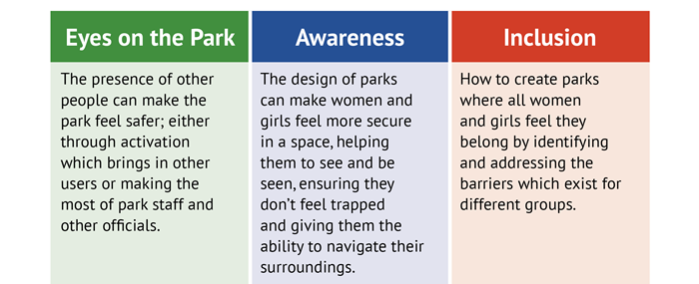
Dr Anna Barker, an Associate Professor in Criminal Justice & Criminology in the University of Leeds’ School of Law led the original research and has organised today’s conference.
She said: “In Britain, women are three times less likely than men to feel safe in a park during the day.
“This is worse after dark, when as many as four out of five women in Britain say that they would feel unsafe walking alone in a park, compared to two out of five men.
“All these factors mean that women and girls are less likely to use parks than men and boys, a situation which has a significant impact on their lives. Our guidelines, covering ten principles for design and management, can enable decision-makers to enact change.”
The guidance will be launched as part of a two-day conference entitled Women and Girls' Safety in Parks: Lessons from Research and Practice. The opening session will be chaired by Alison Lowe OBE, Deputy Mayor for Policing and Crime in West Yorkshire, and the guidance itself will be introduced by the Mayor of West Yorkshire Tracy Brabin, who funded the work as part of her Safety of Women and Girls Strategy
Among others attending will be representatives from the Suzy Lamplugh Trust, Women in Sport, Keep Britain Tidy, and Make Space for Girls.
Keep Britain Tidy’s Chef Executive, Allison Ogden-Newton OBE, said:
“It’s critical that we understand what makes women and girls feel safe or unsafe across our green spaces and what needs to change to make them feel able to use their local park.”
“Our own research already shows that 70% of people in urban areas do not have access to good quality green space, rising to 75.8% in the most deprived areas. When coupled with women’s concerns about using those few green spaces they have access to, it means there is a real inequality. We must tackle it collectively, and as a priority.”

The organisations behind the new guidelines hope decision-makers will now review all their parks in partnership with the police and engage with women and girls specifically on safety, ensuring that those who do not currently use the parks are included.
They are also calling for the new guidance and the results of their discussions with women and girls to be incorporated into management plans for parks and green spaces and reviewed regularly.

Answer to a common question asked at the Planning Update on Nature Recovery Plans.
Question: We are all aware of how affordable housing is planned in at the beginning of the planning process and then, the number of houses is always reduced. This has become common practice. Much was made of planning in biodiversity net gain of 10% early on in the process, as if this would secure the desired outcomes. What will happen if a developer does not deliver biodiversity net because of viability? Will there be a financial penalty?
Answer: Applicants must demonstrate to the authority’s satisfaction that the mandatory 10% Biodiversity Net Gain (BNG) can be achieved by a proposal prior to decision making. This 10% can be delivered on- or off-site if it is not possible to deliver some or all the 10% on-site to help developers meet their obligation. The 10% will be secured in a legal agreement which will provide a legal binding mechanism for BNG delivery. We are currently waiting for secondary legislation which will provide clarity on details such as penalties for defaulting on BNG delivery and what provisions must therefore be in the legal agreements.
The Environment Act, under which BNG is enshrined in law, also enhances the existing Biodiversity Duty (originally conferred by the Natural Environment & Rural Communities Act, 2006) means that Dorset Council will be legally required to report on the delivery of BNG which will require compliance monitoring and enforcement. This will be built into the BNG end-to-end process within the planning system and is currently being discussed whilst we wait further government guidance.

Several viability studies have been undertaken. The 2019 Department for Environment, Food & Rural Affairs (DEFRA) evidence base and impact assessment considers that the 10% requirement is unlikely to significantly affect viability issues for development. The Department for Levelling Up, Housing and Communities (DLUHC) and DEFRA are not aware of any evidence to the contrary. Essentially the 10% set out in legislation is mandatory and therefore there is no scope for planning authorities to allow a reduction on viability grounds. It is also interesting to note that a number of Local Nature Partnerships and planning authorities in England have conducted their own viability assessments. None of these have concluded that BNG is likely to significantly affect viability, in some cases these assessments have provided an evidence base to require more than 10% in their local plans.

When requirements such as BNG are considered from the outset of the site design stage, there should be minimum impact on development costs. Additional costs arise when a developer needs to revisit proposals and amend the scheme to retrofit BNG requirements. This is something that has been seen previously when there was a requirement for sustainable drainage to be considered from the outset to address on-site surface water flows. In addition, when a development is designed with space for green infrastructure and for biodiversity, it can often be more attractive than a standard scheme that does not build in sufficient space for nature. This can often add to the receipts that can be obtained from the sale of the homes on a site enhancing the development’s overall viability. Any impact on viability is likely to be short term as developers reflect the costs of developing a site (which will include BNG) when negotiating the purchase price for land.

APPENDIX 2
Village Environment Working Group – Summary Report. July 2023

Working Group Objective:
- Development and improvement of village amenities, principally within PC control
- Particular focus on Recreation Ground + Library Green areas + School Car Park/Sports Project.

Working Group Participants:
Ken Morgan, Alf Bush, Andrew Huggins, Karen Korenevsky, Vicky Abbot, Hannah Khanna

Details:- Hannams Gate, Pond, Sports Pavilion/Scout Hut works, Boules, Table Tennis, Rocket Park, School Car Park/Sports Project.
- Hannams Gate. Design submitted to PC. See Agenda Item 20.
- Sports/Scout Bldgs Entrances, Stores, Terrace + T Tennis. Design submitted to PC. See Agenda Item 22.
- Pond – Survey measurements + levels + detailed design required.
- Boules/Petanque Pitches – Layout/positions agreed. Detailed design required.
- Village Notice Board Replacement – Design submitted to PC. See Agenda Item 21.
- Rocket Park – Surface – Continue with bark or replace with rubber compound – whole or part?
- Finger Post Renovations – Progress on Upper X with discounted parts available. Assemble volunteer team for training + seek sponsorship.
- Dog Area – additional planting required – Woodland Trust to supply. Autumn planting preferred.
- Jubilee Walk – restriction required at Huntick Road end? See DC advice.
- School Parking/Sports Project. Topo survey required. See quotations Agenda Item 19.

Dependencies:
Hannams Close Management. Sports/Football Club. DC Highways. Funding/Grants.

Status/Next Steps:
- Agree designs for Sports Pav/Scout Hut/PC stores Notice Board + Hannams Gate. Invite tenders.
- Boules/Petanque Pitches + Pond– Develop + agree designs and invite tenders.
- Accept quotation for school car park/sports project topo survey.

Financial Forecast:  (£000’s, excluding VAT) | 2023-24 | 2024-25 | 2025-26
Expense to date
Forecast | Sp/Pav /TT/Terrace 55  Topo survey 1  Hannams Gate 5  Pond 15  Notice Board 5  Contingencies 20 | Rocket Park Surface 80  Fingerposts 5  Contingencies 30 | ?
Total | 101 | 115 | ?

APPENDIX 3
Highways Working Group – Summary Report

July 2023

Working Group Objective:
Review of all Highways related projects and establishing close liaison with Dorset Council Highways.

Working Group Participants:
Andrew Huggins, Ken Morgan, Alf Bush, Peter Webb, Beverly Barker, Rob Aspray

Background:
PC projects that require Dorset Council Highways interaction and agreement. To set up a more formal working arrangement with DC Highways to progress those projects.

Dependencies:
DC Highways approval and partial funding

Status / Next steps:
- School Crossing – Highways have been given the green light to proceed with the Zebra crossing proposal, subject to various checks, audits, orders, etc. Probably Easter 2024 for installation.
- Huntick Road Cycleway – apply for approval for next section - Rozalia Meadows to Jubilee Walk
- High Street Crossing – apply for permission to install as a ‘place’ project.
- Tesco Island – Create formal notice to Tesco of intentions with DCH approval.
- 20 MPH Zones – Apply for central village area to be set to 20 mph.
- Drop kerbs – proposal to July 2023 Full Council for installation of dropped kerbs on the Spinney, Burbidge Close and Vineyard Close. Cost Approx £13.5K. Budgeted £15K

Financial Forecast:
Financial Forecast:  (£000’s, excluding VAT) | 2023-24 | 2024-25 | 2025-26
Expense to date
Forecast | 255¹ | 80² | 1,000³
Total | 255 | 80 | 1,000
Notes:
- School crossing – 100, High St crossing 75, 20MPH – 30, Drop kerbs – 15, Huntick cycleway stage 2 – 35
- Tesco forecourt - 80
- Huntick cycleway stage 3 – 1,000

Appendices:
None

APPENDIX 4
Neighbourhood Plan 2 Working Group – Summary Report
July 2023
Working Group Objective:
To renew the Lytchett Matravers Neighbourhood Plan (LMNP) in readiness for the Dorset Local Plan.
Working Group Participants:
Alf Bush (Chair), Ken Morgan, Micki Attridge, Karen Korenevsky, Peter Webb, Ian Taylor

Background:
The current NP1 was limited in scope by Purbeck District Council and further by the examiner. The plan was prevented from identifying any type of development and in addition many policies/strategies for the community were removed. e.g. infrastructure and employment requirements. A renewed plan is required to address the chronic erosion of the green belt over the last 40 years, to ensure development is beneficial to the community in addressing its needs. i.e. sustainability, CCE net zero, design standards, local employment, community infrastructure and amenities.

Dependencies:
- PLP2 adoption – delayed due to need for new hearing on Morden Park (July 2022)
- Judicial review approach
- DLP next consultancy stage
Status/Next Steps:
1. Local residents have managed to apply TPO to the tree valley between Deans Drove and Glebe Road, essentially an extension of the Foxhills valley. This will add as an impediment for the development of that valley proposed by DLP.
2. Look for other TPO opportunities
3. Update action plan in line with ongoing dialogue between DC Planning and PLP2 Examiners
4. Follow up with Wessex Water on wetlands and Natural England nitrates/phosphates
5. Continue work on draft NP2 policies
6. Work with CAN/CPRE on DLP issues
7. Follow up with DC on government reply to DLP delay letter

Financial Forecast:  (£000’s, excluding VAT) | 2023-24 | 2024-25 | 2025-26
Expense to date
Forecast | 10
Total | 10

Appendices:
None

APPENDIX 5
D-Day Anniversary community event 2024

This item relates to plans to commemorate the D-Day landings on the 6th June and the possibility of organising a separate event for the community along similar lines to the Coronation Picnic event.

The D-Day event on the 6th will involve the lighting of the beacon and the reading of the International Tribute at 9:15pm. Perhaps some ancillary activities could take place beforehand such as a showing of the film The Longest Day in the village hall if that could be arranged.

As regards a community event, we have be careful that it doesn't clash with other major events in the local area. This rules out the weekend of the 8th/9th June which is likely to be the Wimborne Folk Festival and Corfe Mullen carnival. The following weekend is Harry Paye Day in Poole, another popular event. LMFC have yet to finalise the date for the football tournament but I believe that the 8th/9th is their first preference but with the 29th as a possible alternative. According to the MacMillan Dorset Bike Ride website next year's event will be on the 7th July.

So we could be looking at either the 22nd or 29th June depending on what LMFC decide to do.

At the meeting on the 24th May a number of 'Next Steps' were listed and these should form the basis of the discussion with the key question being whether there is sufficient interest in the village for a community event bearing in mind that the Coronation Picnic celebrated an important occasion and that, coupled with good weather, resulted in a good turnout.

The other main question is who should organise and fund an event. In the era of the Carnival and subsequent village fayre the Parish Council was not directly involved but did provide some financial support. The events were run by a committee comprising local people with the objective of providing an opportunity for local organisations and charities to raise money for their cause. Unfortunately participation dwindled to the point where the Carnival became unviable and attempts to replace it with a village fayre were unsuccessful. The community just lost interest.

My view is that if we decide to try and resurrect an event we will need to consider what it is aiming to achieve and how it will be organised and promoted.

Rob Aspray
25th July 2023

APPENDIX 6
Report Subject: Annual Parish Meeting 2023

Date (Month Year): June 2023

Reported by: Cllr Andrew Huggins

Subject Status:
Annual Parish Meeting took place on sunny Saturday 10th June 2023, 10am-12am, on library green, having prepared a suitable risk assessment.
The Gazebo was manned by 5 councillors.
Some people came specifically to talk to us about issues, and some were passing and looked interested so we engaged with them about what they liked and didn’t like in the village.
We spoke to approximately 20 people. We showed several the aspirational plans for Tesco island, Astro parking, Hannams Gateway, Rec Carpark buildings Enhancements (Storage)
Topics covered were:
- Brambles on the Library path
- Places for the public to obtain free drinking water
- Request for Stop sign/line at Rose and Crown Crossroads
- Greater Police Presence
- Cutting grass verges to improve visibility and safety
- Damaged Pavements
- Deans Drove Parking
- Suggestion of Commercial Bin at Hannams Gateway.
- Dislike of Chippings on Rocket Park
- Suggestion of PC doing presentation to the WI on what it does.
- Pavement alongside Wimborne Road
- Suggestion of Talbot Village Trust for project grants
- Suggestion of using Dorset Countryside Volunteers for the pond (leaflet)
- Yobs driving down Wareham Rd firing pellets/ball bearings, large camper van windscreen shot and elderly couple left frightened after their house window hit. Police informed but wouldn’t attend.
- Complaint about parking on pavements. (Suggest put in Parish Mag – Can only be request because it’s not yet illegal).
- Request for Boules pitches.
- 2 x Requests for outdoor table tennis.
- Query re progress of 20mph restriction.
- Church cemetery & PC responsibility
- Hedges overgrowing pavements
- High Street traffic calming in general
- School parking
- Support for 20mph (why is DC so pedantic in comparison to London and Devon/Cornwall?)

We all agreed that this had been a successful format.

APPENDIX 7
LAND ADJOINING SOUTH AND WEST SIDES OF PRIMARY SCHOOL
POSSIBLE CAR PARK + SPORTS FACILITIES – TOPOGRAPHIC SURVEY

Land (0.86Ha) to the south of the School is owned by Dorset Council , leased to the Parish Council and accommodating the Astro Court with associated access track from Wareham Road. Apart from the court and track, the remainder of the area comprises scrub.
Sketch designs for a school drop-off car park on the land have been developed by the Village Environment WG and frequently discussed at PC meetings in the context of the Wareham Road traffic chaos.

The field (1.78Ha) to the west of the School, accessed via School Walk off Eldons Drove is also owned by Dorset Council. It is let out for horse grazing.

The 2017 adopted Neighbourhood Plan proposed new sports pitches on the DC land, to include a pavilion for changing rooms with carparking and access from Wareham Road. Hopefully the sports facilities could combine with the School’s existing pitch for dual use.

The proposed school drop-off car park would also serve the sports facilities.

The PC have been engaging with DC for transfer of the land.

In order to progress these 2x projects, including agreeing a suitable highway access, a detailed land survey is required to establish exact dimensions, levels, tree positions and other constraining features. A topographical survey of this type requires a specialist contractor.

3x land survey companies have been approached (all of whom have been successfully engaged by the writer on previous projects). They were asked to submit 2x prices, one for the land south of the School (A), the second for the west field (B). (See sketch plan below). Their quotations are summarised below;-

Land Development Surveys (A) £1475.00 (B) £1075.00 (A+B) £2550.00
Total Survey Solutions (A) £650.00 (B) £650.00 (A+B) £1300.00
Casterbridge Surveys (A) £650.00 (A+B) £995.00

LDS are the longest established and largest of the 3. They advise of the need to either contain grazing horses or have them temporarily relocated.

All 3 firms can start within a short time frame.

My recommendation is to accept the Casterbridge (A+B) quotation of £995.00 + vat.
Before work commences the PC must arrange access to field B, including horse containment.

Cllr Ken Morgan (on behalf of the VEWG) 24th July 2023

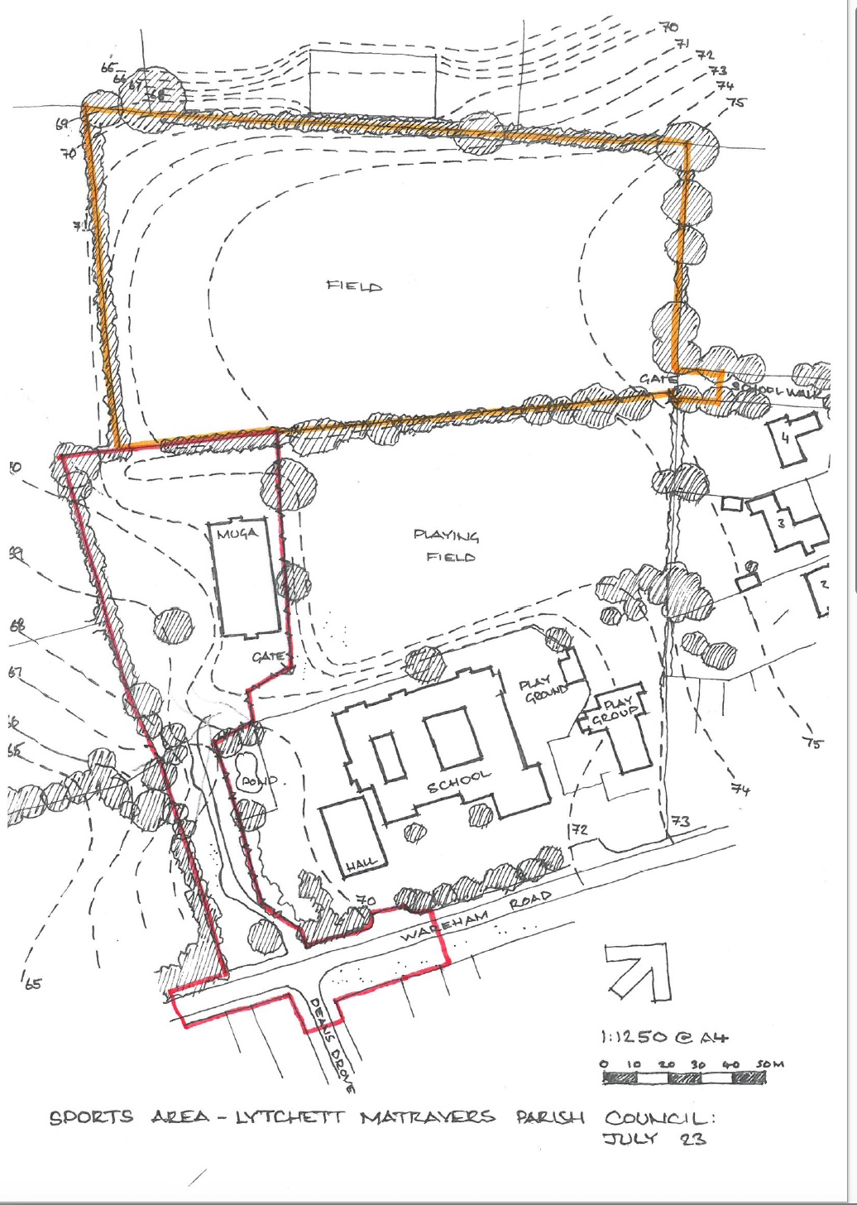

APPENDIX 8
HANNAMS GATE – PROPOSED ENHANCEMENTS

The entrance from Hannams Close onto the Rec is presently characterised by a collection of wheely bins and an unloved bund. The bins are from the various flats facing on to the Rec. sometimes they are removed back to their respective curtilages but typically there can be half a dozen bins left on the highway.
The area marks the meeting point of new and existing paths, features one of the new exercise points, makes an attractive picnic spot shaded below oak trees with the potential to make a prominent and attractive ‘gateway’ to the Rec.

The proposal is to accept the inevitability of the bins, but to screen them from wider view whilst allowing easy use and collection. 2 x screens made from vertical oak sleepers, each accommodating 4x large bins, will be provided, one on each side of the entrance, effectively framing the ‘Gateway’.
Between them the bund and old tree stump will be levelled to make an attractive sitting area with L shaped oak benches, planted behind the kerb line and protected from vehicles with substantial oak posts.

Ownership of the area between highway kerb and path is probably a combination of Highway, Hannams Close Management Company and Parish Council land. The agreement of all bodies will be required before implementation.

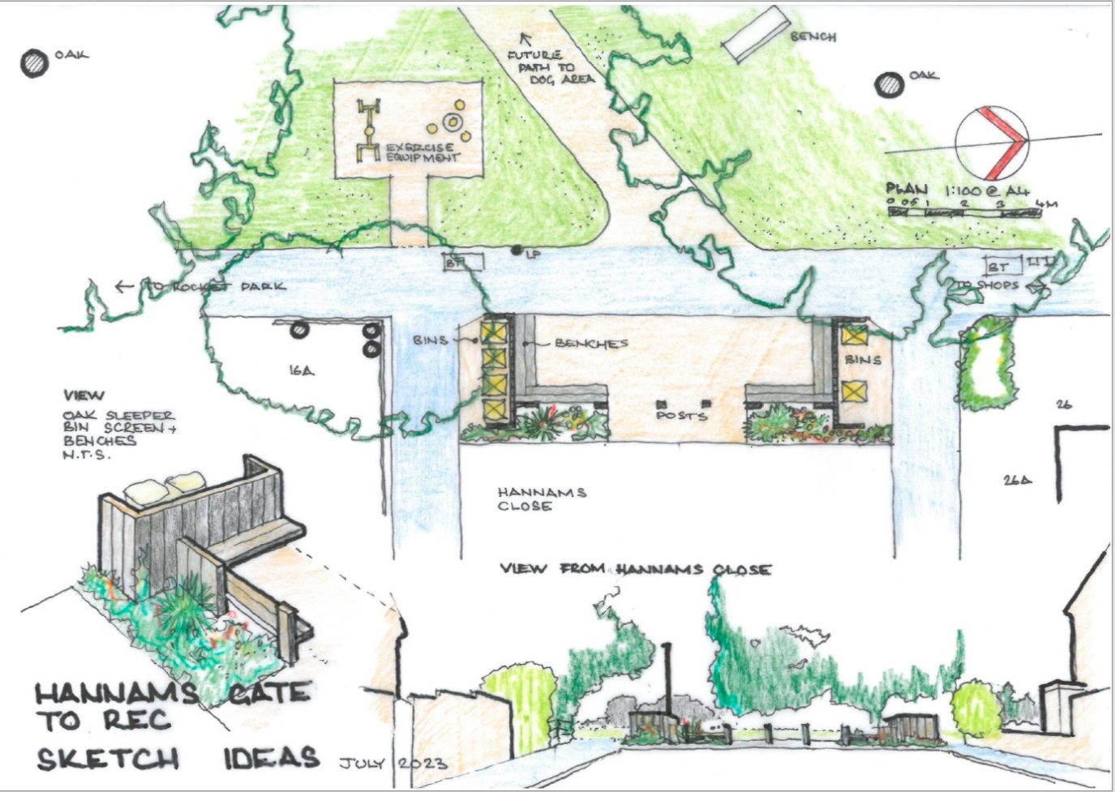

Cllr Ken Morgan (on behalf of the VEWG) 24th July 2023

APPENDIX 9
REPLACEMENT VILLAGE NOTICE BOARD

The existing Notice Board is in a shabby condition requiring either a major refurbishment or replacement. It is well placed at the heart of the village close to the shops, library and carpark. Its shallow V shaped form is also well oriented to catch the attention of probably the busiest pedestrian paths in the village.

However, being set back from the pavement, it is difficult to clearly see the detail of displays.

This corner is the most likely spot for casual meetings and many conversations take place here – a prime candidate site for more seating – a pleasant green space set back from the traffic with open views across to the Rec.

So, if we combine new seating with the Notice Board, there is a much higher chance of notices and Posters actually being read. Who knows – perhaps people might actually read the PC Vacancy Notices and apply to join us!

It has been suggested that the Notice Board should be visible from all sides, ie not having a back face. The solution is to make a freestanding , multi facetted notice board set much closer to the pavement with seating arranged to see all sides.

The notice cabinets must be waterproof, secure, vented to obviate condensation and, very importantly, be sturdy and vandal resistant. To achieve this 3x proprietory metal framed and glass fronted lockable units, each c 1m wide, are proposed, to be supported in an oak framed triangular structure. The High Street side would be fronted by an oak sleeper trough planted with sedums and similar drought resistant plants.
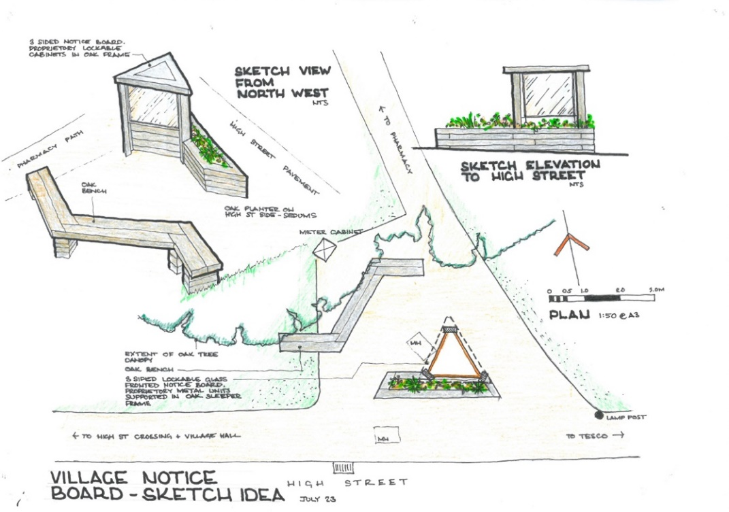

Cllr Ken Morgan (on behalf of the VEWG) 24th July 2023

APPENDIX 10
SPORTS PAVILION + SCOUT HUT – PROPOSED ENHANCEMENTS

The Sports Pavilion and Scout Hut occupy a prominent frontage in the village centre, both orientated towards the Recreation Field ,only presenting their backs to the High Street. These elevations were screened from wider view by a hedge, but that in turn created a dismal area characterised by vandalism and graffiti. As part of the car park enlargement works, the hedge was partially replaced with planted landscape to enhance the footpath.

Both the Pavilion and Scout Hut need adaptations to make them fully (wheelchair) accessible. Also both user groups would benefit from additional secure storage.
We now have the opportunity to provide these improvements and simultaneously upgrade the High Street frontage to make a vibrant and attractive community space.
The proposals are shown on the design drawings (2023.02A+03A) below and include:-

1….A widened Pavilion Entrance with a level threshold.

2….An enclosure around the excellent new (but unsightly) air source heat pump, sufficient to accommodate refuse bins.

3….A enlarged pitch-side terrace providing aa attractive sitting out area protected by a traditional pavilion style white trellis fence.

4….A pair of external table tennis tables on the High Street side, shielded from the prevailing south westerly breeze. Each is set on a level platform 3.5m x 6.5m, guarded from the adjacent footpath with matching trellis fences.

5….The 3.6m wide gap between the buildings, unsightly but usefully accommodating the 9m long goal frames, will be covered over. The roof profile has to be raised above both buildings to give adequate height. The north end of the store will be closed in but with a tall rolling shutter for access at the south end. This structure must be weathertight and secure, but can be left uninsulated .

6….Space released from the existing Sports Club store can be partitioned off to provide secure storage for Parish Council equipment – cones, signs etc.

7….To facilitate level access into the Scout Hut, the entrance door could be relocated to the High Steet side where the rising ground level obviates the need for steps. The consequent internal rearrangement will require some new storage space in an extension on the High Street side. This can be accessed either externally or possibly from inside as well.

8…Although this has not featured in previous discussions, it would be possible to include a fully accessible cubicle for general use. Possibly this could serve the existing buildings if funding or space is not available for fully accessible wcs internally.

Cllr Ken Morgan (on behalf of the VEWG) 24th July 2023
